

**PROPERTY AND PLANT MANUAL**

**BUSINESS AND FINANCIAL SERVICES**

**Updated 3/16/2022**

Table of Contents

Overview 5

Capitalization Thresholds 6

Art and Museum Objects 6

Buildings and Building Improvements 6

Movable Equipment and Furniture 7

Acquisition Cost of Movable Equipment 7

Intangible assets 8

Land 8

Land Improvements 8

Leasehold Improvements 8

Library Materials and Collections 8

Software 8

Infrastructure 8

OBJECT CODES 9

Capital Equipment Object Codes 10

acquisition of capital equipment 11

Direct Purchases 11

Donations and Gifts 11

Donations and Gifts of Capital Assets General Ledger Entries 11

Donation - Gifts Given Directly to an Organization or Department 13

Gift-In-Kind - Gift 13

Retirement of Gift Assets 13

Fabrications (WIP’s – Work In Progress) 13

Capital Equipment and Model Fabrication 14

Internally Developed Software >$50,000 15

Internally Developed Software WIP or SPWIP 16

Internally Generated Modification of Computer Software 17

Impairment Indicator 17

Inventory Requirements 18

Internally Generated Intangible Assets 18

Classification of Internally Generated Patents as Intangible Assets 18

Copyrights, Patents, and Trademarks 18

Land 18

Land Improvements 19

Setting up a WIP (89) 19

89 Equipment WIP Prorates 19

Tracking the WIP 30

Non-Capital Models 31

Deliverables 31

Lease Agreements 31

Lease Classifications 31

Capital Leases 32

Operating Leases 32

Rental Agreements 32

Use Charge 32

CSURF Leases 32

CSURF Line of Credit Lease ($50,000 or Less) 33

CSURF Municipal Lease (Over $50,000) 33

Internal Approval Required 34

Acquisition of and Title to Equipment 34

Reporting Requirements 35

Setting up a Lease-Purchase 35

Assigning an Asset Type Code for Equipment Purchased on a Capital Lease 36

Preparing an Adjustment/Accrual Voucher Document 36

Accounting for a Lease-Purchase 37

Capital Lease Payments 37

Distribution of Income and Expense 37

Payment Request from PO 38

Transferred-In Equipment 39

Contract, Grant, or Agreement Transfers 39

Direct Transfers 39

Federal Surplus Property or Reutilization 39

Accounting for Transferred-In Capital Assets 40

Creating a Transferred-In Asset 41

Loaned Equipment 41

Creating a Loaned Asset 41

Loaned Assets to a Research Account 41

Loaned Assets Given to an Organization Directly 41

intangible assets 42

Intangible Capitalization Thresholds 42

Characteristics of Intangible Assets 42

Recognition 42

Measurement 42

Amortization Issues 43

Impairment Indicator 43

Disclosure 43

Software 43

Software Purchases 43

Licenses, Maintenance Fees, and Service Contracts 44

NON-CAPITAL ASSETS 44

Creating a Non-Capital Asset 44

Weapons 44

High-Theft Items, Precious Metals, and Sensitive Property 44

Hazardous Materials 45

tagging capital equipment 45

Decals 45

CSU Owned Capital Equipment 45

Sponsor Owned and Federal Owned Equipment 45

Leased Equipment 45

Non-Capital Equipment 45

Identification of Assets 45

Stand-Alone Assets 46

System Assets 46

Other Assets 46

Procedure for Tagging Assets 46

Non-Decal-Able Assets 47

WIP (Work-In-Progress) Assets 47

Other Situations 47

Mail-Outs 48

Special Precautions 48

PHYSICAL INVENTORIES 48

Procedure 49

Planning/Scheduling 49

Data Verification 49

Untagged Assets on the Equipment List 50

Inventory Reconciliation 50

Untagged Assets Not on the Equipment List 50

Reporting 51

Property Closeout 51

Property control 51

Federal, Sponsor, and Other Owned or Funded Property 51

Title Release of Federal or Other Owned Property 53

Processing Title Release of Federal Owned or Other Owned Property to CSU 53

Managing Propery 54

Department Roles and Responsibilities 59

Self-Assessment 60

Kuali Documents 60

Requisitions 60

Capital Asset Tab 60

Capital Asset System Type 60

Capital Asset System State 61

Capital Asset Transaction Types for Services 61

Equipment in Progress 62

Asset Global (Add) 63

Acquisition Type 63

General Error Corrections (GEC’s) 63

Re-Classify an Expense to Capital 63

Re-Classify a Capital Item to an Expense 65

Merge an Asset 66

Separate an Asset 66

Asset Retirement 67

Retirement Reasons 67

Requesting Authorization to Relinquish Equipment 68

Transferring an Asset to Surplus Property 69

Retiring an Asset 71

Unauthorized Disposal 72

Additional Retirement Reasons Used Exclusively by Property Management 73

Control Assets 73

Asset Edit 73

Internal (Department to Department) Transfers 73

Equipment Loan/Return 74

Procedures for Processing an Equipment Loan/Return Document 74

Loaning Equipment Off-campus 75

Extending a Loan 75

Returning Equipment 75

Export Control 76

Insurance Coverage 76

Office of Foreign Assets Control (OFAC) 76

ACCOUNTING ENTRIES FOR Trade-inS 76

Accounting for the Trade-In of Similar Capital Equipment Using Book Value as the Cost Basis Adjustment 78

Accounting for the Trade-In of Similar Capital Equipment Using FMV to Determine the Cost Basis Adjustment 79

FMV Results in a Loss 79

FMV Results in a Gain 80

Assigning the Object Code on Capital Requisitions With a Trade-In 81

Non-Monetary Exchanges 81

equipment purchased for recharge / 21 fund equipment 82

Recognition of Depreciation Expense 83

Determining the Object SUB-TYPE Code Used for Capitalization 84

PLANT FUND ACCOUNTING 85

Assigning an Account For a New Project 85

Capitalization Criteria 85

Plant Sub-Funds 87

Prorates For Construction–In-Progress (automated journal vouchers) 88

Plant Fund Transfers 88

75 Reserve Fund Transfers 89

Capitalization Enteries 89

Expenses That Post to CIP After Capitalization Entry Has Been Made 90

COFRS Capital Construction 91

LONG-TERM DEBT OBLIGATIONS 91

Year-End Processes 92

Plant Fund 92

Property 92

REPORTS 93

APPENDIX 95

Operating Definitions 95

# 

# OVERVIEW

The purpose of Capital Asset Management (CAM) is to help organizations utilize and effectively manage their assets. The Kuali CAM System is used to record and report the capital assets for Colorado State University (CSU).

All assets located in the university-owned or leased buildings, purchased through the university financial system, or used in university operated research projects are deemed to be in the custody of the university, regardless of who ultimately retains title to this equipment. This includes equipment purchased with contracts, grants or other monetary awards through CSU. This does not mean that all assets are capitalized, tracked and depreciated/amortized in the CSU Property System.

# CAPITALIZATION THRESHOLDS

Thresholds for capital equipment acquisition are necessary for accountability. Capitalization acknowledges that a transaction meets all criteria necessary to be a fixed asset of the university and recognizes depreciation expense for them. Listed below is the financial threshold for each asset category:

**Type of Asset** **Capitalization $ Threshold**

Art and Historical Collections $5,000 per item or collection

Building and Building Improvements $50,000

Intangible Assets $5,000/$50,000

Land All acquisitions are capitalized

Land Improvements $50,000

Leasehold Improvements $50,000

Library Materials and Collections Physical materials are capitalized

Electronic materials are not capitalized

Movable Equipment and Furniture $5,000

Software – purchased $5,000

Software – internally developed $50,000

## **Art and Museum Objects**

## Art and Museum objects are non-depreciable pieces or collections purchased or donated to the university. Art and museum pieces shall be capitalized at their historical cost or fair market value at time of acquisition, if that value is $5,000 or greater. If a collection is greater than $5,000 then it will be capitalized as a collection.

## 

## **Buildings and Building Improvements**

## Expenditures per building for new construction, alterations or renovations greater than $50,000 and with a useful life > 1 year are capitalized. The costs per building project include expenditures related directly to their acquisition or construction. These costs include (1) materials, labor and overhead costs incurred during construction, and (2) professional fees and building permits. All direct costs incurred from excavation to completion are considered part of the building project. Equipment that is merely attached or fastened to the building should be classified as moveable equipment to the extent feasible. Equipment built into the structure is considered fixed equipment.

Structural remodeling and additions completed subsequent to the original building construction should be included under buildings as improvements to buildings. Improvements are capitalized only if the following conditions are met:

1. The cost of the project is equal to or over $50,000
2. The improvement provides an economic enhancement or extends the useful life of the building

Examples of projects to capitalize include conversion of the use of the space (a classroom to a lab), adapt space to accommodate startup for a new faculty, replace roof, duck points or a new HVAC system.

Example of projects to expense include conforming to construction codes, PCB removal, asbestos removal, handicapped access additions, cyclical maintenance such as paint, window and coverings, floor coverings, replacement of fixed equipment fixtures or major components due to premature breakdown, design flaws and unforeseen events.

Appropriate documentation will be maintained to support what constitutes an enhancement or useful life extension.

## **Movable Equipment and Furniture**

## Moveable equipment includes machinery (which is not a part of a building’s mechanical system), scientific instruments, office machines, maintenance equipment, recreation equipment, vehicles, software, furnishings, and other similar assets. Generally, equipment that is attached to a building is capitalized as movable equipment when removing the equipment does not cause structural damage to the building and will not destroy the equipment. An item must meet two specific criteria in order to qualify as a capital purchase. It must have (1) an acquisition value of at least $5,000 (unless part of a contract or grant where it specifically states equipment will be tracked at any value), and (2) a useful life expectancy of one year or greater.

***Acquisition Cost of Movable Equipment:*** Assets are recorded net of cash and other earned discounts. In addition, a trade-in allowance can result in the reduction of the acquisition value. Other charges to include in the acquired value are:

* + Cost of assembling the asset
  + Cost of installation
  + Shipping or Freight
  + Transportation or In-transit Insurance
  + Preparing the site and asset for its intended use
  + Costs of modifications, attachments, accessories, or auxiliary apparatus necessary to make the property useable for the purpose of which it was acquired.

*Betterments will be capitalized according to the Business Rules for Modifying Existing.*

* If the betterment is purchased within the same fiscal year as the existing asset and costs $1,000 or more, it is capitalized using “modify existing”.
* If the betterment is purchased in a different fiscal year than the existing asset, it must meet the $5,000 or more criteria. It is capitalized using “new” and the existing asset or decal number needs to be provided in the capital asset tab on the requisition. Property Management will determine if a new asset will be created or if the cost will be added to the asset by creating a new asset and using a dash on the existing asset’s decal number.

Expenses should be recorded in the period incurred. The following are not considered capital equipment or included in the acquired value regardless of cost or useful life:

* + - * Repair or replacement parts that are not considered a betterment
      * Spare parts that cannot be used independently
      * An item or substance that has no shape or identity, or loses that shape or identify upon detachment or removal from its original location
      * Maintenance, Warranty, Support, or Service Agreements
      * Training
      * Demolishing or dismantling, reassembling or reinstalling due to movement or rearrangement of equipment.
      * Software license agreements are not capitalized unless ownership is indicated within the license agreement. Software license agreements not indicating ownership should be expensed to object code 6225 Computer Hard/Software or 6201 General Supplies.
      * Modular Furniture is normally purchased in individual pieces on separate line items and then configured to make furniture. The normal practice is to capitalize only those line items that meet the capitalization threshold. Any furniture items that are not modular and do not meet the capitalization threshold will be recorded as supplies and expensed (e.g., a conference table costing $4,000 would not be capitalized). Mass purchases of furniture are not capitalized (e.g., the purchase of 100 beds with a unit cost of $700 each).

## **Intangible Assets**

The cost of an intangible asset must be $50,000 or more to be capitalized, with the exception of purchased software, which is capitalized at the cost of $5,000 or more.

**Land**

Land is real property and is not subject to depreciation*.* All costs incurred in acquiring land or getting the land ready for its intended use should be considered as part of the land cost. These expenditures shall include (1) the purchase price, (2) closing costs such as title work, attorney's fees and recording fees, (3) costs incurred in getting the land in condition for its intended use, such as grading, filling, draining, and clearing, and (4) the assumption of any mortgages or liens.

If both a building and land are purchased, the cost of the land should be capitalized separately from the building cost.

## **Land Improvements**

## The cost of a land improvement project must be $50,000 or more to be capitalized. A land improvement project could include the cost for paths, septic systems, athletic fields, bleachers, tennis courts, golf courses, retaining walls, parking lots, fountains, fencing and gates, landscaping, sprinkler systems, swimming pools, yard lighting, playground equipment, etc. Land improvements differ from infrastructure that consists of improvements like streets, sidewalks, utility lines, etc.

## **Leasehold Improvements**

## Leasehold improvements represent physical enhancements by or on behalf of the university to property that is leased by the university. When improvements are made, and those improvements are permanently affixed to the property, the title to those improvements transfer to the owner of the property at the end of the lease term. To be capitalized as leasehold improvements, the total cost of the improvements to the leased space must be $50,000 or more. The capitalized costs incurred by the university in constructing leasehold improvements represent an intangible asset or a license to use the improvements.

## 

## **Library Materials and Collections** All physical and cataloged library acquisitions shall be capitalized. There is no capitalization threshold as to the cost per unit. Departmental purchases of manuals or other professional guides not cataloged in the university library system will not be capitalized and neither will electronic library materials.

## **Software**

Purchased software includes any acquisition of packaged software or individual licenses to software for use greater than one year and with a fair market value of $5,000 or more. Internally Developed Software threshold is $50,000 or more.

## **Infrastructure**

It is the policy of the State of Colorado that only the Departments of Transportation and Natural Resources will record and report infrastructure capital assets. This category therefore will not be used for CSU, which falls under the Department of Higher Education. Infrastructure includes improvements related to land, but not associated to buildings. These items have a life exclusive of a building.

**OBJECT CODES**

The asset management system is driven by object codes; therefore, it is important to assign the correct object codes on capital transactions. When purchasing capital equipment, multiple factors come into play as to which object code will be used. The account being used, the fund source code on each account being used, the asset type code, and title ownership all need to be taken into consideration.

The Fund Source Code is located on the Central Administration tab of the Account Lookup.

Ownership for research projects (53 accounts) is found on the RPS report for that account. This is the report maintained for any research grant account with the Office of Sponsored Programs.

*Use below for Sponsor Funding by Title and Fund Source Code:*

|  |  |  |  |
| --- | --- | --- | --- |
| ACCOUNT FUNDING SOURCE | **TITLE FROM RPS REPORT SPONSORED PROGRAMS (Federal funds)** | | |
|  | SPONSOR TITLE | CSU TITLE | FEDERAL TITLE |
| 22 | 8235 | 8240/8255/8265 | 8245 |
| 32 | 8235 | 8240/8255/8265 | 8245 |
| 34 | 8235 | 8240/8255/8265 | 8245 |
| 41 | - | 8240/8255/8265 | 8245 |
| 51 | - | 8240/8255/8265 | 8245 |
| **Below are Object Codes based upon CSU funding and/or Other Funding Sources** | | | |
| 11 | - | 8210/8250/8260 | - |
| 21 | 8235 | 8230 | - |
| 31 | 8235 | 8230 | - |
| 33 | 8235 | 8230 | - |
| 35 | 8235 | 8230 | - |
| 61 | Split funding not allowed | 8210/8250/8260 | Split funding not allowed |
| 71 | Split funding not allowed | 8210/8250/8260 | Split funding not allowed |

Asset Type Codes can help determine what object code to use. Capital equipment asset type codes end in the following letters: SI (Scientific Instruments); OF (Office Equipment-furniture, etc.); IS (Info Systems-computer hardware, etc.); ME (Machinery-farm/ground, tractors, shop/maintenance, etc.); RE (Recreation Equipment-includes ATV’s, Golf Carts, etc.); VH (Vehicles-Buses, Trucks, Vans, Automobiles and Motorcycles); VH* (*Other Vehicles- includes watercraft, aircraft, trailers, and snowmobiles); SW** (Software-stand-alone); and AH (Art/Museum Objects). If you are unable to locate the Asset Type Code, try searching with a wild card (*) on both sides of a portion of the word (i.e. *micro* for microscope).

*Aircraft, Golf Carts, ATV’s, Watercraft, Snowmobiles, and Trailers should be treated like equipment (not vehicles) when determining which object code to use.

**If software is loaded into equipment, use the equipment object code not the SW object code.

**Capital Equipment Object Codes**

|  |  |  |  |  |
| --- | --- | --- | --- | --- |
| DECAL # | FUNDING/TITLE | FUND SOURCE CODES | ASSET TYPE CODES/NOTES | OBJECT CODE |
| 3 | CSU FUNDED EQUIP/CSU TITLE | 11, 61, 71 | SI, OF, IS, ME, RE, VH* (ATV'S, WATERCRAFT, TRAILERS, ETC) | 8210 |
| 3 | CSU FUNDED VEHICLE/CSU TITLE | 11, 61, 71 | VH (CARS, TRUCKS, VANS, BUSES, AND MOTORCYCLES ONLY) | 8250 |
| 3 | CSU FUNDED SOFTWARE/CSU TITLE | 11, 61, 71 | SW (STAND-ALONE/>$5K/CSU OWNS LICENSE) | 8260 |
| 7 | CSU FUNDED ART MUSEUM OBJECTS/CSU TITLE | 11, 61, 71 | AH (NON-DEPRECIATING) | 8280 |
| 3 | (53/Other) SPON FUNDED/CSU TITLE | 21, 31, 33, 35 | SI, OF, IS, ME, RE, VH* (ATV'S, WATERCRAFT, ETC) | 8230 |
| 5 | (53) SPON FUNDED/SPONSOR TITLE | 21, 22, 31, 32, 33, 34, 35 | ALL INCLUSIVE EQUIP TYPES, NO SPLIT FUNDING | 8235 |
| 3 | (53/Other) FED FUNDED/CSU TITLE | 22, 32, 34, 41 ,51 | SI, OF, IS, ME, RE, VH* (ATV'S, WATERCRAFT, ETC) | 8240 |
| 6 | (53) FED FUNDED/FEDERAL TITLE | 22, 32, 34, 41, 51 | ALL INCLUSIVE EQUIP TYPES, NO SPLIT FUNDING | 8245 |
| 3 | (53/Other) FED FUNDED VEHICLES/CSU TITLE | 22, 32, 34, 41, 51 | VH (CARS, TRUCKS, VANS, BUSES, AND MOTORCYCLES ONLY) | 8255 |
| 3 | (53/Other) FED FUNDED SOFTWARE/CSU TITLE | 22, 32, 34, 41, 51 | SW** (STAND-ALONE/>$5K/CSU OWNS LICENSE) | 8265 |
| 3 | (99/Other) COUNTY EXT SHARED COST/CSU TITLE | 61, 71 | MOST 99 ACCOUNTS, 4XXX ORG CODE | 8270 |
| 3 | (77) CSU FUNDED EQUIP/CSU TITLE | 11, 61, 71 | SI, OF, IS, ME, RE, VH*(ATV'S, WATERCRAFT, ETC) | 8910 |
| 3 | (77) CSU FUNDED VEHICLE/CSU TITLE | 11, 61, 71 | VH (CARS, TRUCKS, VANS, BUSES, AND MOTORCYCLES ONLY) | 8915 |
| 3 | (77) CSU FUNDED SOFTWARE/CSU TITLE | 11, 61, 71 | SW** (STAND-ALONE/>$5K/CSU OWNS LICENSE) | 8930 |
| 7 | (77) CSU FUNDED ART MUSEUM OBJECTS/CSU TITLE | 11, 61, 71 | AH (NON-DEPRECIATING) | 8900 |

*Use below for Asset Type Codes, Funding Source, Account, and Title:*

All equipment $5,000 or more not owned and used by a governmental agency will use object code 6210 on all 99 funds. If the funding entity wants to gift the item to CSU, it can be done, and the item will either be brought in through Advancement (GIK) or as a Direct Transfer to CSU and no CSU funding would show on the asset.

**ACQUISITION OF CAPITAL EQUIPMENT**

There are multiple ways the University can acquire capital equipment including directly purchasing either new or used items, receiving donations and gifts, fabricating, leasing, transferred-in, reutilizing and loaned.

**Direct Purchases**

Initiation of a Kuali Requisition document is used to make a direct purchase from a vendor.

A requisition is initiated and submitted in the Kuali Financial System where it is electronically routed to the Property Management Office (as well as other necessary individuals or groups) and reviewed for compliance with acquisition procedures, object code usage, and capital asset information. Additional information to help with the object code usage and the capital asset tab can be found on the Property Management website. If approved, the requisition is electronically routed to Procurement for processing and is assigned a Purchase Order Number. The Office of Procurement will make purchases approved by the principal investigator and, when required, the Office of Sponsored Programs. Purchases will be made in compliance with university policy and procedures, general federal regulations, and any special procedures required by the sponsoring agency or specific contract, grant, or agreement. After an item of equipment is received and payment has been made, the Purchase Order is closed. Property Management creates the asset, assigns a decal number, records the purchase on the department’s property inventory list, and affixes a property decal to the equipment. An Inventory Specialist will contact the responsible party assigned to the asset in order to set up a time to decal the equipment.

Consideration should be made as to buy new or used. The Procurement Services department regulates the purchasing process.

**Donations and Gifts**

The university frequently receives donations and gifts from a variety of sources such as commercial companies, alumni, and private parties. There is a difference between a donation and a gift for Property Management purposes, however, regardless of whether the property is a direct donation or a gift; there will not be any performance expectations of the university in exchange for having been given the asset.

## **Donations and Gifts of Capital Assets General Ledger Entries**

Both GIK’s and direct donations are recorded the same with the exception of which gain object code is used. The asset(s) is brought into the system under the Education+General Plant-Investment-In-Plant account number 7720000 via the *add asset document*. The type of asset being gifted will determine the object code usage. Object code 4101 is specifically reserved for GIK assets brought in through the Advancement Office. Object code 4419 is for direct donations to a CSU department. If the asset is moveable capital equipment, then object code 8210 should be used. If the asset is a vehicle, then object code 8250 should be used. If the asset is software, then object code 8260 should be used. If the asset is an art or museum object, then object code 8280 should be used. The asset(s) will be recorded with an acquisition type of “G” for Gift if acquired through the GIK program or “T” for Transferred if acquired through a direct donation. Educational and non-profit discounts are excluded from GIK, however, “deep discounts” (above and beyond educational and non-profit discounts) will result in an asset being created using the GIK value and any additional amount paid by CSU will be added to the cost of that asset.

For Gift-in-Kind “use of equipment”, see loaned equipment.

If the add asset global document uses 7720000-8210 then the following general ledger entries will be automatically generated:

| **Account Number** | **Object Code** | **Debit** | **Credit** |
| --- | --- | --- | --- |
| 7720000 | 1821 | $acquisition value |  |
| 7720000 | 8210 | $acquisition value |  |
| 7720000 | 4101/4419 |  | $acquisition value |
| 7720000 | 9011 |  | $acquisition value |

If the add asset global document uses 7720000-8250 then the following general ledger entries will be automatically generated:

| **Account Number** | **Object Code** | **Debit** | **Credit** |
| --- | --- | --- | --- |
| 7720000 | 1825 | $acquisition value |  |
| 7720000 | 8250 | $acquisition value |  |
| 7720000 | 4101/4419 |  | $acquisition value |
| 7720000 | 9011 |  | $acquisition value |

If the add asset global document uses 7720000-8260 then the following general ledger entries will be automatically generated:

| **Account Number** | **Object Code** | **Debit** | **Credit** |
| --- | --- | --- | --- |
| 7720000 | 1826 | $acquisition value |  |
| 7720000 | 8260 | $acquisition value |  |
| 7720000 | 4101/4419 |  | $acquisition value |
| 7720000 | 9011 |  | $acquisition value |

If the add asset global document uses 7720000-8280 then the following general ledger entries will be automatically generated:

| **Account Number** | **Object Code** | **Debit** | **Credit** |
| --- | --- | --- | --- |
| 7720000 | 1854 | $acquisition value |  |
| 7720000 | 8280 | $acquisition value |  |
| 7720000 | 4101/4419 |  | $acquisition value |
| 7720000 | 9011 |  | $acquisition value |

Object codes: 1821=Equipment – Univ Title 8280=Art & Museum Objects

1825=Vehicles-$5000 & Ovr 4101=Gifts-Equipment 1826=Software 4419=Capital Donation

1854=Nondep Collect Obj 9011=Equip Acquisitions

8210=Capital Equipment – CSU

8250=Vehicles>$5000

8260=Software

***Donation - Gifts Given Directly to an Organization or Department:***Donations should be reported to Advancement whenever possible. However, if an organization or department receives donated equipment directly from an outside agency, and the agency is not wanting to go through Advancement for tax purposes, CSU requires the organization or department to promptly report the donation to Property Management. A list of the donated items, a signed statement from the relinquishing agency releasing title of the property to the university, and a signed letter of acceptance from the university dean or department head acknowledging receipt of the property are all required documents that will need to be submitted to Property Management. The department may use the Incoming Property Declaration Form, located on Property Management’s webpage, in place of any or all of the required documents. See above for entry and asset addition information where 4419 gain object code is used and assigned an acquisition type code of T.

***Gift-In-Kind - Gift:***CSU receives non-cash contributions from donors. The Advancement Office handles donations of non-cash gift-in-kind. The Advancement Office requires the donor to provide an appraisal if the donated item is determined to be $5,000 or greater. The Advancement Office collects and records information regarding gifts, compiles a list with pertinent information, and sends it (via email) to Property Management and FRA at the beginning of each month (gifts listed are for the previous month). Property Management will review the list. Items that meet capital criteria will be entered into Kuali by Property Management. The organization in receipt of the gift(s) may be contacted for any additional information needed to create the asset(s). The Asset Processor will assign a PO# number by using a G and the last seven (7) digits of the gift number. This will be referenced in the PO# field. If an item was capitalized, a copy of the donation sheet listing the PO# and Decal number assigned is given to one of the FRA accountants. See above for entry and asset addition information where 4101 gain object code is used and assigned an asset type code of G.

### *Retirement of Gift Assets:* CSU must report information to the IRS regarding dispositions of charitable deduction property made within three years after the donor contributed the property. When a gift asset is retired within three years of the creation date, IRS Form 8282, “Donee Information Return”, must be processed. CSU does not allow the retirement of a gifted asset within three years after the donor contributed the property. When an asset must be retired prior to the minimum three-year retention, the Tax/AP department within BFS will be notified and the proper IRS forms filed. If an asset is obtained to be sold, the value will be recorded as $1 until the asset is sold and, for tax purposes, the asset donation amount will be reported at the amount the asset was sold for.

**Fabrications (WIP’s – Work-In-Progress)**

A fabrication takes place when the university makes or builds something in-house. The most important consideration for in-house fabrications is the capacity and expertise of organization staff and the facilities and tools required. Equipment, models, software, intangibles, and deliverables that are fabricated or based on the specification set forth by a researcher may result in an asset that requires identification and control. The university’s Kuali Financial System (KFS) allows for the accumulation of costs incurred for fabrications to a Work-in-Progress account when the anticipated total cost will meet or exceed $5,000; or for internally developed software or internally generated intangibles when the anticipated total cost will meet or exceed $50,000. The Work-in-Progress accounts are a Project-To-Date account, which means you can track revenues and expenses across multiple years. Upon completion of the fabrication, the accumulated costs are transferred from the Work-in-Progress account to the account that the finished product will reside in and the appropriate object code is applied. For capital assets, this generates the capitalization entry and creates the asset record, so depreciation can begin. Fabrications are exempt from F&A charges providing the equipment or model fabricated meets capital equipment criteria and is not considered a deliverable. If the asset does not meet capitalization criteria or is considered a deliverable, it will not be prorating to 1823 Equipment in Progress. Instead, the costs will be moved to an appropriate expense object code and subject to F&A costs.

Property Management or the Office of Sponsored Programs play a key role in tracking the costs that accumulate while fabricating an asset.

Costs to be capitalized for internal software should be captured from the point management has authorized and committed funds until the program is in use. These accounts may also be used for special projects for Telecommunications and Facilities Management upon approval from Business and Financial Services.

***Capital Equipment and Model Fabrication***

Movable fabricated capital equipment and capital models are assets created (built) by a university organization. A fabrication is not something that can be configured at a store or assembled (like a system) by the organization. Materials and direct labor used in the construction of the asset can be capitalized as part of the fabrication. Direct labor for fabrications is defined as all hands-on assembly labor of the fabricated equipment, plus the direct supervision of that hands-on labor. Labor associated with research and the design of a fabricated asset should be expensed. In addition, labor costs that are impossible or impractical to trace to a specific fabrication should be expensed. The cost of individual components may be less than the capitalization limit; however, if the finished, tangible asset meets capital criteria, it will be capitalized.

Items having an acquisition value of $5,000 or more will be capitalized on their own merit if they are, or can be, stand-alone equipment (i.e., a computer, a power supply unit, etc.).

The term “Fabrication” is used in conjunction with movable equipment, models, and software and should not be confused with building construction projects or deliverables. Fabricated equipment or models can be distinguished by any one of the following characteristics:

* *Original Development.* The fabrication construction creates a one-of-a-kind piece of equipment or model that is built (designed) and assembled from individual parts for use within the university.
* *Original Components.* Original components bear no relationship to the finished equipment and should be attached to, or internal to the finished equipment. Original components should not include equipment that can be used independent of the fabricated asset.

In order to be considered a Capital Equipment or Capital Model Fabrication, all of the following criteria must be met. The fabricated equipment or instrument:

1. Meets unique specifications (typically as outlined in a research proposal or award),
2. has a total estimated cost of $5,000 or more,
3. has an estimated useful life of 1 year or more,
4. when completed, will not be affixed permanently to a building or structure,
5. is tangible and capable of specific identification and continuous control through tagging and periodic physical inventory, and
6. is not considered a deliverable.

When a department has identified the need to capture costs for a fabrication, a work-in-progress (WIP or SPWIP sub-fund) account must be set up. The source of a SPWIP sub-fund account is a sponsored project fund account (53) and will be administered by Sponsored Programs. The funding source of a WIP account is any other university fund account and will be administered by the Asset Processor in Business and Financial Services.

Departments will need to submit a request to set up a Work-in-Progress account. For all sponsored project fund accounts, a SP-11 form, found on the Sponsored Programs website, should be completed and returned to Sponsored Programs in order from them to set up an 88 SPWIP sub-fund account. For all other accounts, an 89 Account Create document should be submitted. The project start and end date, estimated budget, and funding account need to be provided. Once approved, the department can set up a subaccount if multiple projects are on the same funding account. The Business and Financial Services Asset Processor will then handle prorating for the 89 WIP account.

If the fabrication will be capitalized in the end, monthly AJV entries (by either the Office of Sponsored Programs or the Asset Processor in Business and Financial Services) will be created that will book the expenses to 1823. For 89 WIP accounts the expenses will be moved to 7720000-1823 and offset the expenses that occur in the 89. Non-capital fabrications or deliverables do not prorate to 1823.

When a capital fabrication is complete, the Asset Processor in Business and Financial Services will move the accumulated expenses in 1823 to the appropriate 8xxx asset object code using a Kuali Distribution of Income and Expense (DI) document. This will also generate the 18xx financial object code for the asset. For all 53 funds, OSP will provide the accumulated amount to the department and the department will need to submit a Kuali Distribution of Income and Expense (DI) document to move the final cost from 53xxxxx-6xxx to 53xxxxx-8xxx and create the capital asset. If the asset does not meet capitalization criteria or is a deliverable, the costs will be moved to an appropriate expense object code.

There are restrictions on the costs that can and cannot be charged to a SPWIP sub-fund account or WIP.

Costs that **may** be charged to a SPWIP sub-fund account or WIP include:

* Materials and supplies needed to fabricate equipment or models,
* software purchased as part of the implementation or development,
* services needed to fabricate equipment, models or develop software,
* salaries of technicians performing the actual fabrication or programming development, and
* any other costs that can be specifically identified as directly related to the equipment fabrication.

Costs that **may not** be charged to a SPWIP sub-fund account or WIP include:

* Salaries of principal investigators or administrative personnel (project managers and other managers). Salaries should be recorded in the funding, or source, account,
* travel expenses,
* indirect costs (charged to funding source if applicable),
* salaries of clerical support staff,
* facilities rental,
* capital equipment (stand-alone items over $5,000 that do not lose their identity through incorporation into a more complex unit), and
* any other costs that cannot be specifically identified as directly related to the equipment or model (i.e.: postage).

***Internally Developed Software > $50,000***

Internally Developed Software is software developed in-house by the government personnel or by a third-party contractor on behalf of the government. Commercially available software that is purchased or licensed by the government and modified using more than minimal effort before being put into operation should also be considered internally generated. No substantive plan exists or is being developed to market the software externally. Costs to be capitalized for internally developed software should be captured from the point management has authorized and committed funds until the program is in use. CSU will account for costs incurred to acquire, develop, maintain, or enhance internal use software.

Outlays incurred for the development of an internally generated intangible asset that is identifiable should be capitalized only upon the occurrence of all of the following:

* Determination of the specific objective of the project and the nature of the service capacity that is expected to be provided by the intangible asset upon the completion of the project
* Demonstration of the technical or technological feasibility for completing the project so that the intangible asset will provide its expected service capacity
* Demonstration of the current intention, ability, and presence of effort to complete or, in the case of a multiyear project, continue development of the intangible asset. Evidence of intention, ability, and presence of effort to complete the intangible asset may include budgetary commitments for funding the project, reference to the project in strategic planning documents, commitments with external parties to assist in the creation of the intangible asset, and efforts to secure the university’s legal rights to the projects

***Internally Developed Software WIP or SPWIP:*** Costs for any internally generated software must be accumulated in a work-in-progress (WIP or SPWIP sub-fund) account. The source of a SPWIP account is a sponsored project fund account. The source of a WIP account is any other university fund account.

When a department has identified the need to set up an account to capture costs for fabricating internally developed software, the appropriate request form will need to be filled out; these forms can be found on the respective department’s webpage.

* For 53 funds, a SP-11 form should be returned to Sponsored Programs
* For all other accounts, an 89 Account Create document should be submitted. The project start and end date, estimated budget, and funding account will need to be provided. The document will route to the Asset Processor in Business and Financial Services. Once approved, the department can set up a subaccount if multiple projects are on the same funding account.

Monthly, the costs are transferred from the SPWIP sub-fund or WIP account to the account that will ultimately receive the benefit from the completed software. The SPWIP account is administered by Sponsor Programs. The WIP account is administered by Business and Financial Services Asset Processor.

Costs that **may** be charged to a SPWIP sub-fund or WIP account include:

* Internal and External costs to develop or significantly modify the software
* Payroll and Payroll related costs of employees directly associated with the software project for configuration, developing interfaces, installation of hardware, and testing
* Interest costs incurred while developing software

Costs that **may not** be charged to a SPWIP sub-fund or WIP account include:

* Salaries of principal investigators or administrative personnel (project managers and other managers)
* Maintenance
* Training
* Data Conversion incidental to the use of the software. For example: Historical information of closed accounts, purging/cleansing of existing data, and reconciliation of data
* Expenses incurred in researching the software selection (including the options to buy or develop)
* Facilities rental
* Annual License Agreements to continue using the software

*Stages*

The activities within the three stages of development may occur in different sequence. It is the nature of the activities done in the application/development stage that require capitalization, not their timing. Outlays associated with application training activities that occur during application development stage should be expensed.

1. *Preliminary Project Stage.* Activities in this stage include the conceptual formulation and evaluation of alternatives, the determination of the existence of needed technology, and the final selection of alternatives for the development of the software. The cost of this stage should be expensed.
2. *Application Development Stage.* Activities in this stage include the design of the chosen path, including software configuration and software interfaces, coding, installation to hardware, and testing, including the parallel processing phase. The cost of this stage should be capitalized provided the following conditions are met:
   * The outlays were incurred subsequent to the completion of the preliminary project stage
   * Management authorizes and commits to funding (either implicitly or explicitly), at least through the current period

For commercially available software that needs to be modified, both of these conditions generally are met at the time a government makes the commitment to purchase or license the software.

Cease capitalizing when software is substantially complete and operational (i.e., ready for use).

1. *Post-Implementation/Operating Stage.* Activities in this stage include application training and software maintenance. The cost of this stage should be expensed.

When the software development is finished, the total costs should be transferred into an equipment software object code with the use of a Distribution of Income and Expense (DI) document. At that time, the Property Management Office will assign and affix a decal to the final product.

***Internally Generated Modification of Computer Software:*** Outlays associated with an internally generated modification of computer software that is already in operation should be capitalized if they qualify as Application Development Stage activities and result in any of the following:

* An increase in the functionality of the computer software, that is, the computer software is able to perform tasks that it was previously incapable of performing
* An increase in the efficiency of the computer software, that is, an increase in the level of service provided by the computer software without the ability to perform additional tasks
* An extension of the estimated useful life of the software

Maintenance: If the modification does not result in any of the above outcomes, the modification should be considered maintenance, and associated outlays should be expensed as incurred.

***Impairment Indicator:*** The provisions for accounting and financial reporting for impairment of capital assets contained in GASB Statement No. 42 are applicable to intangible assets. In addition to the indicators included in Paragraph 9 of GASB Statement No. 42, a common indicator of impairment for internally generated intangible assets is development stoppage, such as stoppage of development of computer software due to a change in the priorities of management. Internally generated intangible assets impaired from development stoppage should be reported at the lower of carrying value or fair value.

***Inventory Requirements:*** In order to inventory software, the department must ensure that the software is still in use by demonstrating the software or providing a screen shot of the software. When the software is no longer in use, the asset should be retired by submitting an Asset Edit document transferring the asset to Surplus Property requesting software termination.

***Internally Generated Intangible Assets***

Outlays incurred for the development of an internally generated intangible asset that is identifiable should be capitalized only upon the occurrence of all of the following:

* Determination of the specific objective of the project and the nature of the service capacity that is expected to be provided by the intangible asset upon the completion of the project
* Demonstration of the technical or technological feasibility for completing the project so that the intangible asset will provide its expected service capacity
* Demonstration of the current intention, ability, and presence of effort to complete or, in the case of a multiyear project, continue development of the intangible asset. Evidence of intention, ability, and presence of effort to complete the intangible asset may include budgetary commitments for funding the project, reference to the project in strategic planning documents, commitments with external parties to assist in the creation of the intangible asset, and efforts to secure the university’s legal rights to the projects

Only outlays incurred subsequent to meeting the above criteria should be capitalized. Outlays incurred prior to meeting those criteria should be expensed as incurred.

***Classification of Internally Generated Patents as Intangible Assets:*** Example. A research university that authorizes a research and development project to create a new medical stitch material from a combination of microfibers that has initially been found to be significantly more durable than existing stitches. The goal of the project is to acquire a patent for the new stitch material in order to improve the quality of services provided to patients of the university hospital. The example requires the capitalization of research and development costs related to the development of this new medical stitch material.

Departments should contact Sponsored Programs regarding internally generated Patents.

***Copyrights, Patents, and Trademarks:*** Copyrights, patents, and trademarks will be classified and recorded as intangible assets only if they are acquired for the primary purpose of enhancing the quality of operational services of the university. Copyrights, patents, and trademarks not meeting this definition will not be classified as intangible assets. Please reference Sponsored Programs PI Manual section XI regarding patent/copyright policies and procedures.

***Land:*** All costs incurred in acquiring land or getting the land ready for its intended use should be considered as part of the land cost. These expenditures shall include (1) the purchase price, (2) closing costs such as title to the land, attorney's fees and recording fees, (3) costs incurred in getting the land in condition for its intended use, such as grading, filling, draining, and clearing, and (4) the assumption of any mortgages or liens.

If both a building and land are purchased, the cost of the land should be capitalized separately from the building cost.

***Land Improvements:*** The cost of a land improvement project must be $50,000 or more to be capitalized. A land improvement project could include cost for paths, septic systems, athletic fields, bleachers, tennis courts, golf courses, retaining walls, parking lots, fountains, fencing and gates, landscaping, sprinkler systems, swimming pools, yard lighting, playground equipment, etc. Land improvements differ from infrastructure (which consists of improvements like streets and sidewalks, utility lines, etc.).

## **Setting up a WIP (89)**

The department will submit an Account Create document. Required information is: (a) Project Title, (b) Project Start Date, (c) Project End Date, (d) Estimated Budget, (d) Funding Account, and (e) The Guidelines and Purpose Tab must be completed. Once the account is set up, if there are multiple projects on the same account, the department will also need to set up a subaccount for the funding account. Each fiscal year, set ID’s change, but the set name (AG or BI) does not change. Campus Services creates the new Set ID numbers for each fiscal year. The Set ID numbers are used to set up prorates.

To find the current fiscal year Set ID numbers, click on “Automated Journal Vouchers Sets” from the main page in Kuali.

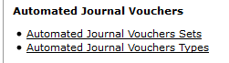

Enter the Fiscal Year you need, the Set Name “AG|BI”, then click on “search”.

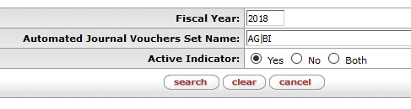

You will receive the following result where you can find the Set IDs for the FY entered.



***89 Equipment WIP Prorates:*** The following two prorates will need to be set up:

1. DR 13/14 acct – 6231 Set Name AG, “89 Acct Entries”: Base is the 89 account.

CR 89 acct – 4800 Object Codes 5000 – 7999

1. DR 7720000 – 1823 Set Name BI, “1823 for 89 WIP Accts”: Base is the 13/14

CR 7720000 – 6231 account. Object Code 6231

Prorates will run this way as long as the expense activity is a normal Debit (DR). Otherwise, if the expense is a credit (CR), the prorate will reverse the entry so that it runs opposite of what is shown above. If the item is determined to be non-capital at the end of the WIP, the second prorate will need to be reversed out.

*To set up Prorate 1: AG, “89 Acct Entries”. Click on “Automated Journal Voucher Types”, from the Kuali Main Menu.*

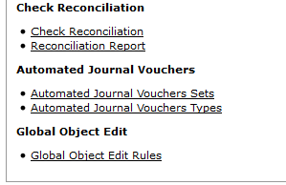

Once open, you have the option to find and use an existing prorate that has already been set up (i.e. copy it and change the fields with new information) or create a new prorate. To create a new prorate, go to Common (G:)\Property\Desk Manual\Property and Plant\Setting up a NEW 89 Prorate.

Enter the assigned Parent Set ID number for the AG current fiscal year and click on “search”.

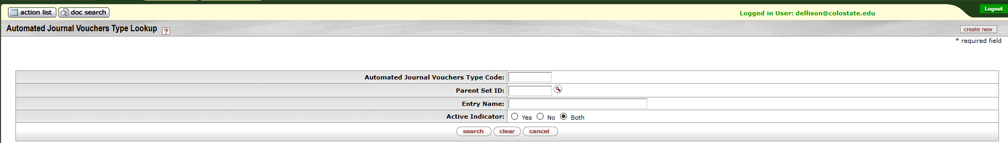

Once open, select one with “WIP 89” somewhere in the Entry Name and click on “copy”.

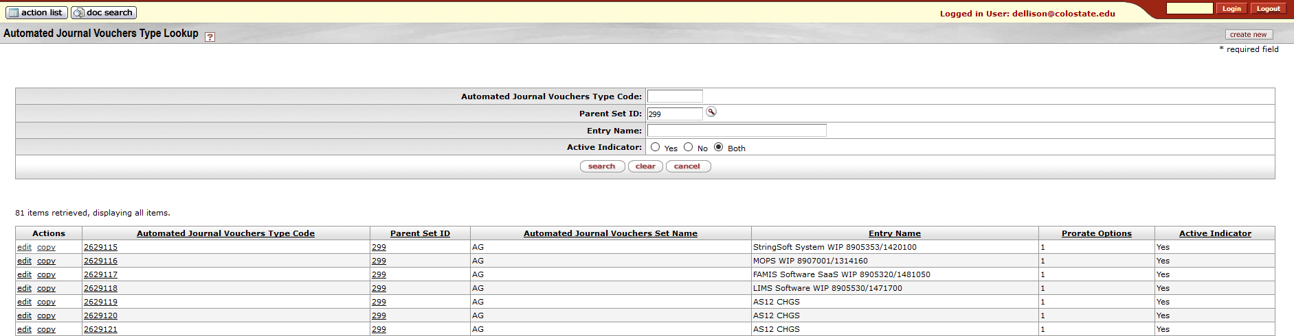

Once open, you will need to enter or change information for the new prorate.

* ***The Document Overview Tab***
  + Description will be “New 89 Prorate”



* ***The Edit Automated Journal Voucher Type Tab***
  + *Change* the Entry Name to the name of the software project followed by the 89 project acct # and the funding acct # (i.e. Kuali Coeus WIP 8960180/1352900)
  + Confirm the Parent Set ID # is the one for the current fiscal year
  + Confirm the Prorate Options is “Single to Multiple”
  + Confirm the Active Indicator box is checked

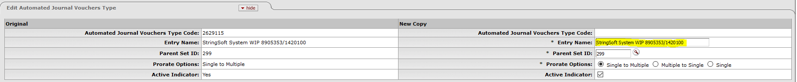

* ***The Edit Prorate Base Account Line Tab***
  + Confirm the Base Chart Code is “CO”
  + *Change* the Base Account to the 89 account number “89XXXXX” being used
  + Enter the Base Sub Account Number, if necessary
  + Confirm the Chart Code is “CO”
  + *Change* the From Account to the 13/14 account number “13XXXXX or 14XXXXX” being used
  + Confirm the From Object Code is “6231”
  + Confirm the Monthly Amount / Annual Amount has “Monthly Amount” selected– if a prorate was not set up in first month of account being created then you can set it up as yearly and all the activity will be caught and then you can change back to monthly so that you don’t continue to catch yearly activity.
  + Confirm the Percent / Amount has “Percentage” selected
  + Confirm the Prorate Percent is “100” percent
  + Confirm the Prorate Amount is “0.00”
  + Confirm the Active Indicator box is checked

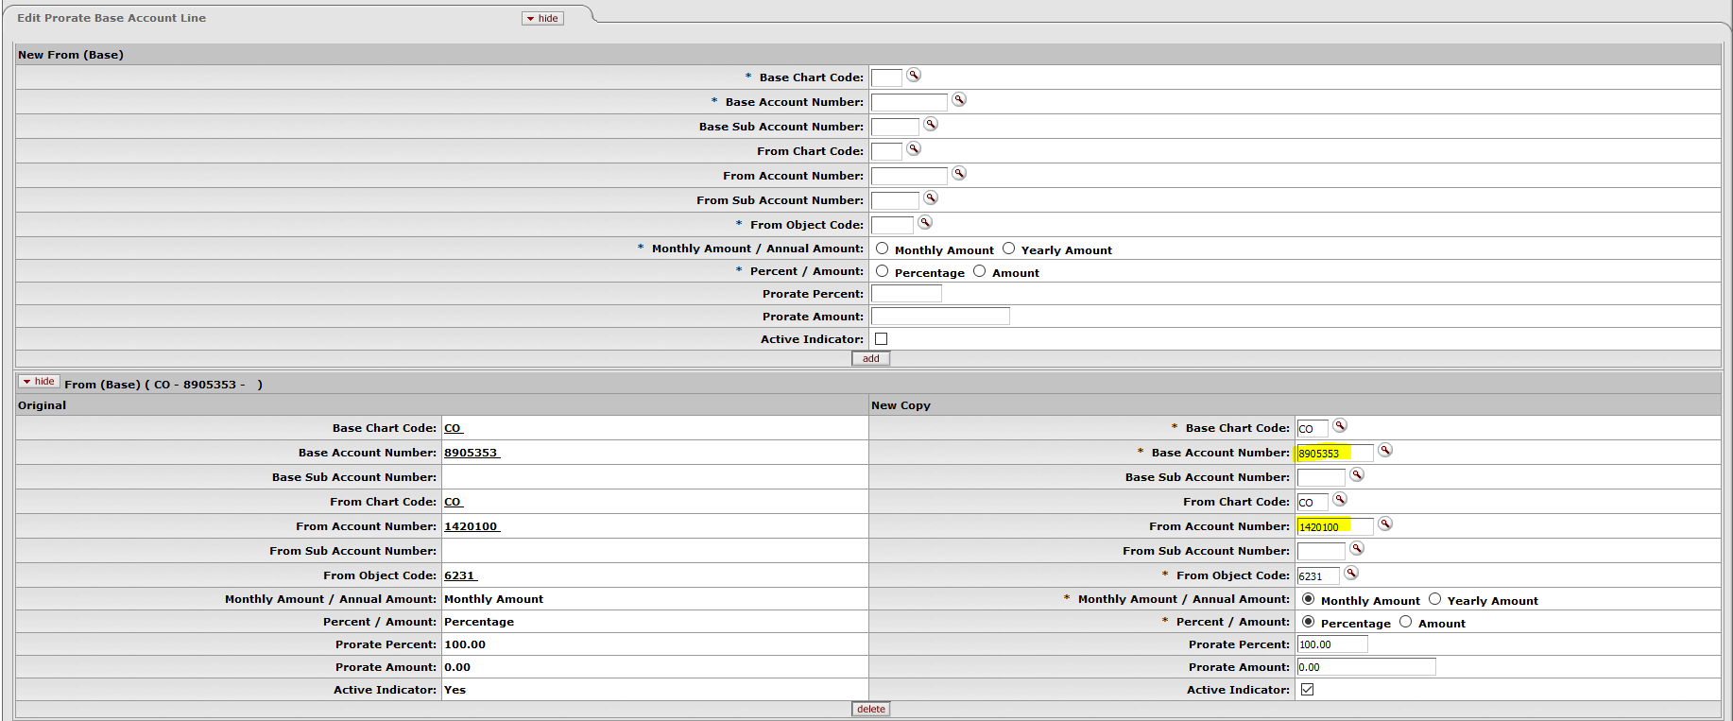

* ***The Edit Prorate Base Object Code Tab***
  + Confirm the Object Code Range Name is “5000-7999” (in order to capture all salaries and expenses)
  + Confirm the Base Chart Code is “CO”
  + Confirm the Object Code Range Low is “5000”
  + Confirm the Object Code Range High is “7999”
  + Confirm the Include or Exclude Object Code Range has “Include” selected
  + Confirm the Active Indicator box is checked

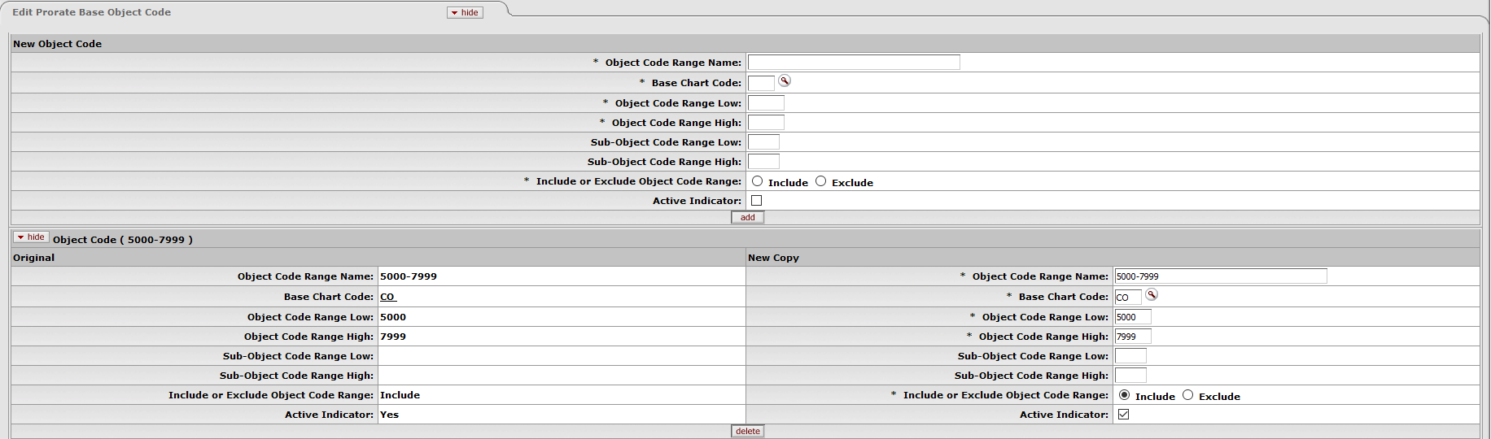

* ***The Edit Prorate To Accounting Line Tab***
  + Confirm the Effective Date From is “07/01/XX” for the year that you are setting up the prorate
  + Confirm the Chart Code is “CO”
  + *Change* the Account Number to the 89 account, “89XXXXX” being used
  + Confirm the Object Code is “4800”
  + Confirm the Override Amount / Percent has “No Override” selected
  + Confirm the Active Indicator box is checked

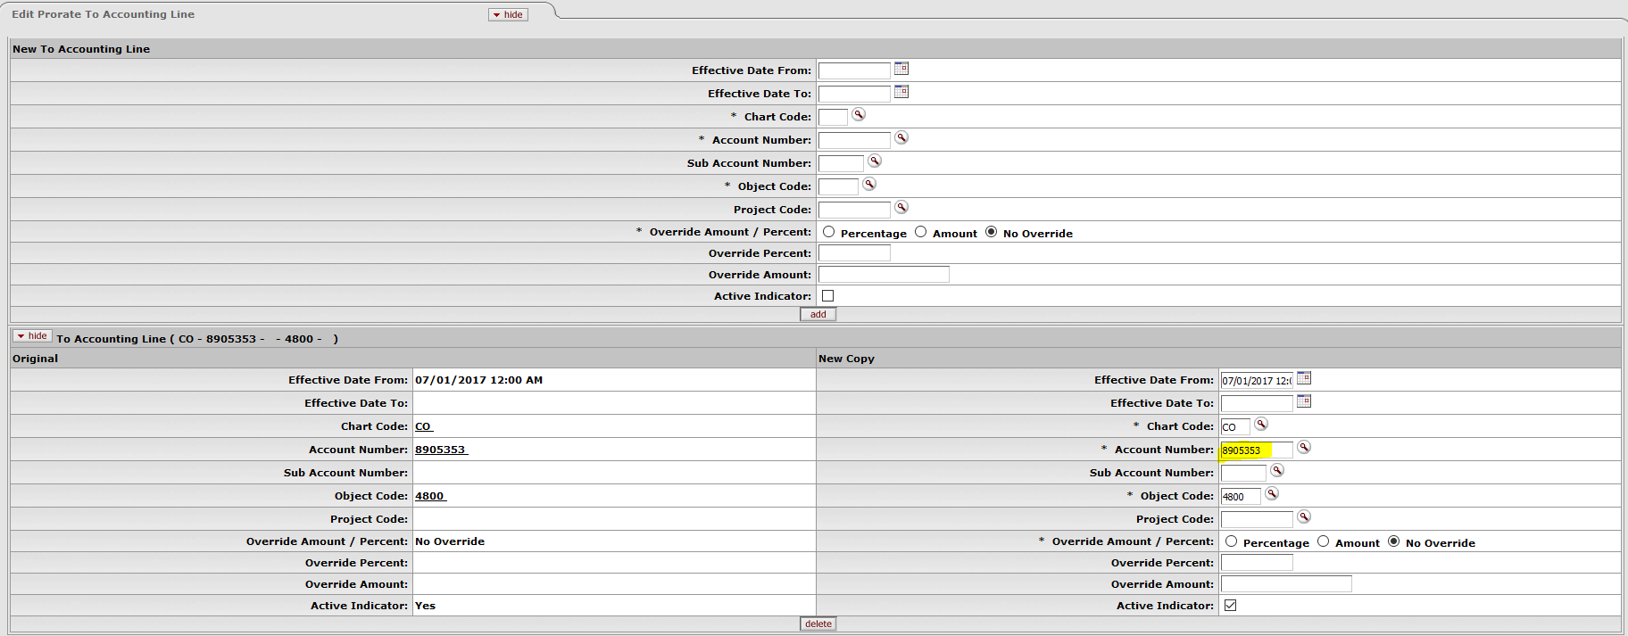

* **Once you have reviewed the document, click on the “submit” button for routing.**

Once the document has routed, Kuali will assign an Automated Journal Vouchers Type Code number. You can find it by doing an “Automated Journal Vouchers Type Lookup”.



Enter the Parent “Set ID” and “Entry Name” used, then click on “search”.

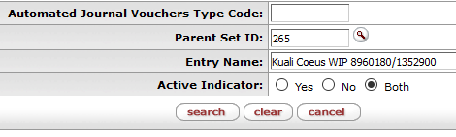

You will get the following result showing the Automated Journal Vouchers Type Code number:

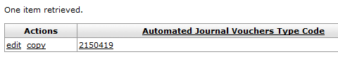

*To set up Prorate 2: BI, “1823 FOR 89 WIP accts”. Click on “Automated Journal Voucher Types”, from the Kuali Main Menu. This prorate prepares entries for capitalization.*



Once open, you have the option to find and use an existing prorate that has already been set up (i.e. copy it and change the fields with new information) or create a new prorate. To create a new prorate, go to Common (G:)\Property\Desk Manual\Property and Plant\Setting up a NEW 89 Prorate.

Enter the assigned Parent Set ID number for the BI current fiscal year and click on “search”.

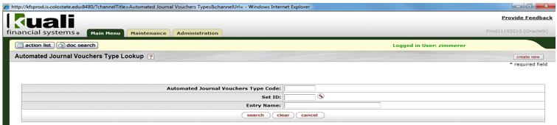

Once open, select one with “WIP 89” somewhere in the Entry Name and click on “copy”.

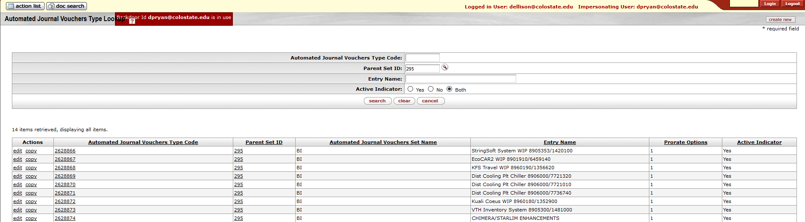

Once open, you will need to enter or change information for the new prorate.

* ***The Document Overview Tab***
  + Description will be “New 89 Prorate”



* ***The Edit Automated Journal Voucher Type Tab***
  + *Change* the Entry Name to the name of the software project followed by the 89 project acct # and the funding acct # (i.e. Kuali Coeus WIP 8960180/1352900)
  + Confirm the Parent Set ID # is the one for the current fiscal year
  + Confirm the Prorate Options has “Single to Multiple” selected
  + Confirm the Active Indicator box is checked

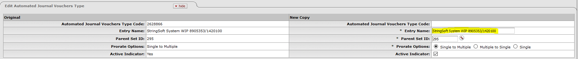

* **The Edit Prorate Base Account Line Tab**
  + Confirm the Base Chart Code is “CO”
  + *Change* the Base Account to the 13/14 account number “13XXXXX or 14XXXXX”
  + Confirm the From Chart Code is “CO”
  + Confirm the From Account Number is “7720000”
  + Confirm the From Object Code is “1823”
  + Confirm the Monthly Amount / Annual Amount has “Monthly Amount” selected
  + Confirm the Percent / Amount has “Percentage” selected
  + Confirm the Prorate Percent is “100” percent
  + Confirm the Prorate Amount is “0.00”
  + Confirm the Active Indicator box is checked

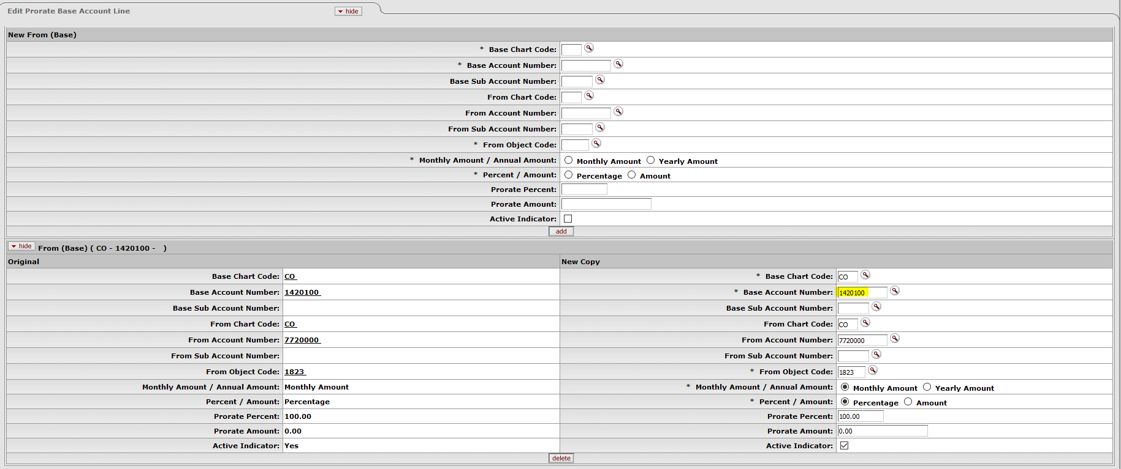

* ***The Edit Prorate Base Object Code Tab***
  + Confirm the Object Code Range Name is “6231-6231”
  + Confirm the Base Chart Code is “CO”
  + Confirm the Object Code Range Low is “6231”
  + Confirm the Object Code Range High is “6231”
  + Confirm the Include or Exclude Object Code Range has “Include” selected
  + Confirm the Active Indicator box is checked

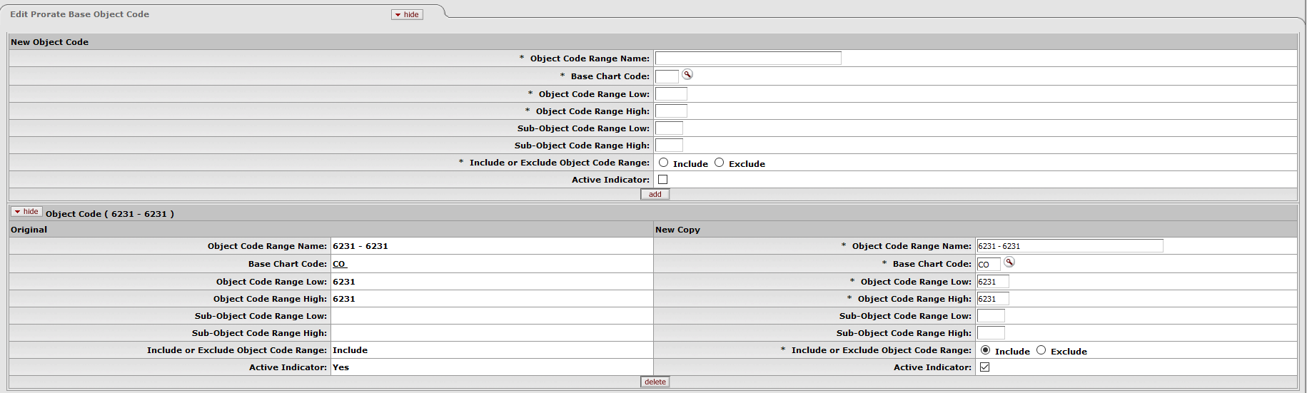

* **The Edit Prorate To Accounting Line Tab**
  + *Change* the Effective Date From to the first day of the month that you are setting up the prorate
  + Confirm the Chart Code is “CO”
  + Confirm the Account Number is “7720000”
  + Confirm the Object code is “6231”
  + Confirm the Override Amount / Percent has “No Override” selected
  + Confirm the Active Indicator box is checked

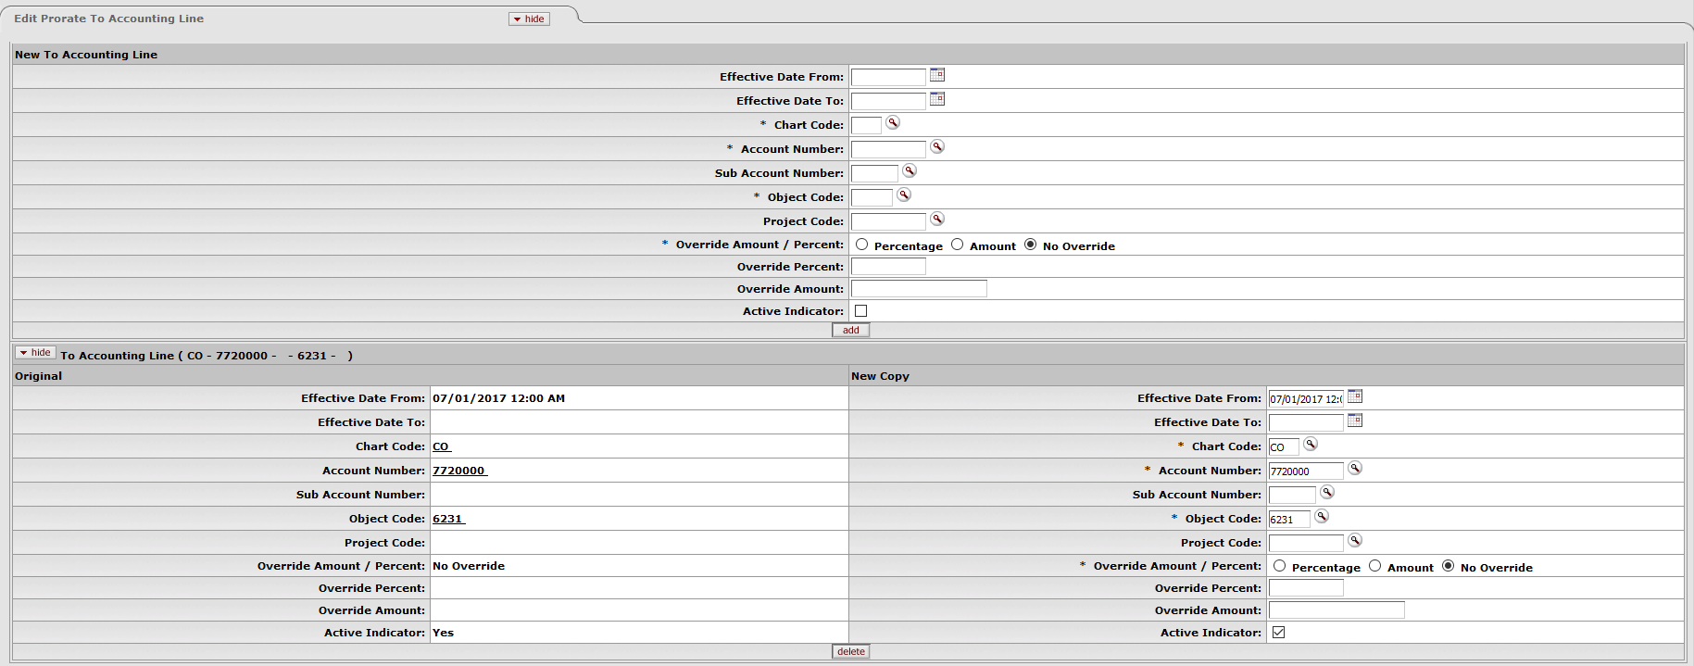

* **Once you have reviewed the document, click on the “submit” button for routing.**

Once the document has routed, Kuali will assign an Automated Journal Vouchers Type Code number. You can find it by doing an “Automated Journal Vouchers Type Lookup”.



Enter the Parent “Set ID” and “Entry Name” used, then click on “search”.



You will get the following result showing the Automated Journal Vouchers Type Code number:

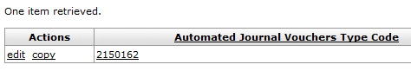

**Account**

7720000 – Education+General Plant-Investment In Plant

**Object Codes**

1823 – Equipment in Process

2100 – Accounts Payable

4800 – Inter-Department Credits

6231 – Work-In-Process – Non-Research

**Monthly Transaction Flow 89* Accounts**

1 PO for Expense. The Payment Request will be submitted from the PO.

Debit 89* Expense

Credit 89* Accounts Payable

89XXXXX 89XXXXX

Obj Codes 5000 – 7999_ Obj Code 2100 _

1 6,647.00 6,647.00 1

1 PO Payment Request

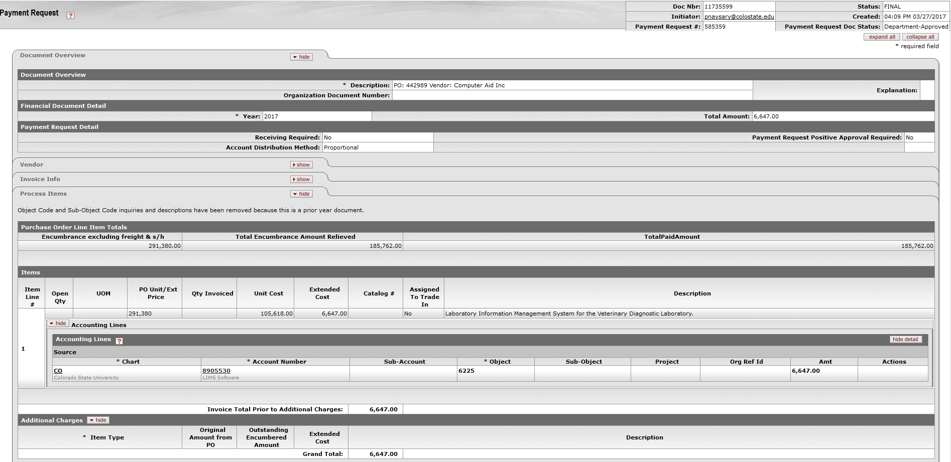

2 Prorate 1 – Look at activity in 89* account object codes 5000-7999

Debit Dept. Acct – Obj Code 6231

Credit 89* - Obj Code 4800

Dept. Acct 89XXXXX

Obj Code 6231________ Obj Code 4800 _

2 6,647.00 6,647.00 2

2 General Ledger Entry Lookup. To find the monthly General Ledger Entry for AG, you will need to find the PRJE doc number. Do a General Ledger Entry Lookup by Fiscal Year, Fiscal Period, and the 89 Account Number. Then click on “search”.

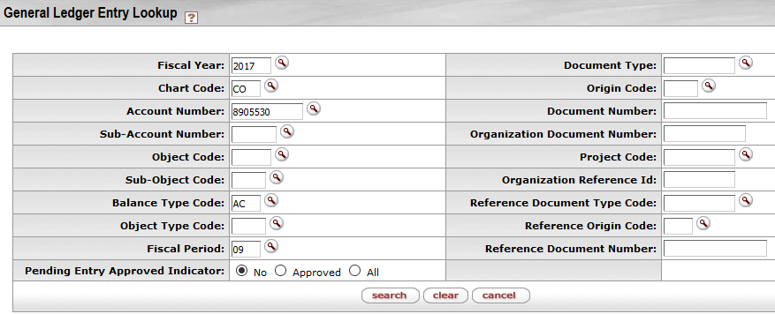

You will get the following result where you will find the Document Number for object code 4800.

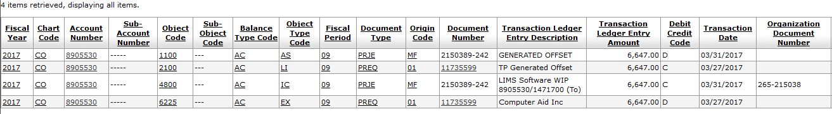

Clear your search and enter Fiscal Year, Fiscal Period, Document Type “PRJE”, and the Document Number. Then click on “search”.

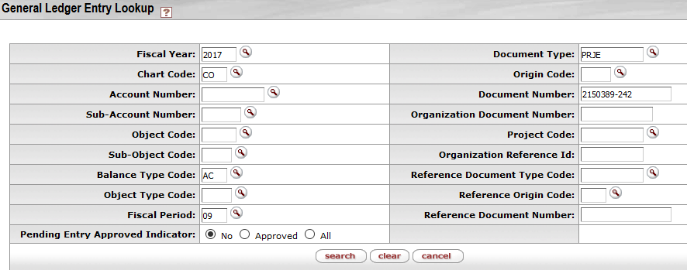

You will get the following result where you will find the entries for the AG Prorate.

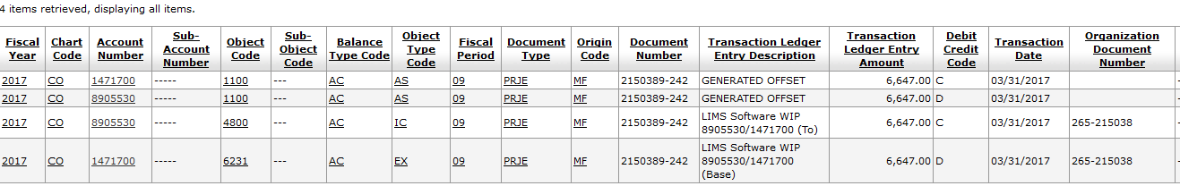

3 Prorate 2– Look at activity in Dept. Account Obj Code 6231

Debit 7720000 – Obj Code 1823

Credit 7720000 - Obj Code 6231

7720000 7720000

Obj Code 1823________ Obj Code 6231 _

3 6,647.00 6,647.00 3

3 General Ledger Entry Lookup. To find the monthly General Ledger Entry for BI, you will need to find the PRJE doc number. Do a General Ledger Entry Lookup by Fiscal Year, Fiscal Period, 7720000 Account Number, Object Code 1823, and Document Type PRJE. Then click on “search”.

You will get the following result where you will find the Document Number for object code 1823:

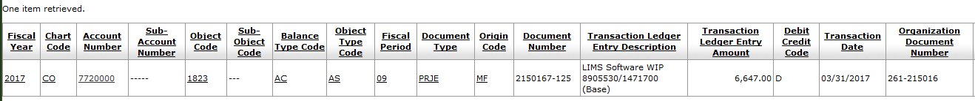

Clear the object code from the search and enter the Document Number. Then click on “search”.

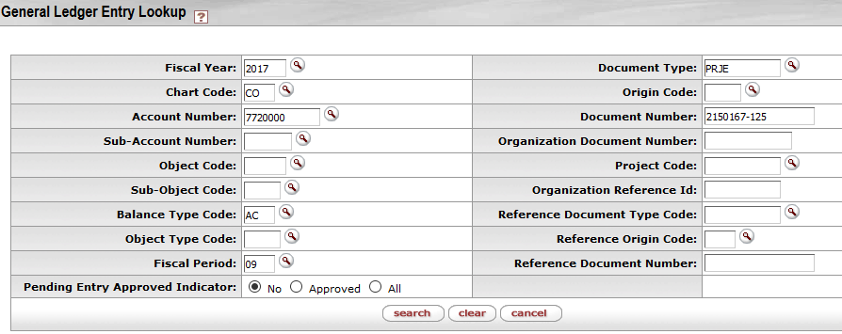

You will get the following result where you will find the entries for the BI Prorate.

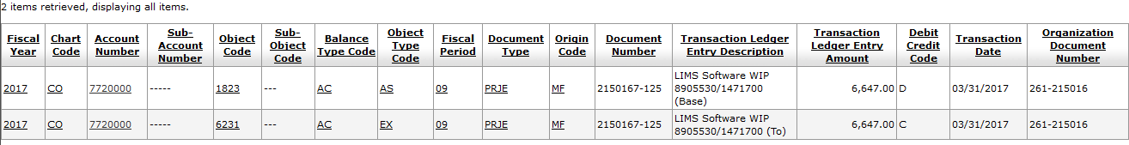

***Tracking the WIP:*** All purchases (debits) on the 89 account using object codes 5000-7999 are shown as credits on 89-2100 (accts payable).

Prorate 1 debits everything from the 13/14 account, object code 6231 (WIP-non-research) to the base 89 account as a credit on object code 4800 (inter-department credits) on a monthly basis.

Prorate 2 prepares the entries for capitalization by debiting the 7720000 account, object code 1823 (Equip in Process) to account 7720000 object code 6231 (WIP) as a credit.

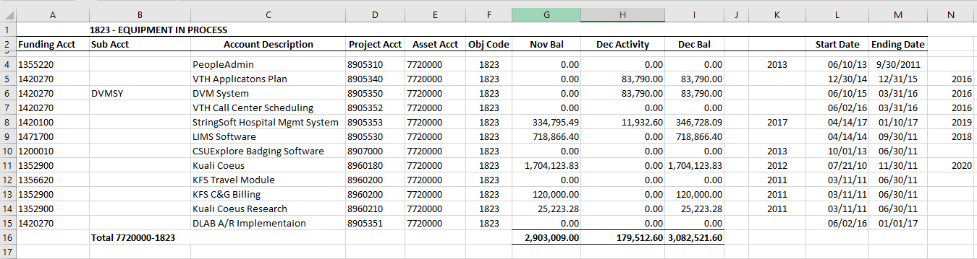

An excel spread sheet showing all active 89 accounts is used to track the activity on each 89 project account. Common (G:)/Property/89 Accounts/89 ACCT WORKSHEET

Once the project is complete, to create the asset, a Distribution of Income and Expense (DI) document needs to be submitted. From 7720000-1823 to 7720000-82XX, create asset. Attach backup to the document. If software is purchased directly on a 77 account (object code 8930), it will prorate to 1874/9773 (on the project account). The DI would be from 1874 to 8260. Assign a decal when the asset is created.

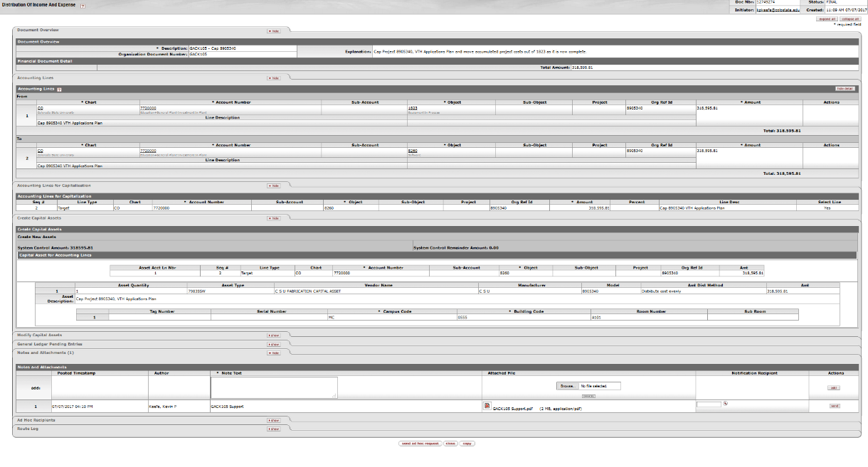

***Non-Capital Models***

Models that last less than one year are recorded as an operating expense and are subject to F&A costs.

***Deliverables***

A deliverable is an item of equipment or scientific instrument created by CSU personnel, usually in connection with a grant or contract funding, to which CSU will be releasing the fabricated asset to the requestor upon its completion. Deliverables are subject to F&A costs unless either of the following conditions exists:

* The deliverable is space hardware (major spacecraft subsystems and scientific instruments carried on space missions), whether purchased or fabricated, that otherwise meets capital equipment or capital model criteria
* The deliverable meets capital equipment or capital model criteria and is installed in a facility to which CSU faculty will have access to the instrument for research purposes

**Lease Agreements**

Departments may need to use a lease to purchase equipment. The department can either do an External Lease (lease directly from a vendor) or use Colorado State University Research Foundation (CSURF). The CSURF equipment-leasing program is administered by CSURF in cooperation with the Vice President for University Operations and Vice President of Research, who is responsible for the overall management of CSU’s participation in the CSURF lease/purchase program, for obtaining any necessary Board of Governors’ approvals, and for assuring that CSU conforms to these policies and procedures. The CSURF lease/purchase program was developed to meet the needs of all institutions of the Colorado State University System to acquire certain scientific administrative support and research equipment and pay for it over a period of years. All leases must adhere to the lease requirements outlined in Section 8 of the Purchasing Manual.

* Lease agreements are contractual agreements and can obligate the university in several ways. Only those individuals authorized to sign contractual agreements may approve lease agreements.
* Lease agreements are university obligations and must be recorded as such, therefore all lease agreements must route through Procurement and Business and Financial Services.
* All proposed lease agreements must be accompanied by a repayment plan covering the entire lease term. Repayment plans are submitted to the lease accountant in Business and Financial Services.
* The use of federal funds for lease payments must be in accordance with federal requirements.
* Leased property may not be sold or otherwise disposed of prior to the termination of the agreement.
* Any modifications of lease equipment during the lease term require prior authorization.

***Lease Classifications***

The lease contract information will need to be forwarded to the Property Management Lease Accountant (in Business and Financial Services). The lease accountant will complete a lease classification analysis in order to distinguish it as either a capital lease, operating lease, rent, or use charge. If it is determined to be a capital lease, the Property Management Lease Accountant will make the necessary capital leasing entries to the general ledger and create an asset.

***Capital Leases:*** The act of acquiring assets by making periodic payments, which generally consist of principle and interest. Interest is an operation expense, whereas the principle payments reduce the balance of the long-term liability. As the liability is reduced the equity in the asset increases.

Leases of buildings or equipment that meet one of the following criteria will be classified as a capital lease:

1. The lease transfers ownership of the property to the lessee (CSU) by the end of the lease term
2. The lease contains a bargain purchase option (BPO)
3. The lease term is equal to 75 percent or more of the estimated economic life of the leased property. However, if the beginning of the lease term falls within the last 25% of the total economic life of the leased property, including earlier years of use; this criterion shall not be used for purposes of classifying the lease
4. The present value at the beginning of the lease term of the minimum lease payments excluding that portion of the payments representing executor costs such as insurance and maintenance equals 90 percent of the fair value of the leased property

Property acquired via a capital lease is depreciated according to the University’s useful life criteria, unless the lease qualifies under criteria C or D (under the capital lease criteria). If so, the property is depreciated over the shorter of the life of the lease or the life of the asset. For CSU purposes, we do not capitalize leases under the $5,000 capitalization threshold; therefore, if a lease meets one or more of the above criteria but is for less than $5,000, it should be tracked as an operating lease.

An asset will be created by the Property Management Lease Accountant and the department will need to submit a requisition to set up the payments for the asset using the proper lease payment object code (8300-Furniture/Fixture, 8310-Other Capital Equipment, etc.). Down payments should be made on the appropriate equipment object code. The Capital Asset tab will need to be completed using “Multiple Systems” as the Capital Asset System Type; “Modify Existing” as the Capital Asset System State; entering the asset number created by the Lease Accountant; and using “Capital Lease” as the Capital Asset Transaction Type. The lease payment terms will need to be entered in the Payment Info Tab and the Lease Agreement attached in the notes section.

***Operating Leases:*** Leases of 12 months or longer and not qualifying as a capital lease are expensed in the current operation period.

A requisition will need to be submitted annually, for each year of the lease term, using the expense object code 6646 and will not result in an asset being created.

***Rental Agreements:*** Payments for the use of land, buildings or equipment where the obligation is for less than 12 months are expensed in the current operation period.

***Use Charge:*** Internal payment by one university department or account for the use of buildings or equipment owned by another university department or account.

***CSURF Leases***

* *Acquiring Department* – The academic or administrative department or division of Colorado State University that acquires equipment.
* *CSU* - Colorado State University.
* *CSURF* - Colorado State University Research Foundation.

CSURF oversees the lease purchase program. The department will need to contact CSURF for instruction on using lease agreements to acquire equipment and property. Departments may acquire equipment through two CSURF capital lease options, the CSURF Line of Credit Lease (LOC) and the CSURF Municipal Lease. The type of lease used depends on the dollar amount of the requested lease/purchase. Purchases may not be artificially subdivided to qualify for a Line of Credit Lease.

The department will need to complete the applicable Request Form and submit it to CSURF; Procurement can assist the department in contacting CSURF. CSURF will collate the lease contract information and provide it to the Business and Financial (BFS) lease accountant for classification as either an operating lease or a capital lease. BFS will determine the appropriate financial reporting of the lease.

Once the Lease Accountant has made the necessary capital leasing entries to the general ledger, the asset will be created in the CAM database and assigned a decal.

***CSURF Line of Credit Lease ($50,000 or Less):*** The CSURF Line of Credit (LOC) lease is funded through CSURF’s $1,000,000 line of credit at a local bank. This $1,000,000 is available for leases to all institutions of the Colorado State University System. The allocation of available funds among the system schools, if necessary, will be agreed upon by CSURF and representatives of the System Institutions. The CSURF Line of Credit (LOC) Lease is designed for equipment purchases of $50,000 or less which can be financed for a term of up to 5 years.

A year-to year, cancelable lease agreement is executed between the acquiring department (CSU) and CSURF. CSU will become the lessee and CSURF will become the lessor. The lessor will reimburse the equipment vendor for the cost of the items acquired. Title to the equipment will remain with the lessor and assigned to the bank as collateral, until the lease has been paid in full.

The interest rate on a CSURF Line of Credit is negotiated annually and CSU pays the prevailing interest rate of the outstanding balance. CSURF assesses an administrative fee for a CSURF Line of Credit Lease. The fee is equal to 4 percent of the total amount borrowed, but not less than a minimum fee of $800 and is payable to CSURF upon signing of the lease.

* An acquiring department completes the applicable Request Form available from CSURF. Acquisitions require a fully completed request form signed by the department head, dean/director, and vice president. Upon obtaining signatures, the acquiring department submits the form to CSURF for additional approval signatures and processing. CSURF will submit the request form to the Office of the Vice President for Research and the Vice President for University Operations for approval. The lease will be signed as soon as practical.
* CSURF will coordinate preparation of the lease documents with all necessary parties, including sending a copy of the lease to the Lease Accountant in Business and Financial Services.
* CSURF will consult with the CSU Procurement Department for selection of a vendor for the equipment.
* The lease accountant records the item as a leased capital asset in the Investment-in-Plant Fund and will create the asset. An offsetting Capital Lease Payable will also be recorded.
* Payments will be the responsibility of the acquiring department. Payment will be initiated quarterly by CSURF’s issuance of a request for a fund transfer into a revolving fund. A check will be generated to CSURF from the revolving fund via a Disbursement Voucher.
* Upon receipt of all lease payments, the lease agreement is terminated and CSURF passes title to CSU.

***CSURF Municipal Lease (Over $50,000):*** The Municipal Lease is for equipment purchases of more than $50,000 and can be financed for a longer term of up to 10 years. CSURF administers the transaction but is not a party to it. The Municipal Lease term is on a fiscal year-to-year basis with renewal options to assure CSU’s liability is limited to the present fiscal year if the lease should be canceled by CSU. This year-to-year cancelable lease agreement is executed between the acquiring department (CSU) and a bank, leasing company, or underwriter. CSU will become the lessee and the cooperating financial institution will become the lessor. The lessor will reimburse the equipment vendor for the cost of the items acquired. Title to the equipment will remain with the lessor until the lease has been paid in full. Cancellation is permitted only in special circumstances involving lack of appropriated funds as specifically set forth in the Municipal Lease document. No Acquiring Department has authority to cancel a Municipal Lease unilaterally. The Vice President for Research must be consulted regarding any proposed cancellation.

The interest rate on a Municipal Lease is set by the lessor, is reflective of market conditions (usually around 80% of the prime lending rate) and is fixed for the life of the lease. Under a Municipal Lease, the Acquiring Department makes clearly defined payments of principal and interest. A Municipal Lease transaction may permit the lessor to treat the interest portion of the lease payments as tax-exempt income. CSURF’s up-front administrative fee for a Municipal Lease is based on the amount financed and is payable upon signing of the lease. The fee rates shall be:

Principal Amount Financed Fee Charged

$ 50,001 to $75,000 3.0%

$ 75,001 to $100,000 2.5%

$100,001 to $150,000 2.0%

$150,001 and Over 1.5%

* An Acquiring Department completes the applicable Request Form available from CSURF. Acquisitions require a fully completed request form signed by the department head, dean/director and vice president.
* Upon obtaining signatures, the department submits the request form to CSURF for additional approval signatures and processing.
* CSURF will submit the request form to the Director of Business and Financial Services for review.
* After review, the form is forwarded to the Office of the Vice President for Research and the Vice President for University Operations for approval. The lease will be signed as soon as practical. Some leases are funded into Escrow when the acquisition period is lengthy (more than 3 months).
* CSURF will coordinate preparation of the lease documents with all necessary parties, including sending a copy of the lease to the BFS’s lease accountant.
* CSURF will consult with the CSU Purchasing department for selection of vendors for both the equipment and the financing arrangements. The lessor is chosen by CSURF in cooperation with the CSU Procurement Services Department through a competitive solicitation process.
* The lease accountant records the item as a leased capital asset in the Investment in Plant Fund and will create the asset. An offsetting Capital Lease Payable will also be recorded.
* Payments are the responsibility of the Acquiring Department. A payment will be initiated by CSURF’s issuance of a request for a fund transfer into a revolving fund. The check will be generated to the cooperating financial institution from the revolving fund via a Disbursement Voucher. The check will be sent to CSURF for transmittal to the cooperating financial institution.
* Upon receipt of all lease payments, the lease agreement is terminated, and the lessor passes title to CSU.

***Internal Approval Required:*** The vice president for research, as the designated and authorized representative of CSU pursuant to a resolution of the board of governors, shall, in connection with the approval of any proposed acquisition of equipment under a municipal lease arrangement, declare CSU’s official intent to reimburse itself for all expenditures made by CSU in connection with the acquisition of such equipment from the proceeds of a tax-exempt lease/purchase transaction which may be completed after such expenditures are made. This declaration shall be made no later than 60 days after payment of the earliest expenditure.

Acquisitions under the municipal leasing arrangement will be subject to CSU’s ability to accommodate the additional debt that will result from the acquisition. CSU’s overall debt capacity for the program is based on an annual debt service not to exceed $2.5 million. The maximum annual debt service can be adjusted by approval of the cabinet budget committee.

* The appropriate department head, dean/director, and vice president must approve equipment that is to be acquired using the CSURF Line of Credit Lease.
* The appropriate department head, dean/director, vice president, vice president for research and the vice president for university operations, must approve equipment that is to be acquired using the Municipal Lease option.

***Acquisition of and Title to Equipment:*** Items acquired under the program, including CSURF Line of Credit Leases and Municipal Leases, will be purchased by CSURF in cooperation with the CSU Procurement department. Under the Municipal Lease program, acquisition is undertaken by CSURF as the agent of the lessor. All purchasing documents issued in connection with the acquisition or financing of such equipment shall reflect that the equipment to be acquired shall at all times be owned by and titled in the name of the lessor subject to CSU’s beneficial interest under a lease/purchase agreement.

***Reporting Requirements:*** All outstanding lease/purchase agreements by the Colorado State System institutions must be reported annually to CSU’s external auditor. CSURF will collate such information and provide it to Business and Financial Services for its use in providing the annual report. The Board of Governors requires a quarterly activity report. This report is compiled and distributed by CSURF.

## **Setting up a Lease-Purchase**

The capital lease liability and assets from a capital lease-purchase will be created on an adjustment/accrual voucher document by Business and Financial Services Property Management Lease Accountant. Current year debt gets booked to object code 2842. Non-current debt gets booked to object code 2840. At the end of each fiscal year, an entry must be made to reclassify the next fiscal year’s debt out of non-current (2840) and into current debt (2842). Equipment and vehicles over $5,000 get booked to object codes 8312 and 8317, respectively. Any property purchases under $5,000 on a capital lease gets booked to object code 8315.

Once a lease is determined to be a capital lease, a copy of the lease agreement, including amortization schedule, as well as any other lease documents must be sent to the Campus Services Accountant. It is important that the amortization schedule break out principal and interest from the total payment amount. The amortization schedule should clearly identify the percentage rate of interest used in the interest calculation.

Principal and interest payments are applied to one of the following object codes when paid: 8300, 8310, 8320, or 8920. A generated entry is then initiated to decrease the current year’s debt in object code 2841 based on the lease payment object code getting used. Every quarter interest expense should be reclassified out of object code 2841 to object code 9408 per the appropriate amortization schedule for the lease agreement.

## **Assigning an Asset Type Code for Equipment Purchased on a Capital Lease**

Leases may contain equipment or vehicles below the individual $5,000 capitalization threshold and/or service costs that need to be financially accounted for. Furniture, furnishings, and fixtures as well as small dollar/large quantity assets costs can be pooled together and reflected on financial statements without imposing the unnecessary administrative burden of tracking each asset separately. Under the pooled asset method, no individual item has a record or separately identifiable book value; rather it is recorded as the total book value of the combined items. Asset Type Code 10000N is reserved for non-capital assets, pooled assets, and/or any non-capital services costs of a lease (such as a warranty). Object code 8315 is used to book 10000N assets.

Asset type codes 00001L1, 00002L2, 00003L3, 00004L4, 00005L5, 00006LV, 00007LS, 00009LV, 00010LV, 00011LV, CB00008, and CL0000 are reserved for capital leases where the individual or system unit cost is $5,000 or more. If the lease agreement is capitalized because it met either criteria 7a or 7b from FAS 13, then the leased equipment must be depreciated using the university’s useful life and assigned the asset type code that matches the useful life based upon university policy. If the lease agreement does not meet FAS13 requirements 7a or 7b, but does meet either requirement 7c or 7d, then assign the asset type code with the useful life that matches the terms of the lease agreement.

## **Preparing an Adjustment/Accrual Voucher Document**

The following example resembles an Adjustment/Accrual Voucher document for the creation of capital lease liability and asset involving the lease-purchase of only one asset. If multiply assets are purchased under a lease agreement, more lines will need to be added until all the values of the assets are entered on the document.

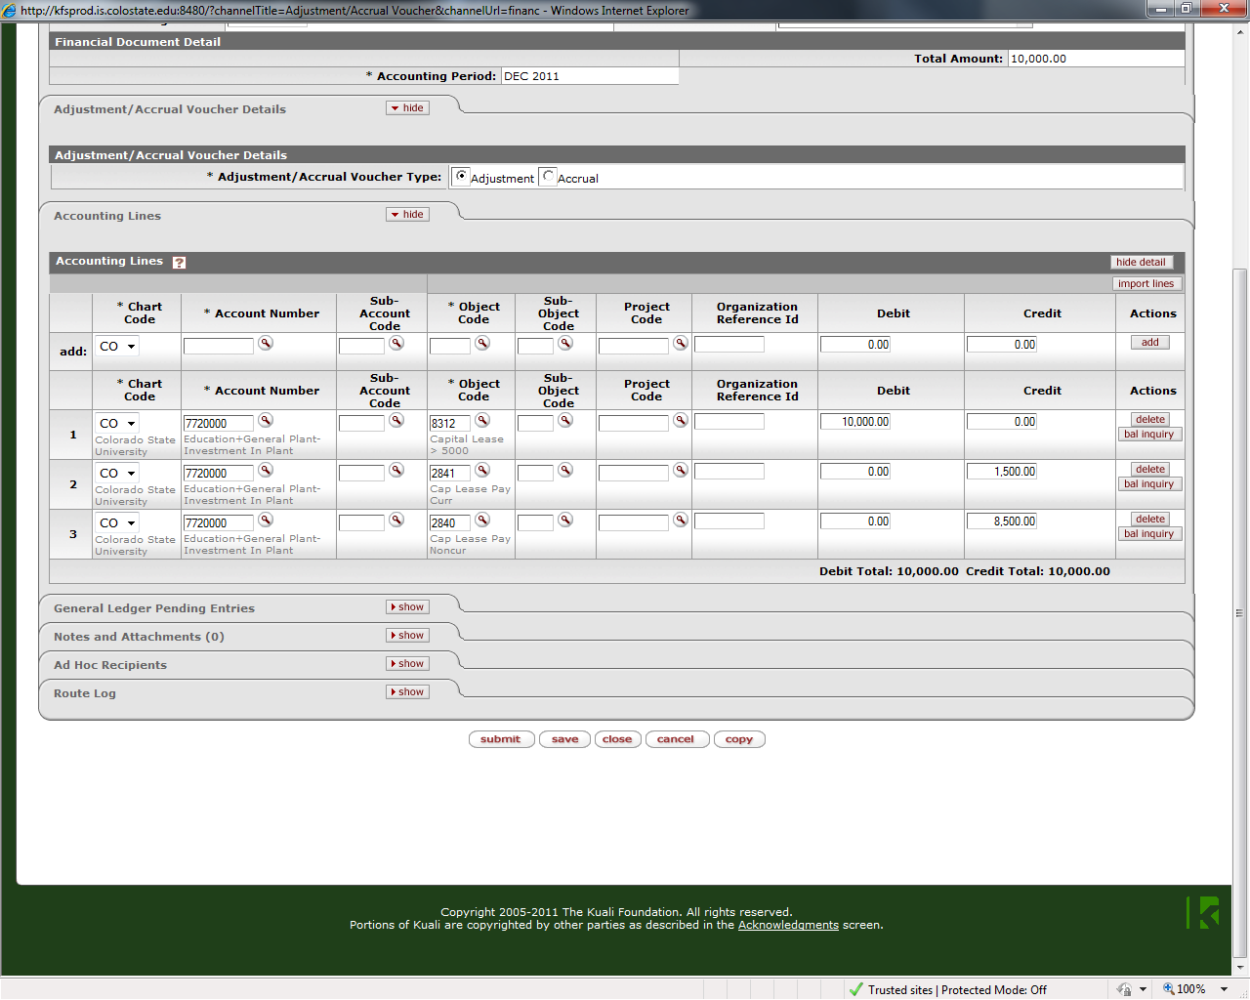

The 8312 and 2841/2840 entries offset each other and have no effect on cash. The 2841 and 2840 amounts entered reflect the current and non-current principle amount due according to the lease agreement.

Capitalization Entry (system generated based on the 8312 object code usage from above):

| **Account Number** | **Object Code** | **Debit** | **Credit** |
| --- | --- | --- | --- |
| 7720000 | 1841 | $10,000 |  |
| 7720000 | 9011 |  | $10,000 |

If object code 8315 was used in the example above the following capitalization entry would be generated:

| **Account Number** | **Object Code** | **Debit** | **Credit** |
| --- | --- | --- | --- |
| 7720000 | 1838 | $10,000 |  |
| 7720000 | 9011 |  | $10,000 |

If object code 8317 was used in the example above the following capitalization entry would be generated:

| **Account Number** | **Object Code** | **Debit** | **Credit** |
| --- | --- | --- | --- |
| 7720000 | 1833 | $10,000 |  |
| 7720000 | 9011 |  | $10,000 |

Object code 9011 is the Capital Expense Elimination, which offsets the object code 8312, 8315, or 8317 expense activity.

## **Accounting for a Lease-Purchase**

FRA maintains a capital lease excel spreadsheet. General characteristics about all capital lease-purchases of the university are recorded in the spreadsheet. The spreadsheet is in numerical order by lease number. CSURF leases are already assigned a lease number by the time they get to FRA, so this number should be used. But if the lease did not come from CSURF then the FRA Accountant will assign the next available PL# (purchasing lease number) to the lease.

At the beginning of each new month, a query is run to see the activity that posted against object code 2841 for the previous month. This query is used to verify that the principle payment amounts incurred during the month match the capital lease spreadsheet. The FRA Accountant then reconciles the capital lease spreadsheet to the amortization schedules and to the general ledger each month.

## **Capital Lease Payments**

Payments for capital leases can be made in one of two ways. CSURF lease payments are made on a Distribution of Income and Expense document while non-CSURF capital leases (PL-XX) payments are paid on a Payment Request from the PO or a Disbursement Voucher.

### *Distribution of Income and Expense:* The following example resembles the accounting lines from a Distribution of Income and Expense document for capital lease payments due to CSURF. The “To” Accounting Lines create a DR in object codes 8300, 8310, 8320, or 8920.

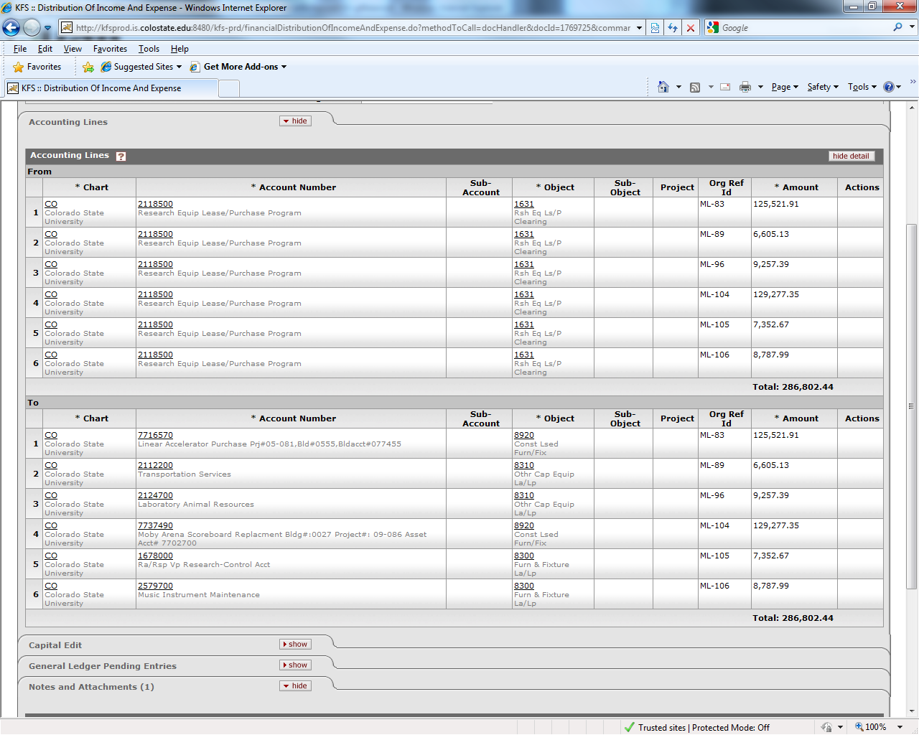

A system-generated entry will take place anytime there is any activity using object code 8300, 8310, 8320, and/or 8920. In the example of a capital lease payment where any of these object codes are debited** then the following entry would be generated to decrease CSU’s current year liability for the lease:

| **Account Number** | **Object Code** | **Debit** | **Credit** |
| --- | --- | --- | --- |
| 7720000 | 2841 | $125,521.91 |  |
| 7720000 | 9011 |  | $125,521.91 |

**NOTE: If object codes 8300, 8310, 8320, or 8920 are used as a credit, the above entry would be reversed therefore increasing the current year liability for this lease.

### *Payment Request from PO:* The following example resembles the Items, Capital Asset, and Payment Info tabs on a Non-CSURF (external) Capital Lease Purchase Order.

### 

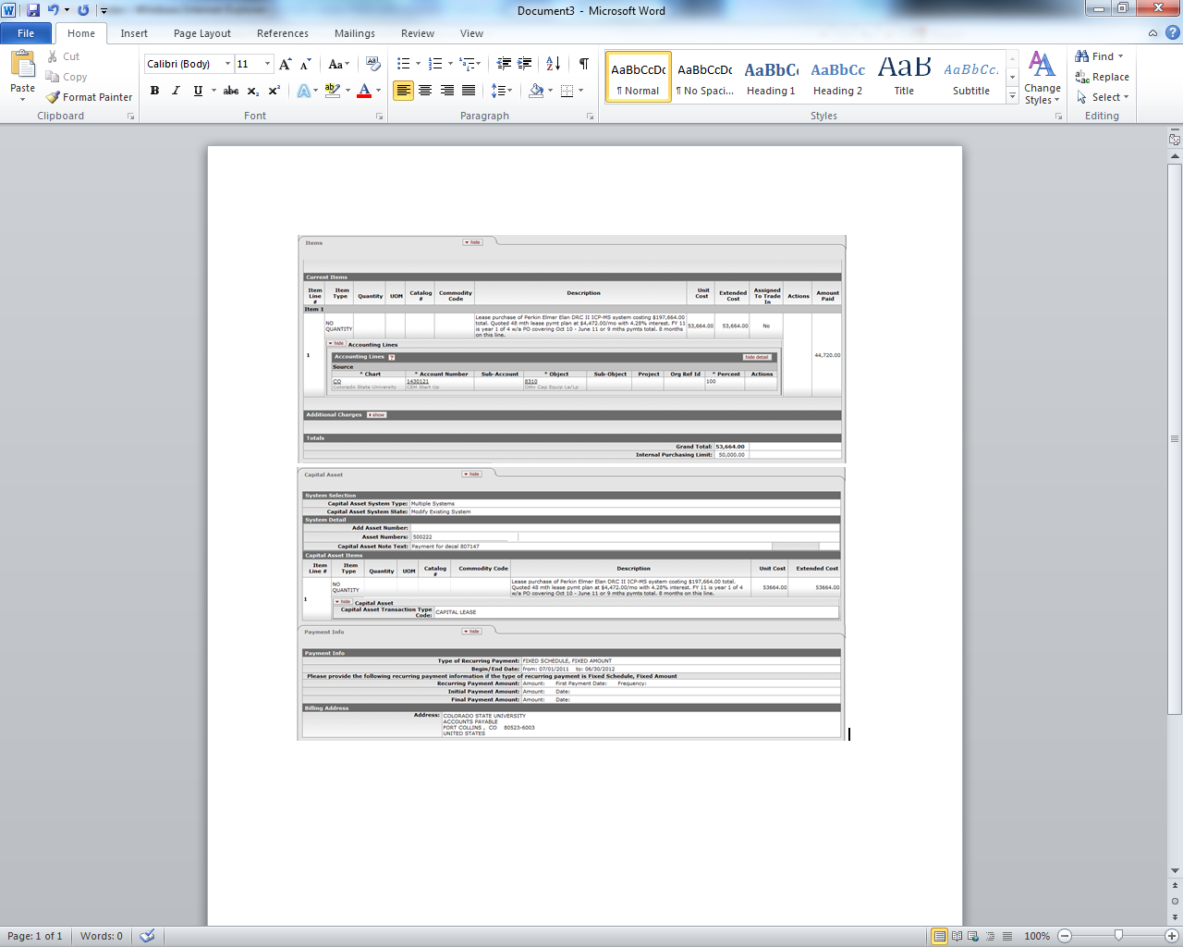

Based on this PO, every time an invoice is received a Payment Request document will be issued. A system generated entry will take place anytime there is any activity using object code 8300, 8310, 8320, and/or 8920. In the example of a capital lease payment where any of these object codes are debited** then the following entry would be generated to decrease CSU’s current year liability for the lease:

| **Account Number** | **Object Code** | **Debit** | **Credit** |
| --- | --- | --- | --- |
| 7720000 | 2841 | $4,472.00 |  |
| 7720000 | 9011 |  | $4,472.00 |

**NOTE: If object codes 8300, 8310, 8320, or 8920 are used as a credit, the above entry would be reversed therefore increasing the current year liability for this lease.

**Transferred-In Equipment**

Equipment that is transferred into the university from another university or other federal agency.

***Contract, Grant, or Agreement Transfers****:* If the transfer of equipment is related to a contract, grant, or agreement the department shall promptly report the transferred-in equipment to the Office of Sponsored Programs. The Office of Sponsored Programs is responsible for obtaining any sponsoring agency approvals necessary regarding the transfer and for collaborating with Property Management to ensure that the equipment being transferred-in is properly reflected in the university’s records.

***Direct Transfers:*** If the transfer of equipment happened at the department level, the department is responsible to report the transferred-in equipment promptly to Property Management. A list of the transferred-in equipment, a signed Letter of Release from the relinquishing agency releasing title of the property to the university, and a signed Letter of Acceptance from the university dean or department head acknowledging receipt of the property are required documents and need to be submitted to Property Management. The department may use the Incoming Property Declaration Form, located on Property Management’s webpage, in place of any or all of the required documents.

***Federal Surplus Property or Reutilization:*** The Federal Surplus Property Program is monitored by the General Services Administration (GSA). The university can acquire property at little or no cost from the federal government through this program. This property is considered surplus by the federal government and could be reutilized. The federal government defines Surplus Property as “Excess personal property not required by any federal agency as determined by the Administrator of the General Services Administration (GSA)”. Excess Personal Property is defined as “Any personal property under the control of a federal agency that the agency head determines is not required for its needs or for the discharge of its responsibilities”.

Procurement has provided Colorado State University departments the necessary eligibility to log in to the Federal Surplus Property website to obtain equipment. You will need an access code and password, contact your Procurement Agent for the code and password. To screen for Federal Surplus Property, go to: [www.gsaxcess.gov](http://www.gsaxcess.gov). Thomas Phillips is the contact person on the government side. His contact information is: [thomas.phillips@state.co.us](mailto:thomas.phillips@state.co.us), 4999 Oakland St, Denver Co, (W) 303-370-2166. If you locate an item or items you are interested in obtaining, email the information to Thomas Phillips, so he can put a “freeze” on the item(s).

It is the department’s responsibility to promptly report incoming federal surplus property received. A list of the acquired items, a signed Letter of Release from the relinquishing agency releasing title of the property to the university, and a signed Letter of Acceptance from the University Dean or Department Head acknowledging receipt of the property are all required documents and need to be submitted to Property Management. The department may use the Incoming Property Declaration Form, located on Property Management’s webpage, in place of any or all of the required documents.

Further information about this program can be obtained at <http://www.nasasp.org>.

***Accounting for Transferred-In Capital Assets***

Transfer-in capital assets are those received from an external organization (usually another university) or government surplus. For example, a professor transferring to Colorado State University may bring equipment from Harvard University. Whether an organization receives equipment through a transfer or from government surplus, the equipment list should be sent to the Property Management Office via the Incoming Property Declaration Form. This form can be located at the following URL http://busfin.colostate.edu/Depts/PropMgt.aspx under the Forms heading. A Letter of Acceptance signed by the CSU department head and a Letter of Release from the releasing agency are required documentation. Those assets that meet the capitalization criteria will be added to the university asset database via the *add asset document*. The asset will be recorded with an acquisition type of “T” for transfer-in. The Asset Processor will assign a PO# number by using the next available “Z” number from the decal log.

When equipment purchased on a grant account is transferred to CSU, it can be considered loaned equipment. Please see the section on Loaned Equipment. If the transferred-in asset(s) was not purchased on a contract and/or grant account, then the Education+General Plant-Investment in Plant account number 7720000 should be used. Equipment transfers for federally funded assets should be recorded in object code 8240, and object code 8245 is used for federally owned.

If the add asset global document uses 7720000-8240 then the following general ledger entries will be automatically generated:

| **Account Number** | **Object Code** | **Debit** | **Credit** |
| --- | --- | --- | --- |
| 7720000 | 1821 | $acquisition value |  |
| 7720000 | 8240 | $acquisition value |  |
| 7720000 | 4419 |  | $acquisition value |
| 7720000 | 9011 |  | $acquisition value |

If the add asset global document uses 7720000-8245 then the following general ledger entries will be automatically generated:

| **Account Number** | **Object Code** | **Debit** | **Credit** |
| --- | --- | --- | --- |
| 7720000 | 1844 | $acquisition value |  |
| 7720000 | 8245 | $acquisition value |  |
| 7720000 | 4419 |  | $acquisition value |
| 7720000 | 9011 |  | $acquisition value |

Object codes: 1821=Equipment – Univ Title 8245=Capital Equip Fed Owned

1844=Fed Owned Equipment 4419=Gain Capital Assets 8240=Federal Funded Equipment 9011=Equip Acquisitions

***Creating a Transferred-In Asset:*** Information the Property Management Office will need to create the assets:

* Account number
* Quantity
* Vendor
* Manufacturer
* Description
* Serial number
* Original acquisition date, original cost, and fair market value
* Date equipment was received by CSU
* Campus, building and room
* Responsible person

**Loaned Equipment**

Loaned equipment consists of assets owned by some organization or person, other than CSU, where CSU has been granted the use of such equipment for a specified length of time. Some equipment may be on loan from a sponsor or the federal government, or the equipment might be on loan to a contract, grant, or agreement. Contact Procurement regarding DEMO’s (try/buy).

* Loaned equipment does not have a minimum tracking value. It is recorded using the monetary value stated on the loan documents.
* Property that will be on loan to the university for more than 30 days is tracked in Kuali.
* If the loaned equipment is directly related to a contract, grant, or agreement, the Office of Sponsored Programs should notify the Property Management Office.
* Excluding DEMO’s, if the loan is initiated at the departmental level, the department is responsible to report the loaned equipment promptly to Property Management.
* Gift-In-Kind, “use of equipment” is tracked as loaned equipment (with the exception of vehicles). The PO# number is ZG and the last seven (7) digits of the gift number.
* A list of the loaned items, with their stated monetary values, and a loan document signed by both parties are the minimum required documents. The department may use the Incoming Property Declaration Form, found on Property Management’s webpage, in place of any of the required documents.

***Creating a Loaned Asset:*** The asset(s) will be recorded with an acquisition type of “S” for Loaned Equipment Federal/Other Owned and use a Z PO number. Since these assets are on loan to CSU, their value is not recorded in the general ledger. Instead, these assets are booked in CAM to object code 8247 (object code for Loaned Capital Equipment). The organization or The Office of Sponsored Programs (OSP) is responsible for providing the loan agreement or dates of the loan period to the Property Management Office. The loan end date will be entered into the Component tab on the asset record and the Asset Processor will follow up with the equipment disposition or extension of the loan period upon termination of the current loan period.

***Loaned Assets to a Research Account:*** If the equipment is on loan to a contract, grant, or agreement then OSP will notify the Property Management Office of the equipment. The asset(s) is brought into the system under the 53 account via the *add asset document*.

***Loaned Assets Given to an Organization Directly:*** The asset(s) is brought into the system under the Education+General Plant-Investment-In-Plant account number 7720000 via the *add asset document*.

**INTANGIBLE ASSETS**

Intangible assets are to be classified as capital assets. As capital assets, intangible assets are subject to existing authoritative guidance for accounting and financial report of capital assets, including the appropriate recognition, measurement, amortization, impairment, presentation, and disclosure, as applicable.

**Intangible Capitalization Thresholds**

Intangible Assets $50,000

Land All acquisitions will be capitalized

Land Improvements $50,000

**Characteristics of Intangible Assets**

Assets that possess all of the following characteristics:

1. Lack of Physical Substance. An asset may be contained in or on an item with physical substance; for example, a compact disc in the case of computer software. An asset also may be closely associated with another item that has physical substance; for example, the underlying land in the case of a right-of-way easement. These modes of containment and associated items should not be considered when determining whether an asset lacks physical substance
2. Nonfinancial Nature. An asset that is not in a monetary form similar to cash and investment securities, and represents neither a claim or right to assets in a monetary form similar to receivables, nor a prepayment for goods or services
3. Initial useful life extending beyond a single reporting period

The following intangible assets are excluded from the preceding provisions:

1. Assets that are acquired or created primarily for the purpose of directly obtaining income or profit; for example, a copyright used primarily to generate royalty income. The accounting and finance reporting for these assets generally should follow authoritative guidance for investments
2. Assets resulting from capital lease transactions reported by lessees, which are addressed National Council of Governmental Accounting (NCGA) Statement 5, Accounting and Financial Reporting Principals for Lease Agreements of State and Local Governments, as amended
3. Goodwill created through the combination of the university and another entity

***Recognition:*** An intangible asset should be recognized in the statement of net assets only if it is identifiable. An intangible asset is considered identifiable when either of the following conditions is met:

1. The asset is separable. The asset is capable of being separated or divided from the university and sold, transferred, licensed, rented, or exchanged, either individually or together with a related contract, asset, or liability
2. The asset arises from contractual or other legal rights, regardless of whether those rights are transferable or separable from the university or from other rights and obligations

***Measurement:*** In accordance with existing authoritative guidance for capital assets, intangible assets received in a non-exchange transaction should be recorded at their estimated fair value at the time of acquisition plus ancillary charges, if any.

In the case of a donated right-of-way easement, the outlay the university would have incurred to acquire the easement in an exchange transaction can be used to estimate the fair value of the easement.

***Amortization Issues:*** The useful life on an intangible asset that arises from contractual or other legal rights should not exceed the period to which the service capacity of the asset is limited by contractual or legal provisions. Renewal periods related to such rights may be considered in determining the useful life of the intangible asset if there is evidence that the university will see and be able to achieve renewal and that any anticipated outlays be incurred as part of achieving the renewal are nominal in relation to the level of service capacity expected to be obtained through the renewal. Such evidence should consider the required consent of a third party and the satisfaction of conditions required to achieve renewal, as applicable.

An intangible asset should be considered to have an indefinite useful life if there are no legal, contractual, regulatory, technological, or other factors that limit the useful life of the asset. A permanent right-of-way easement is an example of an intangible asset with indefinite useful life. Intangible assets with indefinite useful lives should not be amortized. If changes in factors and conditions result in the useful life of an intangible asset no longer being indefinite, the asset should be tested for impairment because a change in the expected duration of use of the asset has occurred. The carrying value of the intangible asset, if any, following the recognition of any impairment loss should be amortized in subsequent reporting periods over the remaining useful life of the asset.

***Impairment Indicator:*** The provisions for accounting and financial reporting for impairment of capital assets contained in GASB Statement No. 42 are applicable to intangible assets. In addition to the indicators included in Paragraph 9 of GASB Statement No. 42, a common indicator of impairment for internally generated intangible assets is development stoppage, such as stoppage of development of computer software due to a change in the priorities of management. Internally generated intangible assets impaired from development stoppage should be reported at the lower of carrying value or fair value.

***Disclosure:*** No special disclosures are required for intangible assets other than that already required for capital assets. Disclosures beyond existing capital asset disclosures required under GASB Statement No. 34 and other existing disclosures that may relate to intangible assets, including those required under Accounting Principles Board (APB) Opinion No. 22, Disclosure of Accounting Policies, are not required.

**Software**

Colorado State University will respect and adhere to all computer software copyrights and adhere to the terms of all software licenses to which CSU is a party. Only legal software should be installed on CSU PCs (including portables) and servers. Unauthorized duplication of software may subject users and/or CSU to both civil and criminal penalties under the United States Copyright Act. Colorado State University must not permit any giving or receiving software from clients, contractors, customers and others. Software acquired will be distributed in accordance with the terms and conditions in any license agreement accompanying a particular software product.

***Software Purchases:*** Purchased software includes any acquisition of packaged software or individual licenses to software for use greater than one year and with a fair market value of $5,000 or more. Software purchases should be assessed for capitalization at the system purchase level; the assessment should not be done based on individual disbursements or bundling, but on a per unit basis, such as cost per license. The purchase price of the software package, the cost of contracted installation labor (no training or maintenance if it can be separated), payroll and payroll related cost of employees directly associated with the software project, and data conversion critical to the use of the software (i.e. General Ledger Accounts and balances), should be captured in the capitalization cost; however, any training, maintenance, data conversion incidental to the use of the software (i.e. Historical information), and/or annual license agreements to continue to use the software should be expensed.

***Licenses, Maintenance Fees, and Service Contracts****:* CSU shall not capitalize annual software licenses or maintenance fees incurred to use or maintain software. CSU shall not capitalize multi-year service contracts.

Software licenses; however, can cover periods ranging from the entire estimated service life of the software (“perpetual license”) to annual or more frequent periods. If the software is considered Software-as-a-Service and CSU will not obtain ownership, these costs will be expensed.

Multi-year service contracts may include hosting arrangements. If a contractual right to take possession of the software during the hosting period without significant penalty exists and it is feasible for CSU to run the software on its own hardware or contract with another party unrelated to the vendor to host the software, the contract will be evaluated further, and the costs associated with this arrangement may be capitalized.

# NON-CAPITAL ASSETS

Many non-capital assets are considered high-theft or sensitive property. Monitoring such items may be beneficial or necessary. Any item costing less than the capital asset threshold is a non-capital asset. Many high-theft items such as; laptops, cell phones and weapons cost less than $5,000 are not tracked as a capital asset in CAM. The department may still want to monitor such assets for various reasons including tracking proprietary information, monitoring smaller items, managing frequently checked out items by various members of the department or shared with other agencies, or to protect high-theft items. They can do so by adding a non-capital asset record in CAM and obtaining a decal in the designated non-capital range 9xxxxx from the Property Management Office.

***Creating a Non-Capital Asset:*** Non-capital assets may be added to CAM using the Asset Global (Add) document. A CAM Processor role is needed in order to submit an Asset Global (Add) document. Select Acquisition Type Code “A” (Non-Capital). Select Asset Status Code “N” (Non-Capital Active). Select Asset Type Code 10000N. The Add Payments tab is optional. If used, enter the account, object code, document number, document type code, posted date, and the asset amount from the document you want tied to the asset record. It is important to note that these transactions do not create accounting entries and the asset will not depreciate. The edit, loan, merge, and separate functions are available with non-capital assets.

To stop tracking the asset in Kuali, non-capital assets may be retired from the CAM database by submitting an Asset Edit document and changing the Asset Status Code to an “O” for non-capital retired. Click on submit when the information has been completed. When the department wants to dispose of the asset, they should do an Asset Edit document to transfer the asset to Surplus Property for disposal and retirement rather than submitting an electronic EACR. A CAM Processor role is necessary to submit an Asset Edit document.

**Weapons**

Departments should refer to the Board of Governor’s website regarding CSU’s Weapons Control Policy.

**High-Theft Items, Precious Metals, and Sensitive Property**

Every precaution must be taken to assure the safekeeping of high-theft items, precious metals, and sensitive property.

* Precious metals must be locked in a safe when not in use. Changes in configuration must be in accordance with contractual provisions including extraction from the original product. Disposal instructions must come from the contracting officer.
* Whenever removed from a secure area, the individual removing them must sign for them and indicate the expected time or date when they will be re-secured. Any transport off campus of weapons, ammunition, explosives, radioactive materials, or hazardous materials or wastes must be conducted in a manner prescribed or approved by Environmental Health Services.
* When in use off campus for an extended time-period or periodic use, a check in-check out procedure must be established.

**Hazardous Materials**

If hazardous or dangerous materials are to be acquired in the course of conducting government or other research, or to be sold after use, consult the Environmental Health Services Office.

**TAGGING CAPITAL EQUIPMENT**

To comply with state and federal standards, movable capital equipment must be tagged with a CSU decal. The Property Management Department is responsible for tagging equipment for which the university is accountable. An Inventory Specialist will attempt to tag new equipment within two (2) weeks of the asset being created (paid-in-full). If the asset cannot be tagged within thirty (30) days, it is recorded in the decal log along with the reason why and the approximate date the tagging attempt was made.

**Decals**

The CSU decal consists of six digits. Ownership can be identified by the first digit of the decal number.

***CSU Owned Capital Equipment***

The 2xxxxx, 3xxxxx and 7xxxxx (art) decal ranges have been designated for CSU owned equipment.

***Sponsor Owned and Federal Owned Equipment***

### Sponsor and Federal owned equipment are also tagged with a CSU decal. The 5xxxxx decal range has been designated for sponsor owned equipment in CSU’s possession. The 6xxxxx decal range has been designated for federal owned equipment in CSU’s possession.

***Leased Equipment***

The 8xxxxx decal range has been designated for leased equipment that requires tracking.

***Non-Capital Equipment***

Non-capital equipment consists of assets that do not meet capitalization criteria. Non-capital equipment in the custody of CSU may be tagged at the discretion of the organization and is not required to be tracked by Property Management. The 9xxxxx decal range has been designated for non-capital equipment.

**Identification of Assets**

The asset processor and lease accountant create assets in the CAM module. Capital assets are created using information obtained from the purchase order or capital lease. Assets can be simple or complex. The asset record information should identify the majority of assets accurately. With more complex assets, before going out to tag the asset, reviewing the purchase order or lease for any additional identifying information may be helpful. The following descriptions can help identify the types of assets created:

***Stand-Alone Assets***

Stand-alone assets are predominantly single unit assets that function on their own. It is important to be consistent where you tag items that look similar in nature. This will make it easier to find the tag when taking future inventories.

***System Assets***

System assets consist of multiple components that are used together as one system. They are to be inventoried as a system versus individual components. It is not required to tag each individual component; therefore, decal placement should be carefully considered. Identification is verified through observation that the system is in existence, for the most part, as a whole and is functioning. The condition of the asset should be updated during the inventory cycle to help track the status of the asset. Use the components tab, located in the asset record, to record any type of information that may be helpful. With system assets, items may be temporarily swapped with items from other system assets. Only if the change is permanent should an asset separation, merge, or cannibalization be considered.

***Other Assets***

Bundled assets are used to properly reflect costs on financial statements without imposing the unnecessary administrative burden of tracking each asset separately. These assets consist of things such as furniture, furnishings, and fixtures; as well as small dollar/large quantity assets. Bundled assets are usually the result of a construction project, lease, or when no individual item has a record or separately identifiable book value. The asset processor, FRA (Plant), and the lease accountant will review these types of purchases to determine proper capitalization. If it is determined that the bundle should be created as a fixed asset (Plant), no decal will be assigned. If it is determined that the bundle should be tracked as movable equipment (Property), one decal is assigned to the asset as a whole. Assets assigned a decal will show up on the department’s inventory. Although a decal is assigned, it is not required to tag or identify each individual item. These assets should be treated and recorded as a non-decal-able asset. Identification is verified through observation that the majority of items are in existence. Once the asset has been established, the dollar amount of the asset remains unchanged until the asset is cannibalized or for as long as the lease remains in existence (i.e. until it is fully depreciated).

*Leases*

CSU is required to track long-term debt associated with leases, including service costs. When a lease involves service costs and/or bundled assets, the lease accountant will use object code 8315 and asset type code 1000N to set up the assets. At the end of the lease, assets with these codes will be retired. Any assets set up based upon services costs will not be assigned a decal and will not show up on a department’s inventory report. Bundled leased assets will be assigned an 8 decal for tracking purposes and will show up on the department’s inventory report. Since these are inventoried as a bundled asset and not as individual items, the department is ultimately responsible for any items that need to be returned for any reason.

**Procedure for Tagging Assets**

Identify the type of asset you are needing to decal. Once you have verified you have the correct asset, if the item is decal-able, place the tag on a flat surface near the manufacturer’s logo in a visible, permanent location where it can be easily seen and scanned during future inventories.

While tagging assets, make sure records are accurate to help identify the asset in the future. Note and report any discrepancies (i.e. quantity ordered) to the asset processor for review. Based upon findings, the asset processor will determine if an asset separate or merge document is necessary. If so, the asset processor will submit the proper document to make any adjustments.

Verify, update, and correct the following information:

* The person responsible for this equipment.
* The responsible department. Note: facilities will often purchase items as part of a contract or remodel, but the department that paid into the project fund should be listed as the responsible department).
* The serial number. If there is no serial number or other unique identifier present, if there are multiple units, or if it is unable to be verified, record; “NONE”, “MULTIPLE”, or “UNKNOWN”, as applicable.
* The manufacturer and model. Record: “MULTIPLE”, or “CUSTOM”, as applicable.
* The correct building and room number. If an asset spans multiple rooms, record the location of the majority of items. Off campus assets will need a loan document submitted.
* The date the asset was verified and tagged. In the components tab of the asset record: record: “DECAL DATE:” in the Component Description field and “MM/DD/YYYY” in the Warranty Beginning Date field.
* Record any additional or beneficial information, which will help with future inventories, in the components tab of the asset record (use the Component Organization Text field).

To enter the above information into the asset record, submit an asset edit document in Kuali.

***Non-Decal-able Assets***

It is a last resort not to tag an item. However, you may not be able to tag an item due to various reasons such as; the size of the asset, delicate nature (i.e. microscope objectives, etc.), surface temperature (i.e. hot or cold), bundling (i.e. multiple items recorded as one asset), systemizing (i.e. multiple components making up one asset), sensitivity (i.e. artwork, sculptures, antiques, some musical instruments, or calibrated research equipment), tangibility (i.e. software, which may or may not have a physical item associated with it), location (i.e. inside of another asset), etc. When assets are located inside of other assets, a note should be entered in the asset record’s component tab referencing the tag number or asset number of the external asset. When it is not possible to tag an asset, record the asset as Non Decal-able in the asset’s record by putting “ND” (in capital letters) at the end of the asset’s description.

Once tagging has been completed, delete the decal line from the decal table. Scan the completed worksheet to G: Property: Decal Worksheets. Save the PDF as its corresponding decal number.

***WIP (Work-In-Progress) Assets***

Reports are pulled based on the vendor (CSU FABRICATION CAPITAL ASSET), manufacturer (LOCAL FAB), and model (CUSTOM). See other similar items for the best practice when recording the asset information.

***Other Situations***

* **IF** the item is being returned to the vendor:
  + **THEN** ask if there will be a credit or replacement item coming and notify the asset processor. Kuali documents or paperwork may be necessary depending upon the situation.
* **IF** the item is being or has been transferred to another institution:
  + **THEN** notify the asset processor. The department will need to complete the proper paperwork for external transfers.
* **IF** the item is an upgrade, enhancement, modification, or addition to a main item:
  + **THEN** this would be considered a “modify existing”. These costs will be tied to the base asset by adding a dash followed by a sequential number (1, 2, 3, etc.) to the base asset’s decal number. A dash decal will not be printed in these situations and all related assets will be merged when the conditions for an asset merge have been met.
* **IF** the item is a replacement or spare part:
  + **THEN** notify the asset processor for review.
* **IF** the item is located off campus (i.e. someone’s home or at a location outside of a work-day’s drive):
  + **THEN** this is considered a *mail out* and a Kuali loan document must be submitted by the DPC/CAM Processor.

***Mail-Outs:*** When assets are located off campus, ask for a contact name and address at the site where the decal can mailed.

* Open H: Inventory: Mail-out.doc
* Enter name and address information for envelope… highlight and copy
* Paste address into letter… (tab lines to line up under name)
* Print the envelope (use pre-printed return address envelope) and mail-out letter
* Open H: Property Management: Decals: DECAL TABLE.xls - record mail-out date under ‘DECAL DATE’
* Note the mailing information in the notes section of the decal table.
* Mail the original worksheet(s) with the letter through campus mail.

Follow up with the contact after 1 month, if you have not received the worksheet back send a reminder and give them another month to return it then send out another reminder etc. until you have received the worksheet back.

***Special Precautions:*** SENSITIVE AREAS; some labs or areas on campus have specialized studies going on that you may harm if you tag the equipment without an operator’s help. Some labs have harmful environments. These areas are usually labeled outside the door. IF YOU MUST GO INTO ANY LAB, FIRST FIND SOMEONE TO HELP YOU.

Some equipment is very sensitive, and you should not tag it if it is running. If this is the case, make an appointment to come back and tag it when it will be shut down.

# PHYSICAL INVENTORIES

# Physical inventories are completed to secure university assets and assist organizations with effective management of capital equipment. The inventory process is an essential part of ensuring compliance with federal requirements, including the mandate to perform an inventory once every two years or more frequently. Circumstances that may warrant inventories being performed more frequently include:

* Award closeout or termination
* Terms and conditions of a sponsored project
* Results of a prior inventory
* Changes in level of departmental compliance
* Large organizational changes
* Emergency response or support

Physical inventories are performed in accordance with university policy and sponsor compliance requirements. The federal government’s Office of Management and Budget (OMB) and FAR 52.245-1 governs CSU. Its official documents entitled, Circulars A110, and A-21 can be found at: <http://www.whitehouse.gov/OMB/circulars/index.html>.

To ensure a separation of duties; the primary inventory verification is performed by an Inventory Specialist, within Property Management, and the reconciliation of exceptions is performed by the department. The Kuali Capital Asset Management (CAM) database is used as the data source and system of record for tracking all physical inventory activity of equipment. An Organization Code (Org Code) is used to identify departments or organizations in CAM. When an asset is created, it is assigned to the responsible department by using the department’s Org Code. Org Codes are divided between the two Inventory Specialists based upon the number of assets in each Org Code, so each Inventory Specialist has approximately the same amount of assets to locate. Each Inventory Specialist is responsible for conducting the physical inventory for their assigned organization codes. The inventory process is comprised of planning/scheduling, data verification, inventory reconciliation, reporting, and property closeout. In general, inventory results are indicators of the overall effectiveness and level of compliance with property management processes and controls; confirm the accuracy of the property records; used as the basis for financial, stewardship, and compliance reporting; and confirm what may be considered as a best practice or may be used to identify areas of potential improvements. Asset accountability is at the department level, with additional stewardship responsibilities at the asset representative and custodian level. Departments are required to meet an inventory performance goal of 98% or higher (100% for federal, sponsor, or other owned) which conforms to the current property management industry standard for the percentage of assets located during an inventory cycle.

**Procedure**

The inventory is completed by locating and, using a handheld computer with a scanner, scanning CSU tag numbers (decals) affixed to capital movable equipment. At a minimum, the process includes a physical sighting or other approved method of verification to confirm the existence, location, department, project accountability, and use status (condition) of the equipment. Once the Inventory Specialist has completed the scanning phase, the DPC will be contacted and provided a report listing all found assets, any unfound assets, and/or any untagged potential capital equipment that was discovered. There are minimum requirements for the physical inventory of government owned, university owned, or other owned property. Property Management shall take a physical inventory of property and the results reconciled with the Capital Asset Management (CAM) database on a biennial schedule or more often if determined by a contract, grant, agreement, or sponsor request. Any movement, loan, responsibility change, maintenance, and retirement of capital equipment must be recorded. For all tracked assets, the Capital Asset Management (CAM) database asset record provides a place to record this information. The asset record should be updated on a consistent basis.

***Planning/Scheduling***

The Property Management Office is responsible for the development and implementation of the biennial inventory schedule. Approximately one week prior to when a department’s inventory cycle is to be conducted, an Inventory Specialist will contact the organizations Department Property Contact (DPC) and provide them an inventory list and let them know that an Inventory Specialist will be in their area scanning. For special circumstances or for larger departments, with one hundred or more assets, an inventory kick-off meeting may need to be scheduled.

***Data Verification***

The inventory will begin with an Inventory Specialist initiating a walkthrough in order to locate and scan all visible capital equipment decals. The Inventory Specialist should verify the location and review the physical condition of the equipment. Throughout the inventory scanning process, the Inventory Specialist will watch for and compile a list of any untagged equipment that could be considered capital equipment but is not listed on the department’s inventory report.

## **Untagged Assets on Equipment List:** The Inventory Specialist should also look for missing, damaged, or removed CSU decals on active capital assets.

* If detected, a new decal sticker will need to be printed and affixed to the equipment.

***Inventory Reconciliation***

The DPC should verify the current utilization and continued need for the equipment, and if needed, update the asset location, condition, and/or responsible person in the CAM database. The DPC should make every attempt to locate all unfound equipment or provide information as to what happened or may have happened to the equipment. When needed, the DPC should contact the responsible party listed on the report or any other pertinent party for assistance.

## **Untagged Assets not on Equipment List:** For any untagged equipment discovered that may have a value of $5,000 or more and not listed on the department’s inventory, the DPC will need to research how the equipment was obtained (i.e. Donation/Gift, Transferred-In, Loaned, or Purchased).

1. Donations/Gifts of capital assets occur either by a gift-in-kind through the Advancement Office or by a direct donation to an organization. All gift-in-kinds need to be reported to the Advancement Office. Property Management will receive a monthly report from the Advancement Office and will use the report to create capital assets. If the asset was not reported to the Advancement Office, it will be determined to be a direct donation. The department will need to complete an Incoming Property Declaration form, located on Property Management’s webpage.
2. Transferred-in capital assets are those assets received from an external organization (unusually another university) or government surplus. All equipment transferred-in on an award needs to be reported to the Office of Sponsored Programs (OSP). OSP should report any award related transferred-in equipment to Property Management. For transferred-in equipment, the department will need to complete an Incoming Property Declaration form located on Property Management’s webpage. The following information is required by Property Management to create the assets:

* Account Number (owner account)
* Source of Acquisition
* Manufacturer
* Description
* Location (campus, building, room)
* Fair Market Value
* Payment Account Number (this account will have income/expense posted to it)

1. Loaned to CSU from a vendor or sponsor. In order to be tracked in Kuali, the department will need to complete an Incoming Property Declaration form located on Property Management’s webpage.
2. Purchased through the CSU procurement system, the purchase order number must be provided in order to research the item. It is possible that the equipment was expensed incorrectly when purchased. If so, a General Error Correction (GEC) document will need to be created to capitalize the asset. Another possibility is that asset was retired in error. If this is the case, the retired asset will be added to the reinstate list for a manual upload into CAM.

Once the DPC has either located or exhausted all efforts to locate any unfound assets and/or has fully researched reasons for any untagged equipment, they should contact the Inventory Specialist. The Inventory Specialist will return to verify and scan each piece of equipment found, determine what equipment should be recorded as unfound until the next inventory cycle or should be retired as a write-off (either lost or improperly disposed of), and review the supporting information on the other equipment until all items are accounted for.

***Reporting***

Property Management will provide reports and information from equipment inventory records; including government property inventory reports. Customized reports may be generated once the completed inventory report has been uploaded into KFS.

***Property Closeout***

If a department successfully meets the performance goal, the Inventory Specialist will deliver a Certificate of Completion (Inventory Certificate) to be signed, by the dean, director, department chair, or department head, and returned to the Property Management Office within two weeks. Departments that do not meet the inventory performance goal due to write-offs or unfound equipment will be required to attend a formal Inventory Closeout meeting and submit a Corrective Action Plan detailing the steps the department will take to improve performance in subsequent cycles. During the Closeout meeting recommendations will be suggested, the corrective action plan will be discussed, a timetable established for the department to correct any deficiencies, and the Certificate of Completion is signed. The Dean or Department Head and the DPC must attend the closeout meeting. A Campus Services Representative and Department Business Officer may also be invited to the meeting. If deemed necessary, the department will be put on a probationary annual inventory cycle. All closeout meetings and signed Certificate of Completions need to be concluded by the end of the university fiscal year. The results of all physical inventories will be sent to the Office of the Executive Director and University Controller of Business and Financial Services at the end of each fiscal year for distribution as they see fit.

**PROPERTY CONTROL**

Certain property control processes, data records, and values are required for the state and university financial statements, insurance coverage, budgeting, equipment control, utilization, and federal and non-federal research contracts, awards, or grants. The federal government requires the university to procure, use, and control property in accordance with federal laws, executive orders, instructions from the federal sponsoring agency and any special instructions contained in the specific grant or contract. It is government policy, however, to rely upon the university’s internal written procedures, subject to evaluation and approval. The Federal Acquisition Rules (FAR) have the most stringent requirements of a property system. The university has set up the property management policy and standards to meet the FAR rules. The applicable policies and procedures apply to the university and its subcontractors and are intended to ensure compliance with general government requirements. The University Property Control System is subject to periodic review and evaluation by government contracting and property personnel. Specific agencies and specific contracts may impose special conditions beyond general agency requirements. In such cases, the special conditions and procedures so prescribed supersede the outlined procedures.

**Federal, Sponsor, and Other Owned or Funded Property**

Due to the variance in rules and regulations across government agencies regarding managing acquired or furnished federal property; principal investigators, division or college research directors, and contract officers must be familiar with specific contractual requirements for properties before initiating: (1) Acquisition, (2) Cannibalization, (3) Disposal, including transfer or sale, (4) Safekeeping, (5) Vesting of title, and (6) Accountability.

* The Principal Investigator is the person authorized to initiate requests for purchase of equipment or to request restricted or government excess property for their project. The principal investigator is responsible for proper use, maintenance and security of all assigned property, and for notifying the Office of Sponsored Programs of any government property received or transferred and any shortage, damage, loss or theft of government property.
* Property purchased in whole or in part using sponsor or federal agency funding, and for which reimbursement as a direct item of cost is to be requested, are made in accordance with standard university purchasing procedures. Title to property purchased or fabricated by the by the university using federal award funds vests according to the provisions of the award. If title to equipment is vested in the university, depreciation, amortization, or use charges are not allowable with respect to that equipment under any existing or future government contract or subcontract.
* Under contracts, title of property costing under $5,000 normally vests with the university and equipment costing $5,000 and over may be titled to the university, possibly with the government retaining the right to take the title for a period of time.
* Under grants, title usually vests with the university, although the government may retain the right to redirect ownership.
* Title to property furnished by the federal government remains with the government until relinquished. Federal, sponsor, or owned property in the custody of the university is subject to Colorado State University “Government Property Control Procedures” and in accordance with the provisions of the contract, including property provided under the contract that may be in possession or control of a subcontractor. The requirements of commercial and other sponsor owned property is subject to control by the university and, in addition, any special provisions required by the sponsor will be adhered to.
* Property Management has been assigned the responsibility of recording all government owned property in the custody of the university and for verifying periodic department inventories. Federal, sponsor, other owned assets are created in the university’s asset database for inventory tracking purposes. Federal assets are depreciated and included on the university’s financial statements. Sponsor, other owned, and loaned assets are not included, however, these assets may later be capitalized and subject to depreciation if title to the equipment is subsequently transferred to the university.
* The university certifies that all materials, supplies, and equipment furnished to the university by the government for use on the contract or for which the university has been or will be reimbursed by the government under the terms of the contract, if not specifically included in the inventory, were expended in performance of the work called for by the project. The head of the custodial department and the principal investigator shall restrict the utilization of property acquired for use under a specific contract to the purpose authorized in the contract and make adequate provisions for the physical security of the material in their custody. Areas containing equipment shall normally be kept locked after business hours or at other times when not in use. Special precautions shall be taken in the case of high value, portable equipment and of sensitive equipment as defined by FAR 45.601. Current equipment needs shall be periodically reviewed so that excess items may be identified. The principal investigator shall advise the Office of Sponsored Programs, who will then report to the contracting officer equipment for which retention is not justified.
* When required by a contract, grant, or agreement terms, the Office of Sponsored Programs will notify Property Management to complete a physical inventory. The Property Management Office will properly identify all equipment records and discrepancies disclosed by the physical inventory, along with a signed statement that a physical inventory of all or certain classes of government property was completed on a given date and the official property records were found to be in agreement with the physical inventory, except for reported discrepancies. The listing and signed statement will be furnished with minimum delay following the completed physical inventory. The Office of Sponsored Programs may waive the physical inventory requirement of government property at the completion of a contract when the property applicable to the completed contract is authorized for use on a follow-up contract.
* When it is desirable to use the equipment on another contract, the university shall secure prior written approval from the contracting officer for such use. During the time that non-expendable personal property is held for use on the project or program for which it was acquired, the recipient shall make it available for use on other projects or programs; if such other use will not interfere with the work on the project or program for which the property was originally acquired. First preference for such other use shall be given to other projects or programs sponsored by the federal agency that financed the property; second preference shall be given to projects or programs sponsored by other federal agencies. If the property is owned by the federal government, use on other activities not sponsored by the federal government shall be permissible if authorized by the federal agency. User charges should be considered, if appropriate.
* Prior approval for altering an item of government equipment shall be obtained from the cognizant government’s contracting officer. This approval will be coordinated through the Office of Sponsored Programs.
* Reasonable measures will be taken to mitigate risks associated with the movement of property and asset records updated in accordance with established policies and procedures.
* Property management will have the departments certify inventoried equipment, under the department’s control, is maintained in good working conditions and is not excess.
* Upon close out of a contract, grant, or agreement, any requested or required final equipment reports will need to be submitted accurately and in a timely manner by the Property Management Office. All responsible parties will need to provide all necessary information to the Office of Sponsored Programs. The principal investigator, the department, or the Office of Sponsored Programs should inform Property Management of any known or preferred disposal method. Property Management will submit a final equipment report requesting the preferred disposal method or requesting disposal instructions from the sponsor if no disposal preference has been provided. If the title of sponsor or other owned equipment is released to the university, the equipment will then be capitalized and subject to depreciation. If title is not relinquished to the university, the granting agency or owner of the asset will forward a letter designating where the equipment is to be shipped. This information is sent to the university organization holding the equipment. The organization has the responsibility of shipping the equipment to its new destination and initiating an Asset Global Retirement Document, reason: External Transfer.

***Title Release of Federal or Other Owned Property***

Departments shall promptly communicate with the Office of Sponsored Programs regarding any information related to title release or external transfer of federal or other owned property. The Office of Sponsored Programs is responsible for obtaining any sponsoring agency approvals necessary for title release or external transfers connected with a contract or grant. The Office of Sponsored Programs will then provide the department and Property Management with the necessary backup to process the title release or external transfer.

***Processing Title Release of Federal Owned or Other Owned Property to CSU:***To record the relinquishment of title in CAM of federal titled assets to CSU, a GEC and an Asset Edit document will need to be completed. The GEC will need to re-class the asset to an object code that reflects a CSU owned federally funded object code (8245 to 8240). A new decal will need to be assigned reflecting CSU title and all government property tags will need to be removed. After the GEC is posted to the asset, an asset edit document will need to be submitted changing the ownership field to reflect CSU and the decal field updated to the newly assigned decal (6 to 3).

To record the relinquishment of title in CAM of a sponsored owned asset, the asset will need to be retired from CAM. If the asset’s FMV meets capital criteria, a new asset will need to be created using an Add Asset Global document, reason: “T”- CapTrf to/From other Univ/Fed (CSU Owned). The asset will reflect a CSU owned sponsor funded object code (8235 to 8230). A new decal will need to be assigned reflecting CSU title (5 to 3).

If the asset was on loan to CSU and title is being relinquished to CSU, the asset will need to be retired from CAM. If the asset’s FMV meets capital criteria, a new asset will need to be created using an Add Asset Global document, reason: “T”- CapTrf to/From other Univ/Fed (CSU Owned). The asset will reflect a CSU owned object code (8247 to either 8230-sponsor/8240-federal/8210-other). A new decal will need to be assigned reflecting CSU title (5 or 6 to 3).

**Managing Property**

Each member of the CSU community has a general obligation to safeguard and make appropriate use of property owned by or accountable to the university.

Managing Property has identified 10 primary life cycle outcomes, in addition to the overall property management system. These outcomes are:

1. Acquisition
2. Receipt/Identification
3. Property Records
4. Consumption
5. Utilization/Storage/Movement
6. Maintenance
7. Physical Inventories
8. Subcontract Control
9. Disposal
10. Property Closeout/Reports

The life cycle outcomes reflect the generally sequential nature of the property management process. The outcomes describe the activities performed by CSU in each phase of the life cycle to ensure the property is prudently managed.

1. **Acquisition.** Requisitions are submitted for the purchase of capital equipment. Procurement shall be initiated in accordance with policies and procedures outlined in the Procurement Manual, to ensure that acquisitions of tangible and intangible property are authorized, consistent with university accounting practices, and compliant with terms and conditions of the university, state, and sponsored projects. These policies will assure the avoidance of purchasing unnecessary or duplicate items, provide an analysis of lease and purchase alternatives where appropriate, provide clear and accurate descriptions of technical requirements, but which do not unduly restrict competition, and comply with applicable federal regulations and any special agency requirements. Property Management reviews new equipment purchases for correct property object codes. Procurement processes requisitions forwarded to them.

The government may authorize the university to acquire property for the performance of a grant or contract. Such authorization is subject to a determination by the contracting officer that it is allocable to the contract and reasonably necessary and is dependent upon the terms of the contract and the regulation of the specific agency involved. When a 53-research account is used, the Office of Sponsored Programs first reviews the requisition for compliance with agreement terms and availability of funds. The Office of Sponsored Programs also maintains the RPS page and is responsible for accurately recording the property title for capital assets on sponsored projects. The asset processor will then review the requisition and reference the Research Project Status (RPS) Report to see if there is an equipment budget and to whom title was assigned, in order to make sure the correct property object code was used. The Property Management Office records the ownership/title in the asset record.

*Excess Government Property*

The university may be authorized to receive excess property by a contracting agency when the property directly furthers an active contract. Such authorization is dependent upon the terms of the contract and the regulation of the specific agency involved. Items are usually allocated on a first-come, first-served basis. Excess government property is usually obtained without cost. However, the university specifies the method of shipping and pays all expenses of packing, transportation and subsequent installation, rehabilitation and maintenance. Standard Form 122 (SF122) or DD Form 1348, with a letter of justification of use, is forwarded to the sponsoring federal agency for approval. The sponsoring agency forwards the SF-122 on to the General Services Administration Office concerned, who will then order the item to be shipped to the university. Additional information can be obtained at https://www.gsa.gov/portal/forms/download/115722 or <http://www.nasasp.org>.

*Furnished Property*

The government or other sponsors may also furnish property. The Office of Sponsored Programs, the department, and/or the principal investigator are responsible for notifying Property Management of any property being furnished through a contract, agreement or grant.

*Gift-In-Kind*

University Advancement provides a monthly report to Property Management and of all property received though Gift-In-Kind.

1. **Receipt/Identification.** The receiving party determines that packages received correspond with the bill of lading and that there is no visible damage. The department is responsible to make a thorough inspection of the shipment. Procurement should be notified promptly if there are discrepancies, adjustment of shortages, overages, or concealed damages; and action taken with the vendor, supplier, or carrier, as appropriate, to resolve the situation.

Government furnished equipment that is received on active project must be promptly reported to OSP and Property Management. Damaged shipments need to be reported on the Government Bill of Lading in the section marked “The Report of Loss, Damaged, Shrinkage” and furnished to the government. Notice of receipt is provided to the government immediately upon receipt of the property. In the instance of contractor acquired property, notice of receipt must be provided to the government no later than the time the university submits application for payment of the property.

Departments will need to submit a receiving document in Kuali to release payment.

Once the item has been paid-in-full, Property Management will create the asset in the Kuali Financial System, assign a unique identification number, identify ownership, and (when practical) physical affix the decal on the asset. Sponsored-assigned markings, when applicable, are affixed per the terms and conditions of the accountable agreement.

*Property Identification Number*

The Property Management Office is responsible for tagging all equipment for which the university is accountable. If the university acquires title to the equipment subsequent to purchase and assignment of a government property tag, then the government property tag is removed. The tag is replaced with a university property number and the change is recorded in the property records. The university tag consists of six digits. Ownership can be identified by the first digit of the tag number:

Tag Number Title/Owner Other characteristic

2xxxxx-3xxxxx University None

5xxxxx Sponsor or External On loan to University

6xxxxx Federal Government On loan to University

7xxxxx University Art/Non-depreciable

8xxxxx Lessor Leased Item

9xxxxx N/A Non-Capital

1. **Property Records.** Records are retained in accordance with contract terms and university policy. Kuali is the established on-line management and record-keeping system used to maintain complete, current, and auditable records of university property. Government property in the care and custody of the university will be maintained in the same university property control system. Unless otherwise stated in a contract, each record will contain (at a minimum) the following information:

* Ownership/Title
* Description/Property Classification
* Identification (manufacturer, model, serial number), if available
* Department Code/Location
* Accountable Contract Number, National Stock Number (if applicable), or Equivalent Code Designation
* Purchase or Acquisition Date and Acquisition Document Reference Number,
* Posting Reference and Date of Transaction
* In Service Date and Decal Date
* Acquisition Cost (Actual or Estimated), including federal funds share of the cost
* Unique Identifier, such as a decal or tag number (university and, if applicable, federal)
* Condition
* Maintenance
* Disposal Method

Source data supporting property records will be available as required by the contract term.

1. **Consumption.** Only supplies, materials, and equipment necessary for performance shall be acquired and used.
2. **Utilization/Storage/Movement.** University, federal or non-federal property, whether furnished or acquired, is to be used for the purpose it was acquired or as authorized. The head of the custodial department and the principal investigator shall restrict the utilization of property acquired for use under a specific contract to the purpose authorized in the contract. Current equipment needs shall be periodically reviewed so that excess items may be identified. The principal investigator shall advise the Office of Sponsored Programs, who will then report to the contracting officer equipment for which retention is not justified. When it is desirable to use the equipment on another contract, the university shall secure prior written approval from the contracting officer for such use. During the time that non-expendable personal property is held for use on the project or program for which it was acquired, the recipient shall make it available for use on other projects or programs; if such other use will not interfere with the work on the project or program for which the property was originally acquired. First preference for such other use shall be given to other projects or programs sponsored by the federal agency that financed the property; second preference shall be given to projects or programs sponsored by other federal agencies. If the property is owned by the federal government, use on other activities not sponsored by the federal government shall be permissible if authorized by the federal agency. User charges should be considered, if appropriate. Prior approval for altering an item of government equipment shall be obtained from the cognizant government’s contracting officer. This approval will be coordinated through the Office of Sponsored Programs. Reasonable measures will be taken to mitigate risks associated with the movement of property and asset records updated in accordance with established policies and procedures. Property management will have the departments certify inventoried equipment, under the department’s control, is maintained in good working conditions and is not excess.

The head of the custodial department and the principal investigator, if a contract is involved, shall make adequate provisions for the physical security of the material in their custody. Areas containing equipment shall normally be kept locked after business hours or at other times when not in use. Special precautions shall be taken in the case of high value, portable equipment and of sensitive equipment as defined by FAR 45.601.

* When storage is necessary, adequate precautions will be taken to ensure storage methods preserve the condition and physical security of the property.
* Temporarily idle equipment must be stored in accordance with sound practices with adequate protection.
* The location of each item of inventorial equipment shall be noted in the Kuali Capital Asset Management (CAM) database. Current records as to movement of equipment shall be maintained in such a manner that any item of equipment can be located for inspection or inventory purposes within a reasonable time. The custodial department shall notify Property Management of any changes in location of inventorial equipment to include permanent change of room location.
* Equipment must be adequately protected while being moved. When authorized, government equipment may be transferred from the university with the prior approval of the Office of Sponsored Programs. A shipping document, transfer document or similar instrument must be obtained.

1. **Maintenance.** Federal Acquisition Regulation (FAR) part 52.245-1, “Government Property,” requires stewards of federal property to have a property maintenance program in place to enable the identification, disclosure, and performance of normal and routine preventative maintenance and repair of federal property. Principal Investigators are primarily responsible for ensuring maintenance is being performed on any government property in their custody. Maintenance is performed to the degree necessary to maximize the useful life of property and/or as specified in the manufacturers’ instructions. Maintenance shall be preventative in nature, providing lubrication, cleaning, calibration, and inspection on a regular schedule. Records of the maintenance program shall provide the description and date of maintenance actions performed, details of inspection, and deficiencies discovered or corrected. The CAM Database can be used to record any performed maintenance on assets. Biannually a system-generated email from the Property Management Office will be sent to the Principal Investigator (or the custodian listed as the responsible person on the capital asset record) and the Department Property Contact (DPC) for federal, sponsor, and conditional titled assets within CAM. This system-generated email will send both people a report showing the assets that may need to have maintenance records updated or entered. Maintenance is generally not required for items in the disposal process.
2. **Physical Inventories.** A physical inventory of capital and sponsored-owned property is performed biennially unless otherwise specified in the contract. A physical inventory is also conducted upon contract completion or termination as required. Property Management notifies the Risk Management Office of additions or deletions of major items of equipment (greater than $100,000.00 such as watercraft and aircraft and not including motor vehicles, flatbed trailers, or livestock) as required for insurance purposes. The inventory process is comprised of:
   * Planning/Scheduling
   * Data Verification
   * Inventory Reconciliation
   * Reporting
   * Property Closeout
3. **Subcontractor Control.** Appropriate language and clauses are included in subcontracts, purchase orders or other work orders to flow down contract terms and protect the interests of the government, customer, and the university.

Subcontract language will address at a minimum, the following areas:

* Acquisition and title
* Records
* Physical Inventory
* Reports, including Loss, Theft, Damage, or Destruction (LTDD)
* Use
* Disposal Method
* Risk and Liability
* Stewardship Responsibilities

1. **Disposal.** Other than land and buildings, Surplus Property has been delegated authority and responsibility for administering and determining the appropriate disposal method of all excess university owned property, regardless of funding or value. Surplus Property is to accomplish such disposal in compliance with financial procedures. University markings shall be removed prior to disposal. The university shall disclose the method of disposal, as required, and shall retain disposal related information. Disposal means include the following:

* Transfer of title to another university or non-profit agency
* Processed through an inventory adjustment due to loss, cannibalization, damage, or destruction.
* Reported, delivered, scrapped, or as otherwise authorized by the contract, grant, or agreement
* Scrapped or recycled
* Sold or auctioned
* Traded-In
* Stolen (In the case of theft of capital equipment, the department is responsible for contacting CSUPD)

Departments and individuals are restricted from unilaterally releasing any university owned property by making, negotiating, or authorizing any external transfer, sale, trade, or donation to any individual, firm, vendor, university, or non-university agency.

All government owned property shall be disposed of in accordance with the U.S. Government instructions. All U.S. Government markings and identification shall be removed or obliterated from equipment that is sold or scrapped, or upon transfer of title to the university.

1. **Property Closeout/Reports.** Upon contract completion or termination, the following actions will be promptly performed by, or under the direction of, Property Management:

* Physical inventory of equipment for disposal purposes,
* Investigate, report, and resolve LTDD cases,
* Complete disposal instructions and adjust property record as needed,
* Submit final report for contract, grant, or agreement
* Issue property closeout certification, as needed, per the contract, grant, or agreement.

Contractually required reports of government property are submitted accurately and in a timely manner. These reports include:

* State and University Financial Statements
* Reports of Discrepancies
* LTDD Reports
* Physical Inventory results
* Reports of Audit and Self-Assessments
* Reports of Corrective Actions
* Other info, per terms of contract or university policies

**Department Roles and Responsibilities**

The university controller establishes university policy and procedures for control and reporting of property in accordance with applicable state and federal policy and procedures. Property Management is part of the Business and Financial Services department under the direction of the university controller. Close communication is required between Property Management, Departments, University Advancement, Procurement, Office of Sponsored Programs, and Surplus Property.

Property Management is responsible for the initial recording of all property acquired by the university and for maintaining a current and accurate property system in order to comply with federal, state, and university regulations. Property Management has been assigned the responsibility for property recordkeeping, reporting of property acquisitions, inventory accounting records, verifying department property management practices by conducting periodic inventories held in cooperation with the Department Property Contact (DPC), assigning property decals (tags) to equipment, and ensuring the timeliness and accuracy of updates to the capital asset management system within the Kuali Financial System. In addition to maintaining the property database, Property Management is responsible for the financial reporting of the capital assets on the university and state financial statements and providing equipment reports for federal and non-federal contracts, agreements, and grants.

Property Management inventory issues are coordinated with the DPC. The functional responsibilities of the DPC role may be distributed among several individuals within a department. The distribution of duties may vary depending on the size and complexity of the property management needs of the department or sponsored project. DPC’s carry out the day-to-day responsibilities within their department and provide guidance to department personnel concerning property matters such as acquisition, coordination of transfers, equipment at sub-recipient locations, maintenance, physical inventory (with the cooperation of Property Management), and disposal.

Deans, directors, department chairs, department heads, and other university officers are assigned property custody and responsibility. This includes property assigned for individual use or as part of a common area. They are accountable for the control, maintenance, use, care, and protection of such property. The Principal Investigator also shares part of the responsibility for equipment. This shared responsibility includes notifying the appropriate DPC of any acquisition, movement, or disposal of property; exercising reasonable care in use to prevent damage or destruction and maintain good condition of the equipment; exercising reasonable security measures to prevent loss, theft, or misuse; and for reporting lost, stolen, damaged, or otherwise impaired property to appropriate parties, including but not limited to, a direct supervisor, building proctor, or lab manager. In addition, library books, art, scientific and museum collections are the responsibility of the respective dean, director, department chair, or department head.

**Self-Assessments**

Self-assessments will be performed periodically as determined by the controller, by Property Management and in collaboration with Internal Audits. Results of the self-assessments will be made available to the sponsor or cognizant government agency upon request.

CSU will perform risk assessments to evaluate the effectiveness and efficiency of its property management system. These risk assessments will be utilized to determine the property system outcomes.

Because of these self-assessments, improvements may be made to the property control system and procedures. Significant deficiencies will be documented and corrected.

# KUALI DOCUMENTS

Kuali documents are used for multiple reasons. A CAM Processor role is required to submit documents.

## **Requisitions**

When movable equipment costing $5,000 or more is purchased, CAM requires information regarding the capital asset category or the type of addition (new/modify existing).

***Capital Asset Tab***

This info will be entered on the Purchase Requisition document under the Capital Asset tab. Information is collected on how line items should be added together to create system assets, which along with other general info on the requisition, will be used as the basis for the Asset Record.

***Capital Asset System Type:*** Listed below are the three types of acquisitions for capital purchases followed by the required information for each:

* + 1. ***Individual Assets*.** When the capital line items on a purchase order will create individual assets, the initiator will click on the “Individual Asset” button.
    2. ***Multiple Systems.*** If any of the line items are added together to create multiple system assets, the user selects the “Multiple System” button. The user is then prompted to enter information that communicates how the line items should be grouped to create system assets. This option should also be chosen when some lines are being combined, while other line items will create individual assets. Another reason to choose this option is when line items on this PO need to be combined with line items from another PO or when using modify existing.
    3. ***One System.*** For the initial purchase of a system, the user may record line items as capital if the items work together to perform one function and the total cost of the system meets the capitalization requirements. Each of the line items must be necessary for the system to function. If all of the line items will be added together to create a system asset, the user will select the “One System” option.

***Capital Asset System State:*** Listed below are the two types of acquisitions for capital purchases followed by the required information for each:

1. ***New:*** Select the "Capital Asset System Type" of **New** when you are purchasing a new capital asset. The transaction type of **New** will indicate to CAM that the invoices should create new asset(s) in the university asset database. When line items are added together to create a system asset, these line items should also be assigned the **New** CAMS Tran Type.
2. ***Modify Existing:*** The transaction type of “Modify Existing” is used to communicate that the line item purchased is a component of an existing asset. An existing asset is an asset that was previously created from another invoice, or purchase order and exists in the university asset database. The best test to determine whether “Modify Existing”is required is to question whether a line item will be added to another PO or invoice that has already been posted to the general ledger.

*Business Rules for Modify Existing*

* + - * When components are added to an existing asset, the asset becomes a system. **System assets** are defined as components that work together to perform one function. These components must be necessary for the system to function as a whole. Removal of any one component would result in the system not operating at the required capacity or for the intended purpose.
      * When a component of a system is $5,000 or more and the life of the component differs from that of the existing asset, the component should be created as its own asset. Use CAMS Transaction Type of "New".
      * The existing asset should be reviewed to ensure the asset category (i.e., movable, fabrication) matches that of the purchased component to be applied.

When selecting “Modify Existing,” the user will be expected to provide the asset number(s) to which the line items should be added. Use the “asset number” field to enter the asset number to which the line item cost should be added. If the quantity is greater than one, you can use the “Add Asset” button to insert more asset number lines.

***Capital Asset Transaction Types for Services:*** Purchasing, Accounts Payable, and CAM have collaborated to develop the procurement system to allow for the capitalization of services without requiring a quantity. Normally, services are paid in increments and are not assigned a quantity; however, the CAMS asset creation module does require a quantity. For this reason, new transaction types were added that identify services that can be capitalized. When these services appear on the requisition, selecting the appropriate “CAMS Tran Type” will allow the service to be coded as capital without requiring a quantity. This will allow for incremental invoicing on the service line item.

Listed below are the “Capital Asset Transaction Types”

* Cost of assembling the asset
* Fabrication
* Cost of installation
* Capital Lease
* Modify Existing
* New
* Other Service
* Preparing the site and asset
* In-transit Insurance

Freight, and Shipping and Handling charges do not have a “CAMS Tran Type;” however, they can and should be capitalized as part of the cost to acquire the asset (select “Other Service”).

***Equipment in Progress:*** Capital assets at CSU are held as equipment in progress and do not begin depreciation until they are placed into service as operational assets. The Property Management Office has identified three conditions in which capital assets are held as equipment in progress.

1. **The equipment will not be received within the current fiscal year, even if the payment is made prior to fiscal year end.**

Capital assets may be purchased and invoiced in the current fiscal year, but shipment does not take place until the next fiscal year. The best practice for identifying procurement orders not expected to be received in the current fiscal year is to determine the delivery date. The vendor should be able to provide an anticipated delivery date. If the order will not be received at CSU by June 30 of the current fiscal year, your procurement order is not expected to be received in the current fiscal year. The payment will remain in CAB until the asset is received and operational. Otherwise, an asset can be created as equipment in progress until it is received and operational.

1. **Partial payments (down payments) issued for the equipment.**

Capital assets may be purchased and invoiced with a partial payment more commonly known as a down payment. The partial payment can be made at the time the purchase order is approved and before the capital asset is shipped. Partial payments can also be made over specified intervals before the capital asset is shipped. If a partial payment is made before the asset can be received, the payment will remain in CAB until the asset is paid in full, received, and operational. Otherwise, an asset can be created as equipment in progress until it is paid in full, received, and operational.

1. **Equipment has been received but will not be placed into service.**

Equipment that has been received but will not be placed into service as an operational asset during the current fiscal year should be capitalized as equipment in progress. This may occur when equipment is received but remains idle until it is installed or until any necessary building modification is completed and the equipment can be used appropriately. Alternatively, the equipment could be purchased under a warranty agreement in which the vendor is required to install the equipment before the warranty is valid.

If any one of the three conditions are met, the "**Not expected to be received in current FY**" box should be checked on the document. Checking this box and clicking on the “update view” button will assign asset type code 10001N. Asset type code 10001N identifies the capital asset as “non-depreciable”. Once the asset has been received, paid in full, and operational; the Property Management Office will change the in-service date, assign the appropriate asset type code and the asset will begin depreciating. The asset in service date assigned will be the date that the asset was tagged.

* + - * The asset type code is required if the "Not expected to be received in current FY” box is not checked. The asset type code assigns the useful life of the asset for depreciation purposes. For this reason, it is important that the most appropriate code be selected. A complete listing of asset type codes can be generated by clicking on the search button next to the field for Asset Type.
      * If "Manufacturer is same as Vendor" is set to "Yes," the system will assign the manufacture. If "no" is the correct response, the processor must enter the manufacturer.

The following information should be entered in the “Capital Asset Note Text” when “Multiple System” is used:

* The total number of systems to be created on this purchase order.
* Indicate each of the line items added together to create a system.
* Include a description for the system assets, location, asset type codes, and the number of system assets you expect to be created.
* If this purchase order will be combined with line items from additional purchase orders, please indicate the corresponding purchase order numbers.

## **Asset Global (Add)**

Asset Global (Add) documents are used to bring assets into the Capital Asset Management system.

***Acquisition Type:*** Listed below are the seven Acquisition Type codes used for entering assets:

* + 1. ***Non-Capital (A).*** Used when adding non-capital assets to CAM.
    2. ***Found (F).*** Found will result in a posting to Income Asset Object Code 9011 and should only be used to bring in assets retired in the same fiscal year. Assets retired in a prior fiscal year will be brought back in by using a GEC.
    3. ***Gift (G).*** Used when adding gift-in-kind asset to CAM. Using Gift will result in a posting to Income Asset Object Code 4101.
    4. ***New (N).*** Used when creating current assets from the payment document. If a decal was assigned using pre-asset tagging, the acquisition type code of Pre-Asset Tagging will show in the asset global document’s acquisition type instead of New. Pre-asset tagging is done in the Pre-Asset Tagging Lookup module by submitting an edit document for the purchase order line item that is selected. Purchase order information is brought into the Pre-Asset Tagging module when the purchase order is created and contains one or more lines over $5,000.
    5. ***Loaned Equipment Federally/Other Owned (S).*** Used when adding equipment that is on loan to CSU for over 30 days.
    6. ***CapTrf to/from otherUniv/Fed (CSU Owned)(T).*** Used when adding equipment that has been transferred to the university and title has been released to CSU. Transferred will result in a posting to Income Asset Object Code 4419.
    7. ***I-Delete (I).*** An I-Delete refers to an asset that no longer meets the current capital asset threshold and was retired upon becoming fully depreciated. You are required to enter the original document number and the document type code that paid for the asset, as well as the posting date. Enter the original value of the asset and click on “add”. Attach any backup information and click on “submit”. I-Delete does not allow a capital object code and will not depreciate. An “I” in the asset status code can only be used for assets under $5,000.

## **General Error Corrections (GEC’s)**

General Error Corrections are used to re-classify an expense to capital, to re-classify a capital item to an expense or to change funding. Identical accounts and object codes need to be combined into one total amount on the GEC lines. Do not use multiple lines for the same account and object code. You are also not allowed to have identical accounts and object codes in the From and To lines that result in a zero transaction.

## **Re-Classify an Expense to Capital:** On the occasion that an item is expensed incorrectly in the current fiscal year, the General Error Correction (GEC) document can be used to reclassify the expense to capital. In the case of movable equipment object codes, it must first be determined whether the transaction will create a new asset or modify an existing one.

It is important to remember that CAM houses many asset categories (i.e. art, buildings, land, leasehold improvements, library books and movable equipment.) These groups are further defined into non-movable and movable assets. Art, buildings, land, leasehold improvements, and library books are considered non-movable assets.

*Create an Asset*

* Enter the appropriate 8xxx equipment object code(s) on the *GEC document in the Accounting Lines tab*.
* Click on the “Generate” button.
* Select the Accounting Line(s) you want to use.
* Select “Distribute cost evenly” (for one asset or if the same amount will be used for all assets) or “Distribute cost by amount” (if different amounts will be used for multiple assets).
* Click on the “create asset” button. Note: If creating multiple identical assets, you can put in more than one in the Asset Quantity. If creating multiple different assets, you will need to click on the “create asset” button for each different asset type you are creating. You can have a combination of multiple identical assets and multiple different assets by using the Asset Quantity and “create asset” button applicably.
* Complete the Create Capital Assets tab:
  + Asset Quantity (if more than one asset, they need to be identical)
  + Asset Type
  + Vendor Name (needs to be entered via lookup)
  + Manufacturer
  + Model
  + Asset Description
  + When completed, click on “add tag/location”.

**This brings up another row of required information:**

* + Campus Code
  + Building Code
  + Room Number
  + Any additional information can be entered, such as “Tag Number” or “Serial Number”, if known.
  + If creating additional different assets, click on “create asset” again and repeat steps.
* Click on “redistribute total amount”.

Assets that were expensed incorrectly in a prior fiscal year will typically not be corrected. Prior year “found” assets will only be recreated when the book value of the asset is material to the university. Property Management will research the asset to determine if a found asset should be recreated. In these cases, a GEC using account 7720000, object code 9417 would be the credit; and 7720000, object code 8210 would be the debit. The amount would be the book value at the time of the retirement and the asset type code should match the remaining life of the asset from the time of the retirement.

*Modify Asset*

* Enter the appropriate 8xxx equipment object code(s) on the GEC document in the Accounting Lines tab.
* Click on the Generate button.
* Select the Accounting Line(s) you want to use.
* Select “Distribute cost evenly” (for one asset or if the same amount will be used for all assets) or “Distribute cost by amount” (if different amounts will be used for multiple assets).
* Click on the “modify asset” button. Note: If modifying multiple assets, you will need to click on the “modify asset” button for each additional asset you are modifying.
* Complete the Modify Capital Assets tab:
* Asset Number
* Note: If using different amounts per asset, enter the amount for each asset. If there is a debit and credit being applied, double the amount that you enter in the amount field. Kuali does not distinguish debits and credits, but you will see the correct amounts on the Target and Source lines.
* Click on “redistribute total amount” (note this amount will be double, again, Kuali does not distinguish debits and credits).

When a financial document is used to move expenses between asset categories, the transaction must be processed in a manner that will allow Property Management to record the transaction correctly in CAM.

## **RE-CLASSIFY A CAPITAL ITEM TO AN EXPENSE:** Sometimes an item will be coded as capital at the time the requisition is submitted and for a number of different circumstances the item may come in with a value that is below the threshold for capitalization.

On the occasion that an item is capitalized incorrectly in the current fiscal year, the *General Error Correction (GEC) document* can be used to reclassify the expense as non-capital. This action will credit the movable equipment asset to zero it out for later retirement. This action should never create a new asset.

*Modify Asset*

* Enter the appropriate 8xxx equipment object code(s) on the GEC document in the Accounting Lines tab.
* Click on the Generate button.
* Select the Accounting Line(s) you want to use.
* Select “Distribute cost evenly” (for one asset or if the same amount will be used for all assets) or “Distribute cost by amount” (if different amounts will be used for multiple assets).
* Click on the “modify asset” button. Note: If modifying multiple assets, you will need to click on the “modify asset” button for each additional asset you are modifying.
* Complete the Modify Capital Assets tab:
* Enter the Asset Number
* Note: If using different amounts per asset, enter the amount for each asset. If there is a debit and credit being applied, double the amount that you enter in the amount field. Kuali does not distinguish debits and credits, but you will see the correct amounts on the Target and Source lines.
* Click on “redistribute total amount”. Note this amount will be double, again. Kuali does not distinguish debits and credits.

When a financial document is used to move expenses between asset categories, the transaction must be processed in a manner that will allow Property Management to record the transaction correctly in CAM.

## **Merge an Asset**

The merge an asset function is used to combine assets that work together as a system. The merged asset(s) are retired with a retirement reason of “M” for merged, and the payments added to the target asset. If an asset can be used independently, it should not be merged.

If it is determined upon physical inspection that two or more assets have been created that should be combined (merged) into one asset, the Asset Processor can process the merge.

For example, a microscope is often purchased as different line items on the purchase order. When a line item is invoiced separately, it is created as an asset unless communicated differently on the requisition.

**The following conditions must all be met before the assets can be merged:**

* The merged asset must result in a true system and meet the university capitalization threshold for movable equipment.
* Only assets with the same depreciable life can be merged.
* Only assets that were created within the **same** fiscal year can be merged unless both assets are fully depreciated
* The assets must have the same ownership/title
* The target asset or the asset to be merged may have pending transactions. An asset merge should not be issued until all pending transactions have been approved.
* The org owner account on the asset to be merged should match the org owner account of the target asset. If they do not match, an *asset edit document* must be processed on the asset to be merged, to match the org owner account of the target asset. Once the asset edit document is fully approved, the asset can be merged.
* The target asset must be an active capital asset in CAM.

If these conditions are not met, do not merge until both assets are fully depreciated.

Select the Merge button on the asset you want to keep active (usually the base decal). The other decal of the asset you select within the merge document will be retired as “merged”.

## **Separate an Asset**

The separate an asset function is used to separate assets because of payments or to remove an item from an asset. The separated asset(s) are created with a reason of “ASEP” for asset separate, and the payments are removed from the source asset. If an asset cannot be used independently, it should not be separated unless it is being retired. The asset separate can be done from either the asset lookup (if the asset is split funded, it will split fund the new asset) or the asset payment lookup (to separate an asset by using a single payment from a selected fund).

If it is determined upon physical inspection that one asset has been created that should be separated into two or more assets or if a payment needs to be removed from an asset to create a new asset or assets, the Asset Processor can process the separation.

**The following conditions must all be met before the assets can be separated:**

* The separated asset must result in an independent asset and meet the university capitalization threshold for movable equipment or removal is for retirement or payment reasons.
* The source asset may have pending transactions. An asset separate should not be issued until all pending transactions have been approved.
* The source asset must be an active capital asset in CAM.

Select the Separate button on the source asset. Enter the Quantity of Assets to be Created. Update or provide any necessary information on the created assets and enter the Separate Source Amount and click on “recalculate” or do not enter amounts and click on “allocate” to separate costs equally among all assets.

## **Asset Retirement**

Prompt reporting and removal of unneeded assets is desirable and necessary in order to maintain an accurate inventory of usable items, to reduce storage of unusable items, and/or to permit sale or reutilization of assets. Verification of the current utilization and continued need for equipment should be done, at minimum, during the department’s inventory cycle. When university owned property becomes excess, unusable, obsolete, damaged, or worn-out and is of no further use to the accountable department; such property should be transferred to the Surplus Property department for disposal according to state and university policies and procedures or, under certain conditions, Surplus Property will authorize the department to take specific disposal action. For multiple reasons, including environmental reasons concerning electronics, no equipment should be discarded by placing it in the trash. Whenever a part is removed from a capital asset to be disposed of for any reason; due to decal placement, serial number identification, and various other reasons, the department is required to contact Property Management. Property Management will determine if an asset separate document is needed, if a new decal should be printed, and/or if the asset record needs to be updated. For active Kuali assets, an Asset Edit document is used to transfer an asset to Surplus Property. The Asset Edit document will not generate any accounting entries. For inactive or retired Kuali assets, an electronic Equipment Accountability Change Request (EACR) is used to transfer an asset to Surplus Property. Transferring an asset to Surplus Property will not retire the asset from the financial records. Once equipment has been permanently removed from campus, it is important that the retirement transaction be performed in a timely manner. For active Kuali assets, an Asset Retirement Global document is used to retire an asset from the financial records. Asset Retirement Global documents will generate accounting entries and retire the asset from the financial records. All retirements of capital assets are final and there is no way to automatically reinstate or reverse a retirement. Assets retired in error will only be reviewed for reinstatement if they have a book value of $5,000 or more and the error was discovered in the same fiscal year. All retirement documents must be approved by the Fiscal Officer, Property Management, and Surplus Property. Office of Sponsor Programs is included in the routing of department submitted retirements involving assets purchased with sponsor funding. A CAM Processor Role is needed in order to submit Asset Edit and Asset Retirement documents. A CSU Employee ID is needed in order to submit an Electronic EACR.

### *Retirement Reasons*

| **Code** | **Reason** | **Description** |
| --- | --- | --- |
| 1 | Sold | University-owned equipment may be offered for sale by the campus Surplus Department, or the organization may sell the equipment with the permission of their campus Surplus Department. Surplus will still need to submit the retirement doc. The name of the buyer and selling price is required on the asset retirement document. |
| 2 | Trade-in | The organization retires equipment that was traded in on a new purchase. The retirement should be issued when the vendor takes the equipment. A note should be included on the retirement document identifying the purchase order number for the new equipment. |
| 3 | Write-Off (Lost/Improper Disposal) | Equipment should only be retired using this code after every effort has been made to locate the equipment. The department should include a note on the document summarizing the efforts made to locate the asset and what will be done to ensure assets are not lost in the future. The department head will need to approve this retirement. |
| 4 | Recycled | Once sensitive data has been removed, Surplus will retire an asset that is being recycled as scrap. |
| 5 | Cannibalized | Parts of the equipment have been used to upgrade or repair other equipment. Surplus will still need to submit the retirement doc. The asset must first be transferred to Surplus via an asset edit doc. |
| 6 | Equipment Release | Equipment given to an external institution or organization. Authorization from the campus Surplus Department must be obtained before releasing equipment. |
| 7 | Theft | Theft of capital equipment must be immediately reported to the campus Police Department. The police case number is required on the *asset retirement document*. |
| 8 | Destroyed | Equipment that is damaged beyond repair and has been disposed of by the organization. Surplus or the Property Management department will need to submit the retirement doc. |
| 9 | External Transfer | Retirement documents must be processed for equipment going to another university or nonprofit organization. |

**Requesting Authorization to Relinquish Equipment:** Departments and individuals are restricted from unilaterally releasing any university owned property by making, negotiating, or authorizing any external transfer, sale, trade, or donation to any individual, firm, vendor, university, or non-university agency. When equipment disposals are not directly performed by Surplus Property, in order to protect the university and departments from improper disposals, prior authorization is required before the department may relinquish any equipment or parts of such equipment to an outside entity. There are two disposal authorization request forms available on Property Management’s webpage:

1. **The CSU Equipment Release Request Form.** Used to request a trade-in, removal of equipment by a vendor, or a non-monetary equipment exchange (including warranty exchanges).
2. **The Equipment External Transfer Form.** Used to request the transfer of equipment to another university or non-profit organization, to transfer loaned equipment back to the lender, or to transfer equipment to a sponsoring agency upon termination of a project.

Departments must complete and submit the proper disposal authorization request form to Property Management, along with any additional required documents. The minimum required documents to release or externally transfer equipment are: A Letter of Release, signed by the Department Head/Dean; a Letter of Acceptance, signed by the Receiving Agency; and a List of Equipment being released or transferred. If no formal documents are available, there are sections provided on each of the disposal authorization request forms that the department may use in place of some or all of the minimum required documents.

Other required documents may include; a quote (showing a trade-in allowance, an equipment removal fee, or a discount), equipment exchange paperwork, or warranty paperwork. The department should contact OSP regarding any required documents for sponsor or federally funded equipment being released or externally transferred.

Once Property Management receives the request form, the equipment is screened for all required authorizations. Required authorizations may include; CSURF and/or Bank authorization for leased equipment, OSP authorization for any active sponsor or federal funded or sponsor or federal titled equipment, Cost Accountant authorization for any equipment still being recharged on a 21 fund, Office of Advancement authorization for Gift-in-Kind equipment not meeting the three-year retention requirement, Environmental Health Services (EHS) authorization for equipment that may contain hazardous materials (contact EHS directly with any questions regarding hazardous materials), and Surplus Property authorization for all CSU owned equipment and/or equipment containing proprietary information.

Once proper authorizations have been obtained, Property Management will return the form to the department.

**Transferring an Asset to Surplus Property:** Transferring an asset to Surplus Property does not always involve physically transferring the asset to Surplus Property. To transfer non-capital or retired Kuali assets to Surplus Property, the department will need to complete and electronic Equipment Accountability Change Request (EACR). The link can be found on both Property Management’s and Surplus Property’s webpage. For capital equipment, the department will need to submit an Asset Edit document. In the Asset Edit document, the Organization Owner Account Number will need to be changed from the Department Default Organization Owner Account Number to the Surplus Property Default Organization Owner Account Number (2288400). The department should indicate the reason for the transfer and may also update the Asset Condition and/or Location of the asset. Transferring an asset to Surplus Property will remove the asset from the department’s inventory list, but will not retire the asset. Transferring an asset to Surplus Property is a means to request Surplus Property to directly dispose of the asset (using an appropriate disposal method determined by Surplus Property) or to request retirement of an asset for reasons the department does not have unilateral authority to perform. Transfers notify Surplus Property to take action. For transfers where Surplus Property will directly dispose of the asset, Surplus Property will schedule a time to pick up the equipment. If the department prefers to take equipment directly to Surplus Property, they should indicate that on the document and, upon final routing, the department may proceed with dropping off the equipment. If the item is determined to be usable for other university requirements, Surplus Property may initiate transfer of the item to another department of the university. After reissue, action is final, and the items are no longer recoverable by the releasing department. Otherwise, Surplus Property will submit the appropriate Asset Retirement Global document once the equipment has been permanently removed from campus.

1. **Sold, Retirement Reason Code-1.** Departments are not authorized to sell capital and/or non-capital assets directly to any external entity and are required to transfer the asset to Surplus Property in order to negotiate and/or process the sale. Sales by Surplus Property may be done by sealed bid, negotiated price, auction, salvage, or scrap.

Proceeds from sales or salvage of property shall be handled as follows:

1. **Contracts and Grants.** Proceeds from the sale of property which was purchased from a contract or grant will be credited to the respective project, if still open. If the federal project has been closed, agency regulations may require proceeds to be returned to the sponsor. Surplus Property will coordinate with the Office of Sponsored Programs and Property Accounting before selling property of this nature.
2. **Revolving Funds.** Proceeds from the sale of property purchased from a revolving fund will be credited to the respective revolving fund.
3. **Current Year Departmental Purchase.** Proceeds from the sale of property which was charged to the departmental budget allocation in the current year will be credited to the account previously charged.
4. **Vehicle Sales**. Most acquisitions of university vehicles are purchased under the state bid, which is written to exclude the privilege of trade-in of an old vehicle. The old vehicle, in such a case, is disposed of through a sale handled by Surplus Property. In any case where an old vehicle is sold, but would have been traded-in if the situation described above did not exist, the credit for the sale will be used in reduction of the expenditure if both transactions are identified with each other and they both occur in the same fiscal year. Otherwise, the proceeds will be recorded as indicated below.
5. **All Other.** All proceeds of a type not outlined above will be credited to the miscellaneous income account of the respective fund as established by the appropriation, bond resolution, etc.

Any proceeds from the sale of assets, minus a handling fee, will be deposited into an account designated by the originating department or handled per agency regulations for equipment purchased on a contract or grant. When a known buyer or interested party has been identified by the department, the department should provide that information on the Asset Edit document. The name of the individual or institution making the purchase is required in addition to the selling price when using the retirement reason of Sold. When selling equipment at auction, the buyer’s name and the sale price must be provided.

1. **Cannibalized, Retirement Reason Code-5.** It may be desirable and advantageous to cannibalize an asset when it can no longer be used for the purpose for which it was acquired and/or it cannot be economically repaired but its components or parts are usable in the repair or improvement of other items. Prior to cannibalizing capital assets, the department should request cannibalization by submitting an Asset Edit document to transfer the asset to Surplus Property. The department will need to note (in the explanation field) that they are requesting cannibalization, the need and justification of the cannibalization, and if there will be any remaining equipment, scraps or parts that need to be picked up by the Surplus Property staff. Cannibalization requests should be confirmed by either an Inventory Specialist or by the Surplus Property staff. Upon confirmation, the department may cannibalize the asset.
2. **Software Termination, Retirement Reason Code-W.** Software may be tangible or intangible. Capitalized software follows the same disposal procedures as other capital assets. Prior to deleting capitalized software, the department should request termination by submitting an Asset Edit document to transfer the asset to Surplus Property. The department will need to note (in the explanation field) that they are requesting software termination and if there will be any physical equipment (i.e. disks) that need to be picked up by the Surplus Property staff. Software Termination requests should be confirmed by either an Inventory Specialist or by the Surplus Property staff. Upon confirmation, the department may delete the software.
3. **Destroyed, Retirement Reason Code-8.** Assets may become damaged by accident or destroyed in a covered loss. The department can contact Risk Management with any questions regarding a covered loss. If the damaged asset poses an immediate threat or danger, the department should take the necessary steps to mitigate additional damage and, when necessary, contact EHS. When the loss involves a capital asset, the department should submit an Asset Edit document to transfer the asset to Surplus Property. The department will need to note (in the explanation field) that the asset was damaged by accident or destroyed by a covered loss and if there are any remaining scraps or parts that need to be picked up by the Surplus Property staff. Requests should be confirmed by either an Inventory Specialist or by the Surplus Property staff. For large losses, Surplus Property can assist the department with the disposal of items or provide recommendations for an acceptable means of disposal (burned, hauled to the dump, etc.).
4. **Equipment Release, Retirement Reason Code-6.** Restrictions apply regarding the release of any CSU titled equipment or parts of equipment without monetary compensation. Contact Property Management involving removal of parts from capital assets. Property Management will assist the department in handing any necessary asset separation documents, decal reassignments, asset record updates, and/or retirement documents. Departments may request release of equipment for the following reasons:
5. **Vendor Removal.** A vendor may offer to remove equipment for free or they may charge a removal fee. This includes removing broken parts or removing items during a remodel or renovation. The department should provide the vendor’s quote showing any removal fees.
6. **Vendor Discount.** Vendors may offer a discount on new equipment, provided old equipment is released. A discount is not considered a trade-in allowance. The department should provide the vendor’s quote showing the discount.

These offers may or may not be beneficial to the university and departments should not agree to these offers without consulting with Surplus Property. If authorized, the department is required to transfer capital assets to Surplus Property using an Asset Edit document. The department will need to note (in the explanation field) that the vendor will be removing the asset. The Asset Edit document number should be cross-referenced with the Requisition document number being used to purchase the new asset.

1. **Equipment Exchange.** A non-monetary exchange where capital or non-capital equipment is exchanged for other capital or non-capital equipment. This includes equipment covered under warranty or parts from equipment covered under warranty.

If authorized, Property Management will determine capitalization of the newly acquired asset based upon the book value of the exchanged asset.

**Retiring an Asset:** A department may submit an Asset Retirement Global document for the following reasons: External Transfer, Trade-In, Theft, and Write-Off (Lost/Improper Disposal). Any requirements need to be met prior to the department submitting an Asset Retirement Global document. For External Transfers and Trade-Ins, the retirement document will remain in Property Management’s action list until the department notifies Property Management that the asset has been permanently removed from campus.

1. **External Transfer, Retirement Reason Code-9.** The receiving entity information is a required field on the Asset Retirement Global document. OSP needs to be involved with external transfers involving sponsor or federally funded assets. Departments may request an external transfer for the following reasons:
2. **Transferring Non-CSU Titled Equipment Back to a Lender.** When a loan period expires, the university organization holding the equipment has the responsibility of returning the equipment back to the lender. Loaned equipment that has been entered into CAM for tracking purposes has an asset type code of 10000L. The decal will start with either a 5 (sponsor) or 6 (federal).
3. **Transferring CSU Titled Equipment to Another University or Non-Profit Organization.** CSU allows faculty members to transfer assets to another university or non-profit organization with proper authorizations. This option also includes transferring conditional titled equipment. CSU titled equipment is identified by decals starting with a 2, 3, 7, 8 or 9; or the asset may be considered non-capital and will not have a decal affixed to it.

There are restrictions on transferring equipment without monetary compensation. The department will need to provide the receiving entity’s information to Surplus Property. When appropriate, Surplus Property may negotiate a sale with the receiving entity.

Research equipment that costs $5,000 or more and was purchased using external funds is often given special consideration due to the uniqueness of the project director’s research. Therefore, the university will allow facility members leaving the university to take equipment purchased from research funds awarded to them upon receiving proper authorizations or CSU will release conditional titled equipment back to the sponsor or agency upon receiving proper authorizations. Title to the equipment will transfer to the receiving entity. Equipment is to be transferred only to the new institution and is not to become the personal property of the faculty member.

The receiving institution will agree in writing to accept responsibility for the equipment and pay any unreimbursed purchase cost, plus all charges in connection with the transfer, including costs of dismantling, packing, shipping, and insurance.

Transfer Procedure with Monetary Compensation

For all transfers involving monetary compensation, the asset will need to be transferred to Surplus Property. The department will need to submit either an Asset Edit document or an electronic EACR document to transfer the asset to Surplus Property. All required authorizations and documents should be attached in the notes section of the Kuali document or forwarded to Surplus Property if an EACR was used. The department should note this is for an external transfer and a sale was negotiated. Surplus Property will complete the sale and, for all active capital assets, submit an Asset Retirement Global document using reason code 1-Sold to retire the asset from the financial records.

1. **Transferring Sponsor or Federal Titled Equipment to an Agency**. When a project closes, if title is not relinquished to the university, the granting agency or owner of the asset will forward a letter designating where the equipment is to be shipped. This information is sent to the university organization holding the equipment. The organization has the responsibility of shipping the equipment to its new destination. Occasionally a Principal Investigator (PI) and/or project will be transferred to another university and any non-CSU titled equipment that was purchased on the project is included in the transfer. Sponsor or federal titled equipment will have a decal that starts with a 5 (sponsor) or 6 (federal).
2. **Trade-In, Retirement Reason Code-2.** University owned capital and non-capital equipment or parts of equipment might be offered for trade-in for similar equipment. Contact Property Management involving removal of parts from capital assets. Property Management will assist the department in handing any necessary asset separation documents, decal reassignments, asset record updates, and/or retirement documents. The trade-in of similar capital equipment is defined as assets that are traded-in to obtain assets for the same general purpose, are the same general type, and are employed in the same line of business such as a computer for a computer. To be considered a trade-in of similar capital equipment, the organization must give up something in return for a trade-in allowance (a reduction to the total cost of a vendor’s invoice). The vendor’s quote will need to show the trade-in allowance on it. The Asset Retirement Global trade-in document number should be cross-referenced with the Requisition document number being used to purchase the new asset.
3. **Theft, Retirement Reason Code-7.** When equipment has been stolen, the department is required to file an incident report with the CSU Police Department. The department will receive a Police Case Number and the report will be sent to Property Management. The Police Case Number is a required field on the Asset Retirement Global document.
4. **Write-Off (Lost/Improper Disposal), Retirement Reason Code-3.** When a department has exhausted all efforts to locate a capital asset for two consecutive inventory cycles (lost) or when assets are relinquished without following state and university policies and procedures (improper disposal), the department will need to write-off the asset.

The Asset Retirement Global document will need to have the following information in the notes: an explanation of the actions taken to find the asset or documentation regarding the improper disposal and what changes have been made within the department to avoid future write-offs. The APO is the accountable party and therefore required to be an approver on the Asset Retirement Global document. If the APO is not listed in the routing, the document initiator will need to ad-hoc them as an approver.

**Unauthorized Disposal:** If the department can provide an acceptable method of proof for the following disposal methods only: Cannibalization, Equipment Exchange, Software Termination, Destroyed, Vendor Removal, External Transfer, or Trade-In; they may complete an Unauthorized Disposal Form and Property Management will submit the appropriate retirement document.

***Additional retirement reasons used exclusively by Property Management***

| **Code** | **Reason** | **Description** |
| --- | --- | --- |
| X | Expired Fund – Remaining Equipment | This retirement reason is used exclusively by the Property Management Office to retire remaining equipment on an expired fund. Equipment may be brought back in as loaned or transferred-in. |
| 0 | Credit | The Property Management Office must retire equipment returned to the vendor, which results in the organization receiving a credit or refund. |
| C | Check Canceled | This retirement reason identifies assets that were created but were cancelled later. |
| E | Asset Created in Error | This retirement reason is used exclusively by the Property Management Office to retire assets created in error (not in same FY). |
| H | Retirement of Control Assets | This retirement reason is used exclusively by the Property Management Office to retire control assets. |
| J | General Error Correction | The Property Management Office uses this code exclusively to indicate those assets retired by a general error correction process (same FY). |
| M | Merged | The retirement reason used to identify assets that were merged into another asset. |
| P | Plant Fund Retirement | The retirement reason used by the plant fund accountant to retire library books and capital-lease assets that are under the capitalization threshold. These are the only capital assets in the university asset database that are retired once they are fully depreciated. |
| R | Razed | The retirement reason used by the plant fund accountant to retire a building that has been razed. |
| S | Asset Separate Retirement | Assets with 10 or more payments must be manually separated by the University Capital Asset Office. This retirement is used to identify manually separated assets. |

### *Control Assets:* Control Assets are set up for to post payments to because of wrong object codes (i.e.: cap to non-cap) or assets that were created in error. Use Organization Owner Account Number 7720000, Owner CSU, Asset Description Control Asset Month Year, Asset Type Code 10000N, Vender CSU, Manufacturer CSU, Bldg. Code 0926, Rm 308. When month for Control Asset is over, check to see that the Total Cost is $0.00. If so, retire the asset through Asset Retirement Global, Retirement Reason Code H (retirement of Control Assets), Ad Hoc the supervisor for approval and submit. Do not mix object codes with 83** with other object codes on a control asset.

## **Asset Edit**

The *asset edit document* is used for multiple reasons. This document does not generate any accounting entries.

***Internal (Department-to-Department) Transfers:*** In order to change the inventory responsibility of an asset, an asset edit document should be submitted.

* After the transfer has been agreed upon by both organizations, either organization may submit the asset edit document. The current owner will retain responsibility until the receiving organization’s fiscal officer approves the asset edit document. It is recommended that the transferring organization contact the receiving organization to ensure that the item is transferred properly.
* To complete the transfer, the department will need to fill in the default organization owner account number in the Organization Owner Account Number field for the department that is receiving the asset. The campus code, the building code, and the room number of the new location will also need to be completed as well as the new asset representative.

When there is an *interdepartmental sale of equipment*, approvals of both the account manager for the transferring account and the receiving account are required. A *transfer of funds* document can be used to move the monies and the *asset edit document* will move the asset to the new owner’s department.

## **Equipment Loan/Return**

The location of capital equipment is required to be recorded in the Kuali system. The Capital Asset Management (CAM) database is used to record the location of equipment. A Kuali Equipment Loan/Return document needs to be submitted whenever capital equipment is loaned to an entity not directly associated with the university and/or residing at a location not listed in Kuali for a period of thirty-one (31) days or longer. Departments may also use this procedure to track the location of non-capital assets, such as high theft items or sensitive property; however, they must first create the asset in the CAM database. Equipment residing at a location not listed in Kuali will be processed the same as loaned-out equipment.

In accordance with CSU procedure, equipment may be loaned for a period of two years or less, and the loan document must be completed within thirty (30) days of the loan. Whenever equipment is not returned at the end of the specified loan period, an Equipment Loan/Return Document must be submitted to renew the loan.

For loan renewals, in order to meet capital asset biennial inventory requirements or when determined necessary due to other factors (i.e. sponsor funding requirements, the department is on a probationary annual inventory cycle, etc.), either an approved method of inventory verification or an Inventory Verification of Loaned Assets document will need to be provided.

When equipment is being returned to the university or if a Kuali document other than an Asset Edit document needs to be processed on any loaned-out asset, a Kuali Equipment Loan/Return document must be submitted to return the asset to a location listed in Kuali.

***Procedures for Processing an Equipment Loan/Return Document***

The Equipment Loan/Return document is used to track assets that are on loan and/or residing at a location not listed in Kuali; to renew loan periods; and to return such assets back from a loaned status. The CAM Processor Role is needed to submit an Equipment Loan/Return document.

**Responsibilities**

Both the department making the equipment loan and the borrower have responsibilities.

1. **The organization making the equipment loan will be responsible for:**

* Submitting the initial Equipment Loan/Return Documents and subsequent documents
* Verifying accuracy of borrower’s information during the course of the loan
* Maintaining accountability of equipment on loan through a valid contact
* Obtaining and submitting any required inventory verification information
* Keeping accurate inventory records of equipment sent off campus for a period less than thirty- one (31) days
* Export control for items leaving the United States or being utilized by Foreign Nationals
* Obtaining Risk Management approval for any special circumstances

1. **The borrower will be responsible for:**

* The timely return of equipment or communicating with the CSU department contact the need to extend the loan
* Exercising reasonable care and maintenance of the equipment
* Providing any required inventory verification information to the CSU department contact
* Returning property to the university upon request.

### *Loaning Equipment Off-Campus:* To Loan-out an asset or record the location of an asset that will be residing at a location not listed in Kuali, you will first need to do an asset lookup. In Kuali on the Main Menu under Lookup and Maintenance, click on “Asset”. On the Asset Lookup page, enter the asset or decal number of the asset you want to loan-out. Once the asset number has been entered and retrieved, under “Actions” notice that the action titled “loan” is underlined. Click on loan. An Equipment Loan/Return document will open. The document will require the following:

* **Borrower ID**

The borrower must have an active KFS user ID. Normally this will be the faculty or staff member in possession of the equipment.

* **Expected Return Date**

The expected return date must not exceed two years.

* **Borrower’s Address/Stored at Address**

The system will require the user to enter the borrower’s address (personal residence or entity address). If the equipment is located at the borrower’s address, the user will only need to complete the borrower’s address section. If the equipment is not located at the borrower’s address, then the stored at address will also need to be completed. Either the borrower’s address or the stored at address will need to be a physical address and not a CSU campus address or a P.O. Box.

Submit the document to route through workflow.

### *Extending a Loan:* To extend a loan, you will first need to do an asset lookup. In Kuali on the Main Menu under Lookup and Maintenance, click on “Asset”. On the Asset Lookup page, enter the desired asset or decal number. Once the asset number has been entered and retrieved, under “Actions” notice the action titled “renew” is underlined. Click on renew. An Equipment Loan/Return document will open. The document will require the following:

* **Expected Return Date**

Enter a new expected return date. The expected return date must not exceed two years.

Submit the document to route through workflow. An Inventory Specialist is included in the routing of the document and will contact the department, if necessary, to request any inventory verification information necessary to meet capital asset inventory requirements.

### *Returning Equipment:* Returning equipment may be done for two reasons, the asset is being physically returned or a Kuali document needs to be processed and is locked because the equipment is in a loaned status. For either reason, to return equipment you will first need to do an asset lookup. In Kuali on the Main Menu under Lookup and Maintenance, click on “Asset”. On the Asset Lookup page, enter the asset or decal number of the asset you want to return. Once the asset number has been entered and retrieved, under “Actions” notice that the action titled “return” is underlined. Click on return. An Equipment Loan/Return document will open. The document will require the following:

* **Return Date**

The system defaults the Loan Return Date to the day the document is created. The user may either use the default date or enter the actual return date.

Submit the document to route through workflow.

***Export Control***

The U.S. Government controls exports of sensitive equipment, software and technology as a means to promote our national security interests and foreign policy objectives. Current export laws control both hardware and information regarding a wide range of technologies in a way that may have a substantial impact on research at CSU. Federal regulations control the conditions under which certain information, technologies, and commodities can be transmitted overseas to anyone, including U.S. citizens, but also to foreign nationals on U.S. soil. Approval must be obtained from CSU Export Control if equipment falls under this category. Any concerns regarding export control should be directed to CSU Export Control.

***Insurance Coverage***

Risk Management covers university equipment with a $1,000 deductible. This includes equipment off campus. If equipment will be located in any country other than the United States, Canada, or Puerto Rico, approval must be obtained from Risk Management. Any concerns regarding insurance should be directed to Risk Management.

***Office of Foreign Assets Control (OFAC)***

The Office of Foreign Assets Control, of the US Department of the Treasury, administers and enforces economic and trade sanctions based on US foreign policy and national security goals against targeted foreign countries and regimes, terrorists, international narcotics traffickers, those engaged in activities related to the proliferation of weapons of mass destruction, and other threats to the national security, foreign policy or economy of the United States.

# ACCOUNTING ENTRIES FOR TRADE-INS

When an asset is given up in trade and a trade-in allowance is received for the exchange a cost basis adjustment may be needed to the asset(s) purchased. The organization received a benefit from trading in an existing piece of equipment. Therefore, the new assets purchased should reflect the benefit received as a cost basis adjustment. When a contract or agreement is arranged involving an annual trade-in, the equipment involved will not be capitalized since it does not meet the one-year criteria for capitalization (i.e. skid-steers, etc.).

Generally, the cost basis adjustment for the trade-in of similar capital equipment should be based on the fair market value of the asset given in trade. Due to the difficulty of determining the fair market value of the asset given in trade, the Property Management Office will use book value of the asset(s) given in trade as the cost basis adjustment to the new assets purchased. The book value is the cost of the asset given in trade less the accumulated depreciation at the time of the asset’s retirement. The book value will be added to the cost of the newly purchased assets.

Assets that are sponsor owned (under object code 8235), federally owned (under object code 8245), or on loan to CSU (under object code 8247) should not be traded-in without proper disposal instructions or authorizations from the owner (attach any approval documents from the owner). Object codes 8235 and 8247 do not generate entries to capitalize equipment to CSU’s balance sheet.

Depreciation will stop when an asset retirement global document is submitted.

The asset retirement document will generate the following entries at the plant fund level:

|  |  |  |  |  |
| --- | --- | --- | --- | --- |
| **Asset number 123356 retired as traded in** | **Account Number** | **Object Code** | **Debit** | **Credit** |
| Loss Capital Assets | 7720000 | 9417 | $ 20,000 |  |
| Accum Depreciation – Equipment | 7720000 | 1830 | $180,000 |  |
| Equipment – Univ Title | 7720000 | 1821 |  | $200,000 |

Please note: The above entry would apply to an asset that is being retired that was purchased using one of the following object codes – 8210, 8230, 8240, 8270, or 8910. If the asset was purchased using object code 8250, 8255, or 8915 then the above entry would change to the following:

|  |  |  |  |  |
| --- | --- | --- | --- | --- |
| **Asset number 123356 retired as traded in** | **Account Number** | **Object Code** | **Debit** | **Credit** |
| Loss Capital Assets | 7720000 | 9417 | $ 20,000 |  |
| Accum Depreciation – Vehicle | 7720000 | 1832 | $180,000 |  |
| Vehicles – Univ Title | 7720000 | 1825 |  | $200,000 |

Please note: If the asset was purchased using object code 8260, 8265, or 8930 then the above entry would change to the following:

|  |  |  |  |  |
| --- | --- | --- | --- | --- |
| **Asset number 123356 retired as traded in** | **Account Number** | **Object Code** | **Debit** | **Credit** |
| Loss Capital Assets | 7720000 | 9417 | $ 20,000 |  |
| Accum Depreciation – Software | 7720000 | 1831 | $180,000 |  |
| Software – Univ Title | 7720000 | 1826 |  | $200,000 |

Please note: If the asset was purchased using object code 8317 then the above entry would change to the following:

|  |  |  |  |  |
| --- | --- | --- | --- | --- |
| **Asset number 123356 retired as traded in** | **Account Number** | **Object Code** | **Debit** | **Credit** |
| Loss Capital Assets | 7720000 | 9417 | $ 20,000 |  |
| Accum Depreciation – Vehicle | 7720000 | 1832 | $180,000 |  |
| Vehicles (lease)– Univ Title | 7720000 | 1833 |  | $200,000 |

Please note: If the asset was purchased using object code 8315 then the above entry would change to the following:

|  |  |  |  |  |
| --- | --- | --- | --- | --- |
| **Asset number 123356 retired as traded in** | **Account Number** | **Object Code** | **Debit** | **Credit** |
| Loss Capital Assets | 7720000 | 9417 | $ 200,000 |  |
| Equipment <$5000 (lease) – Univ Title | 7720000 | 1838 |  | $200,000 |

Please note: If the asset was purchased using object code 8312 then the above entry would change to the following:

|  |  |  |  |  |
| --- | --- | --- | --- | --- |
| **Asset number 123356 retired as traded in** | **Account Number** | **Object Code** | **Debit** | **Credit** |
| Loss Capital Assets | 7720000 | 9417 | $ 20,000 |  |
| Accum Depreciation – Equipment | 7720000 | 1830 | $180,000 |  |
| Equipment (lease)– Univ Title | 7720000 | 1841 |  | $200,000 |

Please note: If the asset was purchased using object code 8245 then the above entry would change to the following:

|  |  |  |  |  |
| --- | --- | --- | --- | --- |
| **Asset number 123356 retired as traded in** | **Account Number** | **Object Code** | **Debit** | **Credit** |
| Loss Capital Assets | 7720000 | 9417 | $ 20,000 |  |
| Accum Depreciation – Equipment | 7720000 | 1830 | $180,000 |  |
| Equipment – Fed Title | 7720000 | 1844 |  | $200,000 |

Please note: If the asset was purchased using object code 8291 or 8290 then the above entry would change to the following:

|  |  |  |  |  |
| --- | --- | --- | --- | --- |
| **Asset number 123356 retired as traded in** | **Account Number** | **Object Code** | **Debit** | **Credit** |
| Loss Capital Assets | 7720000 | 9417 | $ 20,000 |  |
| Accum Depreciation – Library Books | 7720000 | 1852 | $180,000 |  |
| Library Books – Univ Title | 7720000 | 1850 |  | $200,000 |

Please note: If the asset was purchased using object code 8280 then the above entry would change to the following:

|  |  |  |  |  |
| --- | --- | --- | --- | --- |
| **Asset number 123356 retired as traded in** | **Account Number** | **Object Code** | **Debit** | **Credit** |
| Loss Capital Assets | 7720000 | 9417 | $ 200,000 |  |
| Non-Depreciable Collectable Objects – Univ Title | 7720000 | 1854 |  | $200,000 |

**Accounting for the Trade-In of Similar Capital Equipment Using Book Value as the Cost Basis Adjustment**

When the purchase order has been fully invoiced and is closed the accounting process will begin. The calculations and entries that follow will be processed by the Property Management Office. The following is presented for information purposes only.

The cost basis adjustment to asset number 123356 is calculated as follows:

Step A: Compute the gain or loss from trade-in.

|  |  |
| --- | --- |
| Asset Given in Trade 123356 |  |
|  |  |
| Cost of asset given in trade | $200,000.00 |
| Less A/D of asset given in trade | $180,000.00 |
| Book Value of traded asset | $ 20,000.00 |

Please note: No fair market value was given by the organization. In the above calculation FMV then becomes the BV of the asset given in trade.

Step B: Compute adjusted cost basis of asset(s) acquired.

|  |  |
| --- | --- |
| List price of asset(s) acquired | $750,000 |
| Less trade-in allowance | $130,000 |
| Cash Paid | $620,000 |
|  |  |
| Plus BV of asset given in trade | $ 20,000 |
| Adjusted cost of asset purchase | $640,000 |

Step C: Entry to adjust the cost basis of asset number 187567. A journal voucher will be used to adjust the cost basis of asset number 187567 as follows:

|  |  |  |  |  |
| --- | --- | --- | --- | --- |
| **Description** | **Account Number** | **Object Code** | **Debit** | **Credit** |
| Capital Equipment (Asset 187567) | 7720000 | 8xxx | $20,000 |  |
| Loss on Capital Assets | 7720000 | 9417 |  | $20,000 |

The account number and object code used to adjust the assets cost is the account number and object code for the newly purchased asset. The asset retirement document generated a loss to object code 9417 for the asset that was traded in. The loss needed to be removed since no gain or loss was recognized from the asset that was traded in. The cost basis adjustment to the new acquired asset is the same amount as the loss to object code 9417. When the JV is issued and approved, the loss to object code 9417 is removed and is applied as the adjusted cost basis to the new acquired asset.

**Accounting for the Trade-In of Similar Capital Equipment Using FMV to Determine the Cost Basis Adjustment**

If the FMV of the asset traded in is determined and reported to Property Management, the FMV will be used to calculate the cost basis adjustment. When using FMV for the trade-in of similar equipment any gain on the exchange should not be recognized and any loss on the trade-in will be recognized. According to GAAP when similar equipment is traded for similar equipment the earnings process is not considered complete and a gain should not be recognized.[1]

Please note, if the book value of the asset being traded in is $50,000 or more Property Management will require the organization to determine the FMV of the asset being traded in.

FMV of the asset(s) given in trade less the book value of the asset(s) given in trade equals a loss or gain.

***FMV results in a loss:*** Asset number 233567 has been retired as traded in with a book value (loss to 9417) of $100,000. The organization was able to supply the Property Management Office with a FMV of $90,000 including supporting document for this value. The cost basis adjustment to the newly purchased asset is calculated as follows:

Step A: Compute the gain or loss from trade-in.

|  |  |
| --- | --- |
| Asset Given in Trade 233467 |  |
|  |  |
| FMV of asset given in trade | $ 90,000.00 |
| Less BV of asset given in trade | $100,000.00 |
| Gain (Loss) on trade-in | ($ 10,000.00) |

Step B: Compute adjusted cost basis of asset(s) acquired.

|  |  |
| --- | --- |
| List price of asset(s) acquired | $750,000 |
| Less trade-in allowance | $130,000 |
| Cash Paid | $620,000 |
|  |  |
| Plus FMV of asset given in trade | $ 90,000 |
| Adjusted cost of asset purchase | $710,000 |

Step C: Entry to adjust the cost basis of asset number 187567. A journal voucher will be used to adjust the cost basis of asset number 187567 as follows:

|  |  |  |  |  |
| --- | --- | --- | --- | --- |
| Description | Account Number | Object Code | Debit | Credit |
| Capital Equipment (Asset 187567) | 7720000 | 8xxx | $90,000 |  |
| Loss on Capital Assets | 7720000 | 9417 |  | $90,000 |

If the exchange transaction involves similar equipment and results in a loss, the loss is recognized. The FMV of $90,000 less the book value of $100,000 resulted in a loss of $10,000 that needs to be recognized. The retirement of asset number 233467 generated a loss of $100,000. The loss generated from the retirement of the asset given in trade needs to be adjusted down to $10,000. When the journal voucher above is approved, the loss to object code 9417 is reduced by $90,000 on the plant fund account, which will bring the true loss from the trade-in to $10,000. The cost basis adjustment to asset number 187567 will increase the assets cost by $90,000.

***FMV results in a gain:*** Asset number 233567 has been retired as traded in with a book value (loss to 9417) of $100,000. The organization was able to supply the University Capital Asset Office with a FMV of $110,000 with supporting document for this value. The cost basis adjustment to the newly purchased asset is calculated as follows:

Step A: Compute the gain or loss from trade-in.

|  |  |
| --- | --- |
| Asset Given in Trade 233467 |  |
|  |  |
| FMV of asset given in trade | $110,000.00 |
| Less BV of asset given in trade | $100,000.00 |
| Gain (Loss) on trade-in | $ 10,000.00 |

Step B: Compute adjusted cost basis of asset(s) acquired.

|  |  |
| --- | --- |
| List price of asset(s) acquired | $750,000 |
| Less trade-in allowance | $130,000 |
| Cash Paid | $620,000 |
|  |  |
| Plus BV of asset given in trade | $100,000 |
| Adjusted cost of asset purchase | $720,000 |

Step C: Entry to adjust the cost basis of asset number 187567. A journal voucher will be used to adjust the cost basis of asset number 187567 as follows:

|  |  |  |  |  |
| --- | --- | --- | --- | --- |
| Description | Account Number | Object Code | Debit | Credit |
| Capital Equipment (Asset 187567) | 7720000 | 8xxx | $100,000 |  |
| Loss on Capital Assets | 7720000 | 9417 |  | $100,000 |

If the exchange transaction involves similar equipment and results in a gain the amount of the gain is not recognized. The FMV of $110,000 less the book value of $100,000 resulted in a gain of $10,000. This gain will not be recognized. The retirement of asset number 233467 generated a loss of $100,000. Since there is a gain and no actual loss, the loss generated from the retirement of asset number 233467 will need to be removed and added as the cost basis adjustment to the new acquired asset. When the journal voucher above is approved, the loss to object code 9417 is removed on the plant fund account and no gain has been recognized. The cost basis adjustment to asset number 187567 will increase the assets cost by $100,000.

***Assigning the Object Code on Capital Requisitions with a Trade-In***

The net book value of the asset given in trade may also determine which object code should be used on the purchase of the new equipment.

**Example – Asset given in trade:** Toro Greenmaster asset number 377304 with a net book value of $1,425.83

New Asset Purchased

Line Qty Description Unit Cost Assign to Trade-in

1 1 Groundsmaster Mower $4,700.00 yes

Trade-in allowance - $1,000

The Lease Accountant in Business and Financial Services processes a journal voucher to increase the cost of the asset by the net book value of $1,425.83. After final approval of the journal voucher, the new cost of the asset will be $5,125.83. In this example, a capital equipment object code is assigned.

**Non-Monetary Exchanges**

A reciprocal transfer between an enterprise and another entity that results in the enterprises’ acquiring assets or services or satisfying liabilities by surrendering other assets or services or incurring other obligations. The department should submit a CSU Equipment Release Request form before initiating any non-monetary exchange involving capital or non-capital equipment or parts attached to capital or non-capital equipment, including warranty replacements.

Equipment exchanges and warranty replacements involving capital assets will need to have the asset being released retired in Kuali. Once Property Management receives the authorized CSU Equipment Release Request back, Property Management will submit an Asset Retirement Global document using retirement reason: Equipment Release, with the authorized CSU Equipment Release Request attached in the notes section of the document. Property Management will determine capitalization of the new asset based upon the book value of the asset being released. If the book value is $5,000 or more, the acquired asset will be brought in using whatever the remaining book value was on the released asset. Property Management will submit an Asset Global (Add) document, reason: “T”, CapTrf to/from other Univ/Fed (CSU Owned) and attach the authorized CSU Equipment Release Request in the notes section as backup regarding the transaction.

If CSU is exchanging a non-capital asset or the exchange is for a warranty replacement part that is attached to a capital asset; once the department receives the authorized CSU Equipment Release Request back, they may proceed with the exchange. The department should retain a copy of the authorized CSU Equipment Release Request for their records. Also, if the replaced part had the decal on it, and/or the serial number was the identifying number on the asset record, the capital asset record should be updated with the new information and a new decal should be requested so it can be attached to the asset again, for future inventories.

# EQUIPMENT PURCHASED FOR RECHARGE / 21 FUND EQUIPMENT

Some departments on campus will purchase capital equipment with the intent to resell it to other university organizations, via a monthly recharge. This equipment will be charged out to a department so that the department that purchased it can recover the actual purchase cost, but no additional profit can be recognized. Facilities Management and Transportation Services purchase the majority of Recharge Equipment, but other departments have the option as well. This process relies on an offset account 2100100, in which the acquisition and recharge cost recovery within the RECHAR accounts will net to zero, as the actual acquisition and depreciation are simultaneously recorded in account 7720000.

The equipment is purchased on the department’s RECHAR sub-fund account in the 21xxxxx range. The initial purchase should be made using either object code 8210 Capital Equipment-CSU or 8250 Vehicles > $5000, on the requisition. Before the requisition is routed for approval, an approved Equipment Acquisition Request (EAR) form should be attached. This form is located on the Business & Financial Services website, [www.busfin.colostate.edu](http://www.busfin.colostate.edu) under Forms. The Department should submit the EAR form to their Campus Services representative for approval. If approved, it will route to the Asset Processor in Property Management. An EAR number is then assigned, an Asset Type code is assigned, and the object code is verified. The Asset Processor should also look to see if a trade-in is being completed. Once finished reviewing the EAR, the Asset Processor will sign it and return it to the department so it may be attached to the requisition. The form is then scanned and filed within the Property Management Office. The Asset Processor will not approve the Purchase Requisition until this form has been attached.

Any acquisition of capital equipment must be charged entirely to the recharge center account making the purchase; however, funds may be borrowed from a 22 fund or 64 fund account. Equipment purchases cannot be split between a 21 fund and a 53 fund.

Once the asset has been received and payment has been processed, an asset record will be created in CAM and financial depreciation will begin as for any capital equipment. Recharge equipment will also be added to an Access database maintained by Campus Services so that the recharge process can begin.

Equipment will be depreciated over its useful life. The standard useful life guidelines can be found in the Kuali Financial System by clicking on the maintenance tab under the heading of Capital Asset Management, then clicking on Asset Type. The Asset Type will open the Asset Type Lookup screen to search for the useful life of an asset. These useful lives are consistent with those used in the university’s indirect cost proposal and rate agreement. Exceptions must be approved by Cost Accounting and Property.

Depreciation is based on the acquisition cost of the equipment, not the replacement cost. Annual depreciation cost rather than expenditures for equipment purchases should be used to establish service center billing rates. Including equipment depreciation in the billing rates will generate funds to recover the cost of the equipment and charge customers their proportional share of the cost of the equipment.

# RECOGNITION OF DEPRECIATION EXPENSE

CAM calculates and posts depreciation expense on a monthly basis. The straight-line method using a half year convention is the basis for the calculation and the “sponsor owned” or “loaned” portion of an asset is excluded from the calculation. In addition, no depreciation is recorded on art & museum objects or land. In the first year of an assets’ useful life the asset will depreciate beginning January 1 of the current fiscal year in order to obtain six months of depreciation. If the asset was purchased after January 1, then the first month of depreciation will catch up any months from the create date back to January 1. In the last year of that same assets’ useful life, the asset will depreciate from July 1-Dec 31 of that fiscal year. Each asset is depreciated from the asset create date (assigned when the Property Management Office creates the asset). Every Asset in CAM is assigned an asset type that has an associated useful life for the depreciation calculation. The depreciation entry will debit depreciation expense and credit the appropriate accumulated depreciation object code based on the object code sub type. Depreciation expense has no effect on cash and is posted to the 7720000 and 7730000 plant fund accounts using object code 6679.

**Example:** Account 13xxxxx purchases a printer for $9,000 in October using object code 8210. Object code 8210 has a financial object sub type code of “CM;” therefore, the asset will be capitalized using object code 1821. Because a movable capital item is being purchased, the capitalization process posts entries to the organization plant fund account number, 7720000.

The following entries are then created:

Actual Purchase from Purchase Order:

|  |  |  |  |  |
| --- | --- | --- | --- | --- |
| **ACCOUNT** | **OBJECT CODE** | **DESCRIPTION** | **DEBIT** | **CREDIT** |
| 13xxxxx | 8210 | CAPITAL EQUIPMENT | $acquisition value |  |
| 13xxxxx | 2100 | ACCOUNTS PAYABLE |  | $acquisition value |

Capitalization process (system generated):

|  |  |  |  |  |
| --- | --- | --- | --- | --- |
| **ACCOUNT** | **OBJECT CODE** | **DESCRIPTION** | **DEBIT** | **CREDIT** |
| 7720000 | 1821 | EQUIPMENT UNIV TITLE | $acquisition value |  |
| 7720000 | 9011 | CAPITAL EXPENSE ELIMINATION |  | $acquisition value |

Printers have a depreciable life of 5 years, so depreciation in January is calculated and posted as follows:

Depreciation Expense = (Depreciable Base x (Number of Months to Depreciate / (Useful Life in Years x 12 Months per Year)))

$150 = ($9,000.00 X (1/ (5 X 12)))

Month 1 depreciation entry (system generated)

| **ACCOUNT** | **OBJECT CODE** | **DESCRIPTION** | **DEBIT** | **CREDIT** |
| --- | --- | --- | --- | --- |
| 7720000 | 6679 | DEPRECIATION EXPENSE | 150.00 |  |
| 7720000 | 1830 | ACCUM DEPR EQUIP |  | 150.00 |

Note that depreciation expense was posted to the same account number that recorded the capitalization of the asset. This will always be a 77 plant fund account.

# DETERMINING THE OBJECT SUB-TYPE CODE USED FOR CAPITALIZATION

The proper balance sheet object code is determined by an attribute of the financial object code. This attribute is called the financial object code sub type and links the capital expenditure object codes (8XXX) to the balance sheet object codes. For example, object code 8210 has an object code sub type of “CM” (which stands for capital equipment movable). All object codes with a sub type of “CM” are capitalized on the balance sheet as object code 1821 (entry shown above).

|  |  |  |  |  |  |  |
| --- | --- | --- | --- | --- | --- | --- |
| **Object Sub-Type Code** | **Description** | **Expenditure Obj Code** | **Capitalization Obj Code** | **Accum Depr Obj Code** | **Depr Exp Obj Code** | **Active Indicator** |
| AM | Art/Museum | 8280 | 1854 |  |  | Yes |
| BD | Building | 8530, 8550 | 1810 | 1812 | 6679 | Yes |
| BF | Building Federal Funded | 8540 | 1810 | 1812 | 6679 | Yes |
| BI | Reserved for CAM |  | 1815 |  |  | Yes |
| BL | Building Lease | 8570 | 1809 | 1814 | 6679 | Yes |
| BX | Building Improvement-Fed Funded | 8560 | 1810 | 1812 | 6679 | Yes |
| C1 | Cap Lease => Cap Threshold | 8312 | 1841 | 1830 | 6679 | Yes |
| C2 | Cap Lease < Cap Threshold | 8315 | 1838 |  |  | Yes |
| C3 | Vehicle Capital Lease | 8317 | 1833 | 1832 | 6679 | Yes |
| CF | Cap Equipment-Federal Funded | 8240 | 1821 | 1830 | 6679 | Yes |
| CL | Capital Lease Purchases/Payments | 8300, 8310, 8320, 8920 | 2841 |  |  | Yes |
| CM | Capital Moveable Equipment | 8210, 8230, 8270, 8910 | 1821 | 1830 | 6679 | Yes |
| CN | Construction in Progress |  | 1860 |  |  | Yes |
| CO | Cap Equipment-Fed Owned | 8245 | 1844 | 1830 | 6679 | Yes |
| CS | Capital Sponsor | 8235 |  |  |  | Yes |
| CT | Capital Loaned | 8247 |  |  |  | Yes |
| CV | Vehicles | 8250, 8915 | 1825 | 1832 | 6679 | Yes |
| LA | Land | 8341 | 1801 |  |  | Yes |
| LE | Leasehold Improvements | 8330 | 1811 | 1813 | 6679 | Yes |
| LF | Library Acquisition-Fed Funded | 8291 | 1850 | 1852 | 6679 | Yes |
| LI | Library Acquisitions | 8290 | 1850 | 1852 | 6679 | Yes |
| LL | Leasehold Land Investment | 8340 | 1806 | 1807 | 6679 | Yes |
| LN | Non-Depr Land Improvements | 8345 | 1808 |  |  | Yes |
| LR | Land Improvements | 8344 | 1805 | 1804 | 6679 | Yes |
| SF | Software-Federal | 8265 | 1826 | 1831 | 6679 | Yes |
| SO | Software | 8260, 8930 | 1826 | 1831 | 6679 | Yes |
| UC | University Constructed | 8500 | 1823 |  |  | Yes |
| UF | Univ Constructed-Fed Funded | 8510 | 1828 |  |  | Yes |
| VF | Vehicle-Federal Funded | 8255 | 1825 | 1832 | 6679 | Yes |

# 

**Note:** Assets are created in CAM for “sponsor owned” and “loaned” items and will appear on inventory listings; however, no payments are capitalized or depreciated. If an object code sub type does not have a Depreciation Expense or Accumulated Depreciation object code, it is because we do not depreciate that type of asset.

# PLANT FUND ACCOUNTING

Financial Reporting and Analysis (FRA) is responsible for the Plant side of Property Management.

## **ASSIGNING AN ACCOUNT FOR A NEW PROJECT**

Facilities Management oversees the actual construction projects, from conception to completion. This includes getting the appropriate approvals, filing any necessary documents with the State, tracking the designated funding, assigning a Project Manager, and creating purchase requisitions. When the project is substantially complete, Facilities Management will notify the Plant Accountant (and Bond Accountant if bond funding was involved) so the capitalization entry can be made in KFS.

Once a project has received the appropriate approvals, Facilities Management will submit a New Account Request to the Plant Accountant. The account request is reviewed to determine the account, sub-fund, fund source, and whether it meets capitalization criteria.

## **CAPITALIZATION CRITERIA**

Each new building project will need to be reviewed to determine if it will be capitalized or not, based on whether it meets both of the following criteria:

* 1. Expected total costs of $50,000 or more
  2. Provides economic enhancement or increases the useful life of the building

Economic enhancement or useful life would be evident in the following examples:

-increased square footage

-change in utility (convert classroom into lab space)

-adapt space to accommodate startup for new faculty member (even if no actual “change in utility”)

-replace critical building system past its useful life, such as HVAC, condensate or steam line replacement, fire suppression system and roofing.

Examples of projects that will not be capitalized

- remodels or renovations to update

- cyclical maintenance: painting, floor coverings, etc.

- changes to conform to code, asbestos removal, handicap access

**Capital Operating**

**Type of Expenditure Asset Expense**

1. Cost of repairs, maintenance and upkeep

occurring annually or on a regular basis

regardless of cost: X

Furnace Repair

Paint, Repair swimming pool

Replace broken window

Repair Leaking Roof

Interior Wall Repainting-general upkeep

Lawn maintenance

Repaint Parking Lot

1. Major items or repairs, maintenance and

renovating (remodeling) not required annually

nor on a regular basis and not meeting X

capitalization requirements

Major Remodel

Building rewiring

Conforming to Building code standards:

Asbestos removal, handicap access, etc.

1. Additions or improvement to buildings costing $50,000

or more & meet capital criteria of New Addition or

Betterment, which enhances the value of the building

Or extends the useful life: X

New Roof Replacement

New Addition to existing Building

New HVAC system where none existed previously

New Fire Suppression System

Increased square footage

1. Replacement or renovation of furniture and equipment:

Costing $5,000 or more each X

Costing less than $5,000 each X

1. New or additional furniture and equipment

Each costing $5,000 or more: X

New movable Dish Washer cost $5,000

New server costing more than $5,000

1. New or additional furniture and equipment each costing

less than $5,000: X

Treadmills costing $3000 each

100 Mattresses at $500 each, total $50,000

1. General Supplies:

Baking supplies- table service X

Vaccinations inventory supply

1. Change in Use of Space costing more than $50,000:

An Office into a Lab X

Trade out one retail business for another X

A Closet into an Office X

Adapt space to accommodate startup for

a new faculty member X

1. Remodel of entrance hall to change door location X

cost $30,000.

## **PLANT SUB-FUNDS**

There are several sub-fund groups available for Plant Fund Accounts. The determination of the appropriate group is based upon the fund source of the project and whether or not it will be capitalized.

KFS sub-fund groups for project accounts:

CPLB Capital Projects, Long Bill 771-range

CPAD Capital Projects, Auxil/Debt 772-range

CPOTH Capital Projects, Institutional 773-range

CPRR Capital Projects, Renew & Replace 774-range

Examples:

CPLB – any project that is funded with money directly from the State, and is included on the Long Bill; these projects have certain other restrictions, covered in the COFRS section

CPAD – any project that is funded by an auxiliary or with a bond issuance; there are specific ranges within the 772 accounts for each auxiliary and a new range is set up for each bond issuance

7722000 – 7722500 Housing & Dining Services

7724000 – 7724490 Lory Student Center

7724500 – 7724990 Health Center

7725000 – 7725250 Rec Center

7725500 – 7725990 Parking Services

7738000 – 7738990 Telecom

CPOTH – projects that will be capitalized and are funded by any funds not bonded or auxiliary

CPRR – any remodel or repair project that will not be capitalized; we still track these projects in a plant fund as they are related to capital assets; there are ranges for the Auxiliaries as well

7742000 – 7742500 Housing & Dining Services

7744000 – 7744490 Lory Student Center

7744500 – 7744990 Health Center

7745000 – 7745250 Rec Center

7745500 – 7745990 Parking Services

KFS sub-fund groups for asset accounts:

CAPAUX Capital Assets, Auxiliary

CAPGEN Capital Assets, General

These sub-funds contain the account numbers for the actual building assets. These are mainly used to track Construction-in-Progress. Once the project is complete, it will be capitalized to account 7730000, which is a CAPGEN sub-fund account.

There are two other important designations on the project accounts, which are the Campus Services Code and the Auxiliary Statement Code fields. The Campus Services Code is broken out by different colleges within the University; ex. Business, Engineering, Senior VP Admin Services. This information will be noted on the account request. The Auxiliary Statement Code field designates which Auxiliary is funding the project, so it will show up on their reports.

If the new project account is within the CPLB sub-fund (771-range), the “COFRS Cap Rpt Categ Code” and “COFRS Cap Approp Code” fields should also be completed. For CPLB accounts, the Capital Construction information should also be completed, including percentage, account type, and account number.

The Plant Fund Accountant will determine the new account number that will be assigned to the project and the account number to copy from. This information will be given to Facilities Management, who will then submit the Account Create document in KFS. Notation should be made on the account create document as to the determination to capitalize or not, and the New Project Account Request form is filed. The new account is also added the current fiscal year Excel spreadsheet to track all new accounts for that year. In addition, at the end of every month, the Plant Fund Accountant will provide a list to the Bursar’s Office of the accounts to which interest should be allocated for each new project account created during the month.

Forms:

Campus will fill out a Facilities Needs Request Form:

<http://www.facilities.colostate.edu/files/forms/fac_needs_request.pdf>

Facilities will fill out a New Project Request Form:

<http://busfin.colostate.edu/forms/fmNewAcctRequestForm.doc>

## **PRORATES FOR CONSTRUCTION-IN-PROGRESS (Automated Journal Vouchers)**

If the project will be capitalized, the expenses will need to be tracked as CIP. CIP is recorded in object code 1860 on the building asset account, or 7730000 for Land Improvements. Once the new project account is active, an Automated Journal Voucher will need to be set up in KFS. This entry will look at the expenses that booked on the project that month, and record them in 1860, using object code 977x as the offset on the project account. Here are the two entries that book for this:

Dr. Asset acct-1860

Cr. Project acct-977x

Dr. Project acct-9012

Cr. Asset acct-9012

The second entry is to offset the cash movement that occurs in the first entry.

## **PLANT FUND TRANSFERS**

Once the new account has been created, funds can be transferred into the project account, via a Transfer of Funds document. Either Facilities or the department that is funding the project will usually submit this document. The lines on the document will be:

From: Funding acct-9905

To: Plant fund acct-9904

This records a transfer expense on the funding account and a transfer income on the plant fund account and moves cash between the two. If possible, the Org Ref ID should be the account number from the opposite line.

The Plant Fund Accountant should review the document for reasonability, i.e. does it make sense for those department funds to be moved to that particular plant fund. Also review any attached documentation to make sure the correct amount and accounts were entered on the document, and any other correspondence that may be relevant.

The other transaction that will be made using the Transfer of Funds doc is returning funds from a Plant Fund account back to the original source. This entry will use the following lines:

From: Plant fund acct-9904

To: Funding acct-9905

This leaves the net balances in 9905 and 9904 equal to what was ultimately used by the plant fund.

## **75 RESERVE FUND TRANSFERS**

A special type of plant fund transfer involves transfers to/from a 75 reserve account. This occurs when a department wants to transfer operating funds into the reserve account, to be used for a specific project later on, or when they need to transfer funds out of the reserve account into a project account.

The departments will normally be originating this transfer with Campus Services, but the Plant Fund Accountant is also an approver and occasionally transfer requests will come directly to them.

The reserve accounts should not be used as temporary holding accounts. They are not swept at year-end, and interest is not allocated out to a central account – it stays in the 75 account. Therefore, transfers in and out of these accounts are strictly monitored so the funds are being used for their intended purpose. Transfers into a reserve account need to have a specific purpose, which is not expected to occur for at least another year. Transfers out of the reserve account will be reviewed to make sure they are being used as originally intended. Any transfer involving a reserve account requires a request form attached with the VP of Budgets/Finance and others’ approval signatures. This form should originate with the department requesting the funds transfer, but it is located on the Business and Financial website as well. The transfer request should route from the department to Campus Services to the Plant Fund Accountant, who then submits it to the VP’s office for final approval. Once all parties have signed it, the Plant Fund Accountant will create the Transfer of Funds doc in Kuali and attach the request form along with any additional backup.

## **CAPITALIZATION ENTRIES**

Capitalization entries are made on a quarterly basis. CSU uses a half-year convention, so we will only recognize 6 months of depreciation regardless of when the capitalization entry is made in KFS.

Facilities Management will send over a Capitalization Worksheet when a project has been determined to be “Substantially Complete”. This is established when the building is occupied for its intended purpose. Often times, there are still open encumbrances on the projects, as we wait for contractors to finish their work and create a final billing. We include these amounts when calculating the project expenses to be capitalized. This leaves a negative balance in CIP, until those invoices are received and the actual expense books to the project account, which then prorates to CIP.

Occasionally, the open encumbrances at the time the project is substantially complete will be too high to capitalize the project. If open encumbrances are more than 10% of expected total costs, the capitalization entry will not be made at that time. The Plant Fund Accountant will print the Account Statement from Jasper, which shows the open encumbrance amount and projected total expenses, as documentation. The project will be reviewed for the following quarter’s capitalization batch, to see if those encumbrances have been paid out and are low enough to capitalize.

The capitalization entry is made on the Distribution of Income document in KFS. The Account Statement report from Jasper is used to show total project expenses to be capitalized, including open encumbrances. Backup showing the current balance in 1860 CIP is also needed and can be pulled from a General Ledger Balance lookup in KFS, or the Excel CIP spreadsheet can be used if there are multiple projects booking the same asset account. The third piece of backup is the Capitalization Worksheet and short report received from Facilities. The 8xxx object code used in the capitalization entry is based on the type of project (new building or improvement, or land improvement, or land) and funding (non-federal or federal).

The entry made on the DI doc is:

Dr. 7730000-8xxx

Cr. Asset acct–1860

Dr. Asset acct-9012

Cr. 7730000-9012

This moves the balance in 1860 into CAM, via 8xxx. The movement into CAM also creates a Generated Capitalization entry that automatically posts to the GL:

Dr. 7730000-1810

Cr. 7730000-9011

The use of the 8xxx requires info to be entered on the Capital Edit tab, which will be used to create the asset record in CAM. Once the DI doc is Final, it will route to Capital Asset Builder GL Transactions in KFS. The Plant Fund Accountant will need to process the transaction here, which creates the actual asset record and posts the payment into CAM.

## **EXPENSES THAT POST TO CIP AFTER CAPITALIZATION ENTRY HAS BEEN MADE**

Often times with construction projects, there will be expenses that are billed after the capitalization entry has been made in KFS, and that were not included as part of Open Encumbrances in that entry. The CIP prorate on the project account is kept active until the account it is closed, so the expenses will book to 1860 CIP as well. Periodically, a review of the CIP spreadsheet is conducted, and any final expenses on capitalized projects will need to either be adjusted on the capitalized amount or cleared from CIP and left as an expense on the project account. This is also checked when an account closure document is created in KFS. Before it can be approved, we need to make sure that there are no other costs sitting in CIP that will end up being left as expense on the account.

The threshold for determining how these expenses will be handled is whether they are > 5% of total project costs. If they do account for more than 5% of total costs, the amount capitalized will need to be adjusted to include them. If they are less than 5%, the CIP prorate entries will be reversed, which includes the 977x offset. This leaves the expenses as just that on the project account.

Entry to adjust amount capitalized to include final expenses:

Dr. 7730000-8xxx

Cr. 77xxxxx-1860

Dr. 77xxxxx-9012

Cr. 7730000-9012

NOTE: You will need to include the Asset Number from the original capitalization entry on the Capital Edit tab, so this “payment” will be added to that record.

Entry to reverse CIP prorate, leaving amount as expense on project account:

Dr. Project acct-977x

Cr. Asset acct-1860

Dr. Asset acct-9012

Cr. Project acct-9012

## **COFRS CAPITAL CONSTRUCTION**

There is a weekly interface feed from KFS to COFRS for any activity on 771- accounts. The State requires that projects funded with money from the State be tracked in COFRS on fund 461, instead of lumped together in the general 320 fund. A member of Financial Reporting & Analysis will submit the feed request, along with a weekly PO feed for these accounts. The batch detail will be used to create a weekly draw entry in COFRS, and corresponding entry in KFS if necessary.

There are several annual projects associated with Capital Construction appropriations in COFRS. The State will generate $0 AP docs for any active appropriation codes in COFRS in early June, for the coming FY. These documents act as a placeholder basically, to keep the spending authority open for the appropriations. The Plant Fund Accountant will create a listing of the AP doc numbers and which project they are for, delete any AP docs for appropriations that will not be active in the coming FY, and print the two-page doc for all the rest. This is given to a level 5 approver.

In the spring, the State emails two lists – Expiring and Continuing projects. If the spending authority is expiring for a project, the remaining balance will need to be either reverted or carried-forward, based on any remaining encumbrances. If the project is continuing, the spending authority balance will need to be carried-forward. This activity is recorded on an AP document in COFRS. No activity needed in KFS. The AP document numbers will need to be included on the appropriate project list, which will need to be sent back to the State around July/August. The actual due date is noted when the lists are initially sent out.

When funding is received for any new construction or controlled maintenance projects from the State, the spending authority will need to be set up in COFRS. The Long Bill will be emailed to CSU with appropriation coding noted on it. Once the State has activated the appropriation code in COFRS, the Plant Fund Accountant can create an AP document for it, and a corresponding account created in KFS.

Encumbrances and expenses are tracked for each appropriation. Encumbrances are affected by the weekly PO batch feed, and expenses are posted according to the JV batch feed. The total of encumbrances, expenses, and uncommitted in COFRS will equal spending authority. Therefore, if a PO tries to post for an amount greater than the uncommitted amount, it will reject in COFRS. In addition, if an expense on a JV tries to post for greater than the uncommitted amount, it too will reject. Further research will need to be done in KFS and with Facilities to determine why it has gone over. When an expense is paid in KFS, a PO doc should feed to COFRS to decrease that encumbrance amount, and the expense will feed on the JV batch.

**LONG-TERM DEBT OBLIGATIONS**

Colorado State University is a government-owned business authorized to issue its own revenue bonds pledged by 10 percent tuition, facility construction fee revenue (80 percent of first $10 credit hour fee and 100 percent of additional $5 per credit hour fee), and auxiliary facilities revenue.

The Board of Governors, on behalf of the university, issues Revenue Bonds. The System Office coordinates all issuances. After the bonds are issued, Financial Reporting and Analysis in the department of Business and Financial Services records them on the university’s financial system. The bond proceeds are recorded in and spent out of the CPAD sub fund. The debt and related accounting are recorded in the CAPAUX and CAPGEN sub funds. Financial Reporting and Analysis provides spending reports to the System Office and performs monthly maintenance and annual reporting for the life of the debt. For each semiannual bond payment, Financial Reporting and Analysis transfers the funds from the departments to the Board and then disburses the funds from the Board.

**YEAR-END PROCESSES**

Both Plant Fund and Property have processes specific to their group.

## **Plant Fund**

* Capitalize all substantially complete projects (Facilities provides the documentation)
* Check Control Account 7730000 – Cash object code 1100, and object code 9012 must be zero
* Finish CIP- Make sure project start and stop dates are entered
* Negative CIP amounts should be accrued to liabilities
* Reconcile Plant to COFRS, including COP Year-end entries
* State Reporting on Spending Authority for Expiring and Continuation Capital Projects.
* Gift $ for construction Project Reconciliation between June1 and June 2 close. (Facilities will provide information)
* Exhibit/Plant Footnotes
* Send Building cap file to Hirons. Enter Hirons componentization when returned.
* Update lease schedules.
* Library Capitalization Entry

## **Property**

* All Purchase Orders that are “Closed” (paid-in-full) and in CAB are fully posted by June 30.
* Monthly Equipment Reconciliation
* Accrue the partial paid capital equipment. (Can have entry partially finished after A/P close, and then just add few last transactions after June 1 close)
* Reverse cap’s 8910 entries and reverse out of 1860/1874
* Record Gifts of Equipment Received prior to June 30
* Retirements approved before June 30
* Hold Invoices in CAB for new FY
* Before June Depreciation
* Confirm no assets exist with the new FY create date
* Review moveable asset not in service – have no create date
* Depreciation confirmed
* Before Final Depreciation, review FY retired documents for assets with remaining book value. They will need to be added to year-end depreciation. Add assets capitalized since last depreciation.

Final Year-End Depreciation: Assets added after the June Depreciation run will need to be added to the Asset Year End Depreciation document. Add assets capitalized since last depreciation.

* + Go to Asset Year End Depreciation Lookup
  + Click create new in the right-hand corner of the screen
  + Enter the Document Header data - VERIFY THE FISCAL YEAR
  + Save document until all YE assets have been added by Property and Plant
  + Ad-hoc to Blanket Approver and submit
  + IS will send confirmation email. Respond with document number and “cc” KFS OPS on the email.
* Review assets retired during the fiscal year to determine if Half-Year depreciation convention has been satisfied. A calculation to bring all retired assets to 6 months of depreciation will need to be prepared.

The result will either be a reduction to depreciation expense, and an increase in loss on assets;

Dr - 7720000-9417 Cr - 7720000-6679

or an increase to depreciation expense and a reduction to loss on assets

Dr - 7720000-6679 Cr - 7720000-9417

Only a GL entry will be made, no change in CAM unless done by Script Load

The GL entry back up will need to be included with the Depreciation Reconciliation for period 13

**REPORTS**

Most Property Management reports are available in the JasperServer. Users can run reports and retrieve information in a variety of formats (such as PDF or spreadsheets). JasperServer is not available to most campus users.

## **Inventory Reports.** Organization Equipment Reports, which show a departments or organizations equipment to be tracked and inventoried, can be run from the Property Management website (<http://busfin.colostate.edu/prp.aspx>) under the Reports heading.

**Bar-Code Error Document.** Identifies problems encountered during the scan. When uploading the inventory file, any records that do no pass validity checks against the asset database are sent to an inventory error document.

## **Contract Equipment Report.** The Contract Equipment Report is used to show which assets are associated with certain 53 accounts. This is the report that is reconciled to the RPS page when a contract, grant, or agreement final letter is sent.

## **Equipment Loans Due.** The Equipment Loans Due Report is used to consolidate any assets that are currently located at an off-campus location and are due back to CSU where the Equipment Loan/Return doc has not been submitted to renew or return the asset. A system-generated email goes out to each Department Property Contact (DPC) who has an upcoming or expired loan doc on the 2nd of every month.

## **Groups and Roles.** The Groups and Roles Report is used to see who within an organization or department has the CAM Processor Role. Any Kuali user is able to view asset records, but only CAM Processors are able to make changes to asset records and submit CAM documents.

## **Inventory Certificate.** The Inventory Certificate Report is used to generate an organizations physical inventory certificate and inventory status, which will later be signed by the Dean or Department Head during the inventory close out meeting.

## **Inventory Status.** The Inventory Status Report is used to group departments or organizations to get a total capital asset count of tags found based on selection of an inventory date.

## **Organization Equipment Report.** The Organization Equipment Report is a listing of capital assets listed as found and not found for a selected date.

## **Plant Fund Expense.** This report shows current month expenses, FY expenses, Project-to-Date expenses, and Open Encumbrances for all accounts within a sub-fund group. It also shows the corresponding 977x and 9012 offsets. The 977x and 9012 should equal each other if both lines of the CIP prorate ran correctly.

## **Prorate Verify.** This is used for the monthly CIP recon. It compares monthly 8800-8955 expenses on project accounts in a specific sub-fund with the related 977x offset. The expenses noted on this report are used to populate the CIP Roll forward schedule.

## **Property Worksheet.** The Property Worksheet is an asset’s tag detail.

## **Received Assets.** TheReceived Assets Report lists the create date, tagged date, and received date for capital assets.

## **Surplus Transfers Excel.** The Surplus Transfer Excel Report lists all the transfers waiting for action by the Surplus group.

## **WIP Expense & Revenue.** This report shows all expenses and 4800 revenue for active WIP sub-fund accounts. (89xxxxx) the expenses and 4800 revenue should equal if the monthly prorates are running correctly.

## **Government Reports.** Reports of government property accountable to specific awards are submitted by Property Management to the government PA annually in October or as required by the terms of the grant or contract.

* Annual Reports: Report Property as of 30 September.
* DOD- Reports are due 30 October. Submit a list of government property for grants. For contracts, use DD Form 1662 (a negative report is needed only when property was previously reported).
* NASA-Reports are due 15 October. Submit a list of government property for grants. For contracts use NF 1018 (negative reports are required).
* Final Property Reports-Inventories of government property are submitted for disposal instructions or to report disposal of previously reported government property.
* DOD-Negative reports are only required for contracts (if previously reported on DD Form 1662).
* NASA-Negative reports are required (use NF 1018 for contracts).

# APPENDIX

## **Operating Definitions**

***Accountable Property Officer (APO)***

Department heads/chairs (or equivalent position titles) and directors (or equivalent position titles) who are entrusted with fiscal responsibility for their assigned organizational units, including the management of property and equipment.

***Acquired Value/Acquisition Cost***

The standard asset value for property, regardless of age or use. The acquired value should be recorded as the net invoice unit price of the property. Other costs to include in the acquired value are services (such as shipping, insurance, modification, installation, etc.) as well as the cost of attachments, accessories, or auxiliary apparatus necessary to make the property usable for the purpose of which it was acquired.

***Acquiring Department***

The academic or administrative department or division of Colorado State University that acquires equipment.

***Acquisition***

(1) The act of acquiring. (2) The acquiring of property or services by contracting with appropriated funds through purchase or lease, or other means, including transfer or fabrication, whether the property or service are already in existence or must be created, developed, demonstrated, and evaluated.

***Acquisition Type Code***

An asset record field within CAM that identifies how an asset was brought into the system. Options include New, Gift, Found, and Non-Capital.

***Active Asset***

An asset that has an “A” status in Kuali and actively being tracked as a capital asset.

***Asset Representative***

A person’s name entered on the property record who is a current user of an asset and responsible for the equipment location.

***Asset Status Code***

An asset record field within CAM that identifies if an asset is active or retired.

***Bargain Purchase Option (BPO)***

A provision allowing the lessee the option to purchase the leased property for a price that is sufficiently lower than the expected fair value of the property at the date the option becomes exercisable such that exercise of the option appears, at the inception of the lease, to be reasonably assured.

***Betterment***

An enhancement, modification, upgrade, or other similar expenditure in connection with an existing asset, which significantly extends it useful life, increases its utility or efficiency, or otherwise adds to the benefits it can yield.

***Buildings and Improvements to Buildings***.

Buildings include all structural elements of buildings, including the shells and components such as heating, air-conditioning, and elevators. Equipment that is merely attached or fastened to the building should be classified as equipment to the extent feasible. Structural remodeling and additions costing in excess of $50,000 completed subsequent to the original building construction should be included under buildings as improvements to buildings.

***Cannibalization***

To remove serviceable parts from an asset for repairing or replacing other equipment of the same kind. This is an alternative to using or purchasing new parts.

***Capital Asset***

The term Capital Asset is interchangeable with Fixed Asset (which is also known as Property, Plant, and Equipment). A capital asset denotes that the capitalization process and the characteristics of the item qualify it for inclusion in the University Plant Fund. A capital asset is any property that benefits a program for more than one year and meets the established threshold.

***Capital Asset Management (CAM)***

CAM is a module of the university Kuali Financial System (KFS). This is the system of record for fixed assets within the Kuali Financial System.

***Capital Asset Management (CAM) Processor***

Any Kuali user can view assets. People need to apply for the CAM Processor role. If granted, the CAM Processor Role can edit, loan, transfer, and retire capital assets; as well as enter non-capital assets into Kuali.

***Capital Equipment***

Capital Equipment, also known as movable equipment, includes items which are not considered an integral part of a university building, are non-expendable, do not lose their identity through incorporation into a more complex unit, have a useful life of more than a year, and have an acquisition cost of $5,000 or more, or another threshold if set by a contract, grant, or agreement.

***Capital Equipment Fabrication***

The creation of an item of equipment or scientific instrument that is built or assembled from raw or semi-finished material by CSU personnel, including internal or external shop staff and meets capital criteria.

***Capital Lease***

The act of acquiring assets by making periodic payments, which generally consist of principal and interest. A capital lease transfers substantially all of the benefits and risk inherent in ownership of the equipment to the lessee. At the end of the payment period, the lessee will obtain title to the asset, yet was able to use the asset and spread the payments out over time easing the financial burden of making a large acquisition.

***Capital Model***

A capitalized model is intended for continued use for more than one year, even though it may be subjected to numerous modifications during its useful life, and costs $5,000 or more.

***Capitalization***

Capitalization acknowledges that a transaction meets all criteria necessary to be a fixed asset of the university. Capitalization does not necessarily mean that the university will be responsible for tracking the individual asset or that the individual asset is subject to depreciation or amortization. Library books will not be tracked individually in the CAM system; however, the accumulated cost of these kinds of assets will be maintained in CAM to coincide with the University General Ledger.

***Check Canceled***

Assets that were created but were canceled later due to payment cancellation.

***Colorado State University Research Foundation (CSURF)***

Technology Transfer Office responsible to protect and manage the intellectual property resulting from research at Colorado State University including negotiating contracts with commercial partners.

***Colorado State University Research Foundation (CSURF) Equipment Leasing Program***

The arrangement between CSU and CSURF to facilitate the acquisition of scientific, administrative support, and research equipment for the benefit of CSU pursuant to lease purchase arrangements. The CSURF Equipment Leasing Program (“Program”) consists of two options: the “Municipal Lease” and the “CSURF Line of Credit Lease”.

***Colorado State University Research Foundation (CSURF) Line of Credit Lease (LOC)***

Used to acquire equipment valued up to $50,000.

***Colorado State University Research Foundation (CSURF) Municipal Lease***

Used to acquire equipment valued $50,000 or higher.

***Construction***

The building of something, typically a large structure.

***Construction*** **or** ***Construction Project*** **or** ***Renovation***: Any construction, alteration, repair, demolition, or improvement of any land, building, structure, facility, road, highway, bridge, or other public improvement for use by or for the University, and maintenance of such facilities. This includes, without limitation:

(1) Purchase of land, regardless of the value thereof;

(2) Purchase, construction, remodeling, renovation, or demolition of buildings or other physical facilities, including utilities, to make physical changes for any reason, including, but not limited to, making programmatic changes, to meet standards required by applicable codes, to correct other conditions hazardous to the health and safety of persons which are not covered by codes, to effect conservation of energy resources, to effect cost savings for staffing, operations, or maintenance of the facility, or to improve appearance;

(3) Site improvement or development;

(4) Purchase and installation of the fixed and movable equipment necessary for the operation of new, remodeled, or renovated buildings and other physical facilities and for the conduct of programs initially housed therein upon completion of the new construction, remodeling, or renovation;

(5) Contracting for or performance of building trades and services, including, but not limited to, electrical, plumbing, painting, flooring, installation or removal of mechanical systems, paving, concrete work; and

(6) Purchase of the services of architects, engineers, land surveyors, industrial hygienists, landscape architects, and other consultants to prepare plans, program documents, life-cycle cost studies, energy analyses, and other studies associated with any construction project, and/or to supervise construction or execution of such capital construction projects.

***Contracting Officer***

The authorized individual delegated by the appropriate authority to enter into a contract and thereafter administer the contract on behalf of the federal government.

***Contractor Acquired Government Property***

Property acquired, fabricated, or otherwise provided by the university for the performance of a contract or grant. Title is vested in the government in accordance with contract or grant terms and conditions.

***Control Asset***

A control asset is used to post transactions that will be reclassified to a more appropriate object code.

***Copyright***

The exclusive legal right, given to an originator or an assignee to print, publish, perform, film, or record literary; artistic or musical material, and to authorize others to do the same.

***Corrective Action Plan***

Documented actions taken by a department and future actions the department will take to ensure accurate reporting and responsible management of all capital assets assigned to them.

***Custodial Department***

The university department or unit having physical control of property.

***Custodian***

The individual in physical possession or control of university property located on campus or at an off campus or non-CSU facility.

***Custody***

Custody occurs when the university becomes responsible for the safeguarding and maintenance of a capital asset.

***Dean***

A person who is in charge of one or the parts of a university (such as a college or school).

***Decal (Tag)***

Bar code label in the form of a sticker that is affixed to an asset.

***Deliverable***

A tangible or intangible object or service that is created with the intent to be delivered to a customer upon completion of the project.

***Department Head/Chair (or equivalent position titles)***

Principal administrators of the school or college’s departments and are accountable to the deans.

***Department Property Contact (DPC)***

A person or persons assigned by the director or department head/chair to coordinate all matters involving property. DPC’s carry out the day-to-day responsibilities within their department and provide guidance to department personnel concerning property matters such as acquisitions, coordination of transfers, equipment at sub-recipient locations, maintenance, physical inventories, and disposals.

***Depreciation***

Depreciation is recognizing the diminishing service capacity of utility, the lost usefulness, and the wasting away of an asset during the periods of service life. Asset lives are linked to the asset type code and are estimates of the useful life of the asset.

***Destroyed***

Equipment that is damaged beyond repair.

***Development Officer***

Person responsible for tracking and reporting to the Division of Advancement any donations of equipment gifted directly to the department.

***Director (or equivalent position titles)***

Principal administrators of organizational units, such as institutes, centers, and administrative departments and are accountable to an officer of the administration (or another fiscal principal).

***Discount***

A deduction from the usual cost of something, typically given for prompt or advance payment or to a special category of buyers (i.e. educational discount).

***Donation***

Gifting equipment without monetary compensation.

***Easement***

A right to cross or otherwise use someone else’s land for a specified purpose. The original owner retains the legal title to the underlying land for all other purposes.

***Electronic Equipment Accountability Change Request Approver (EEA)***

Appointed by the department head/chair (or equivalent position titles) and is responsible for approving all electronic EACRs for all non-capital property or retired Kuali assets routing to Surplus Property for disposal.

***Enhancement***

An increase or improvement in quality, value, or extent.

***Equipment Accountability Change Request (EACR)***

Electronic document used to request pick-up and disposal of non-capital or retired Kuali assets.

***Estimated Useful Life***

The period over which an asset will be amortized.

***Excess Government Property***

Property that has additional useful life but is no longer required by the federal agency and is available to other federal agencies or federal contractors, such as the university.

***Export Control***

The U.S. Government controls exports of sensitive equipment, software, and technology as a means to promote our national security interests and foreign policy objectives.

***External Lease***

A direct lease agreement between a department and a vendor.

***External Transfer***

The transfer of equipment to another institution or non-profit agency.

***Fabrication***

A manufacturing process in which an item is made from raw or semi-finished material instead of being assembled from ready-made components or parts.

***Facilities and Administrative Costs (F&A)***

Facilities and Administrative costs are costs necessary to support research and other sponsored projects, but which cannot be readily assigned to individual projects (the indirect overhead costs). F&A rates are negotiated with the U.S. Department of Health and Human Services. F&A rates are applied to modified total direct costs of a project (Sponsored Funds).

***Federal Acquisition Regulation (FAR)***

FAR is the governing body for contracts.

***Federally Funded***

Federally funded capital equipment requisitions are those that will encumber funds provided by a federal sponsoring agency, the full amount of the purchase or any portion thereof. This includes non-federal agencies providing federal-pass-through funds.

***Fiscal Officer/Officer of the Administration (or another Fiscal Principal)***

A person responsible for maintaining day-to-day financial, accounting, administrative and personnel services in order to meet legislative requirements and support municipal operations.

***Fixed Asset***

The term Fixed Asset is interchangeable with Capital Asset and includes personal property and equipment of a durable nature that has an estimated useful life to an organization of at least one year and meets the established capitalization threshold. A fixed asset does not actually have to be “fixed”, in that it cannot be moved. A fixed asset is also known as Property, Plant, and Equipment (PPE).

***Found Capital Asset***

An asset that has been located for inventory purposes, or an asset that has been retired in error or incorrectly coded as non-capital.

***Gift***

A thing given willingly to someone without payment; a present.

***Government Furnished Property/Equipment (GFE)***

Property in the possession of, or directly acquired by the government and subsequently delivered to or otherwise made available to the university for use under specified contracts and grants. This could include excess government property and/or transferred property. The unit acquisition cost of government furnished property shall be determined by the government and furnished to the university. Transportation and installation costs will not be considered as part of the unit price for this purpose. Normally, the unit price of government furnished property will be provided on the transfer document covering shipment of the property to the university.

***Government Property***

All property owned or leased by the government. Such property acquired under contracts with the university include government furnished property and contractor acquired government property.

***Government Property Administrator***

The individual designated as an authorized representative of the contracting officer to administer the contract requirements and obligations relative to government property in possession of a contractor.

***High-Theft Items***

Items of property which are susceptible to being appropriated for personal use or which can be readily converted to cash. This includes, but is not limited to, computers, radios, cameras, microscopes, etc. These items must remain in a secure area when not in use.

***Industrial Plant Equipment (IPE)***

Equipment used for machining or otherwise altering the properties of materials, etc.

***Infrastructure***

Infrastructure assets are long-lived capital assets that normally are stationary in nature and can be preserved for a significantly greater number of years than most capital assets. Infrastructure assets are often linear and continuous in nature and consist of sidewalks, culverts, street signage, guard rails, curbs, bridges, traffic lights, tunnels, alleys, streets, roads, highways, railroads, fire hydrants, canals, waterways, dams, drainage ditches/systems, utility lines, etc.

***Impairment***

In assessing estimated useful life, entities should consider the effects of obsolescence, technology, competition, and other economic factors. If any of these affect the value or useful life of the asset, an asset is considered impaired and should be adjusted in the general ledger.

***Improper Disposal***

Relinquishing assets without following state and university policies and procedures.

***Intangible Assets***

Intangible assets are capital assets having no physical existence. Their value is limited by the rights and expected benefits that possession confers to the university. Examples of intangible assets include easements, water rights, timber rights, patents, trademarks, and computer software. Copyrights are also included as examples of internally generated intangible assets in GASB Statement No. 51, Paragraph 45. Intangible assets can be purchased or licensed, acquired through non-exchange transactions, or internally generated.

***Internal Asset Transfer***

An asset transferred within the campus to another CSU department. This includes transferring a capital asset to the Surplus Property department for disposal***.***

***Internal Use Software***

Software that is purchased from commercial vendors “off the shelf” (COTS), internally developed, or contractor-developed solely to meet CSU’s internal or operational needs, and during the software’s development or modification, no substantive plan exists or is being developed to market the software externally. For the purpose of this guidance, internal software includes:

* Internally developed software that employees of CSU actively develop, including new software and existing or purchased software that are modified with or without a contractor’s assistance.
* Contractor-developed software where CSU pays a contractor to design, program, install and implement, including new software and the modification of existing or purchased software.

***Internally Developed Software***

Software developed in-house by CSU personnel or by a third-party contractor on behalf of CSU. Commercially available software that is purchased or licensed by CSU and modified using more than minimal effort before being put into operation is also considered internally generated. Examples of more than minimal effort would include changing code or fields, adding special reporting capabilities, etc. No substantive plan exists or is being developed to market the software externally.

***Internally Generated Intangible Assets***

Intangible assets are considered internally generated if they are created or produced by the university, or if they are acquired from a third party but require more than minimal incremental effort on the part of the university to begin to achieve their expected level of service capacity. Examples of internally generated intangible assets include; copyrights, patents, trademarks, and computer software.

***Land***

Land is non-depreciable property purchased by the university. There is no capitalization threshold as to the total cost spent for land.

***Land Improvements***

Capital land improvements are those items that have a life of their own exclusive of the land or building(s) and are non-infrastructure betterments to the property.

***Land Rights***

Includes water, mineral, and timber rights.

***Lease***

Grant or rights by a lessor to a lessee to possess and use real or personal property for a stated time-period in exchange for rent or other consideration.

***Lease Agreement***

A contractual agreement conveying the right to use property, plant, or equipment usually for a stated time-period. A lease agreement involves at least two parties, a lessor and a lessee. The lessor agrees to allow the lessee to use the item for a specified time-period in return for periodic payments. There are two types of lease agreements available, an operating lease and a capital lease.

***Leasehold Improvements***

Leasehold improvements include betterments and additions made by the university to property that is leased by the university. The improvements become the property of the property owner upon expiration of the lease.

***Library Materials***

Includes all volumes, microfilm, government documents, manuscripts and archives, audio/visual materials (CDs, DVDs, maps, software, music scores, etc.), and costs of binding/rebinding which are incurred by the university’s recognized libraries.

***Lost***

Unable to locate.

***Maintenance Fee***

Service charge assessed, typically based on the number of licenses, for the vendor to support or keep the software functioning as intended (i.e., maintain the software).

***Material***

Property which may be incorporated into or attached to an end item to be delivered under a contract or which may be consumed in the performance of a contract. It includes, but is not limited to, raw and processed material, parts, components, assemblies, and small hand tools and supplies.

***Materiality***

Materiality is the relative importance of the dollar amount of a transaction as the transaction affects and asset classification. There are different materiality dollar limits depending upon the classification groups of types of assets. Movable equipment must cost at least $5,000 to warrant consideration for capitalization.

***Model***

A model is similar to equipment but is used and consumed during testing. An example is a wind tunnel model that is destroyed during testing.

***Modification***

A minor change, adjustment, or alteration of an asset resulting from external influences, and not inheritable.

***Movable Equipment***

Movable Equipment is interchangeable with Capital Equipment, has a life of more than a year and an acquisition cost of $5,000 or more, or other threshold if set by a contract, grant, or agreement.

***Non-Capital Asset***

An item that costs less than the capitalization threshold and/or has a useful life of less than one year. Consumables or items that lose their identity when incorporated into a more complex unit.

***Non-Capital Model***

A model that has a useful life of less than one year, regardless of cost.

***Non-Expendable***

Items such as equipment, instruments, and tools that are not consumed in a manufacturing process, and which retain their original identity and characteristics during their useful life. An item is non-expendable if it is characteristically restored to service by replacement of lost, worn, or damaged parts.

***Non-Monetary Equipment Exchange***

A reciprocal transfer between an enterprise and another entity that results in the enterprises acquiring assets or services or satisfying liabilities by surrendering other assets or services or incurring other obligations. This can also be a warranty exchange.

***Office of Management and Budget (OMB)***

The governing body for grants.

***Operating Lease***

Includes a lessor (vendor), who collects rent, and a lessee (the university), who uses the leased equipment or property and pays periodic rent for such use. The lessee merely uses the equipment and/or property and there is no transfer of ownership or any risk of benefit of ownership. An Operating Lease is for a period longer than 12 months.

***Organizational Unit***

A subset of university operations. An organizational unit may be a department or any other distinct operational activity with the following characteristics: organizational permanency, programmatic autonomy, and an annual operating budget that is fiscally independent.

***Ownership***

Ownership of an asset occurs when the university holds legal title of an asset. Most generally, university funds are disbursed to acquire the asset; however, the title may also be transferred to the university by gift or donation. The asset will be presented individually or in a lump sum total on the financial statements of the university as an addition to the respective campus plant fund when the university has acknowledged ownership of the asset.

***Patent***

A government authority or license conferring a right or title for a set period, especially the sole right to exclude others from making, using, or selling an invention.

***Personal Property***

The personal property of university faculty or staff that is located on the campus. Personal property should be clearly marked “Personal Property of (name).” Personal property is not subject to an inventory and is not covered by university insurance.

***Plant Equipment***

Personal property of a capital nature (consisting of equipment, machine tools, test equipment, furniture, vehicles, and accessory and auxiliary items, but excluding special tooling and special test equipment) used or capable of use in the manufacture of supplies or in the performance of services or for any administrative or general plant purpose. Other than IPE.

***Principal Investigator***

The manager of any contracts with sponsor agencies and responsible for reporting all movable capital assets associated with the project.

***Property Control***

Property Management has been assigned the responsibility of recording all property in the custody of the university, and for verifying periodic department inventories except library books, publications, and educational media, which are the responsibility of the dean/director/department head. Each department head is responsible for the control and maintenance of equipment assigned to their department.

***Physical Inventories***

Physical inventories of capital assets occur when the Property Management Office either visually inspects or uses another approved method of verification to confirm the existence and condition of assets assigned to and in the custody of the organization.

***Prorate***

Determining the daily amount of a monthly charge based upon dividing the monthly charged amount by the number of days in the cycle (30 is normally used). To divide, distribute, or calculate proportionately.

***Purchase***

Acquiring something by paying for it.

***Razed***

To completely destroy a building, to tear down; demolish; level to the ground.

***Real Property***

For purposes of accounting, classification means: (1) land and rights therein; (2) ground improvements; (3) utility distribution systems; (4) buildings; and (5) structures. It excludes foundations and other work necessary for the installation of special tooling, special test equipment, and plant equipment.

***Recycled***

To treat or process to make suitable for reuse or scrap.

***Refrigerator, Freezer, and Laboratory Equipment Declaration (RFLE) Form***

The RFLE form is required when disposing any refrigerator, freezer, or laboratory equipment that has been in contact with chemical, biological, or radioactive material.

***Rent***

A payment or series of payments made by a lessee to an owner in return for the use of machinery, equipment, etc. Also, a payment made periodically by a tenant to a landlord in return for the use of land, a building, an apartment, an office, or other property.

***Rental Agreement***

Payment for the use of land, buildings, or equipment where the obligation is for less than 12 months.

***Repair/Replacement Part***

A part that restores an asset to its original condition. The part must not be able to be used independently.

***Retired Asset***

An asset that has an “R” status in Kuali due to retirement.

***Retirement***

An asset is considered retired when it is permanently taken out of service, such as through a sale, cannibalization, transferring the asset to another institution, disposal, etc. The asset must be taken off university premises.

***Return***

Equipment that is returned to the vendor for a credit or refund.

***Reutilization***

Use again or for a different purpose.

***Sensitive Property***

The government defines sensitive property as property potentially dangerous to public safety or security if stolen, lost, or misplaced or that shall be subject to exceptional physical security, protection, control, and accountability such as classified property, weapons, ammunition, explosives, controlled substances, radioactive materials, hazardous materials or waste, or precious metals. These items must remain in a secure area when not in use.

***Software***

An application and operating system programs, procedures, rules, and any associated documentation pertaining to the operation of a computer system or program.

***Software-as-a-Service (SaaS)***

A software licensing and delivery model in which software is licensed on a subscription basis and is centrally hosted. It is sometimes referred to as “on-demand software”. SaaS is typically accessed by users using a thin client via a web browser.

***Software Enhancements and Upgrades***

Includes modifications to existing internal use software that result in additional functionality; modifications to enable the software to perform tasks that it was previously incapable of performing.

***Software License***

A per unit or concurrent unit right to use software.

***Software Package***

Software purchased or licensed with the software code already written and developed. The useful life must be over 1 year.

***Sold***

To transfer goods to or render services for another in exchange for money.

***Spare Equipment***

An asset that can be used independently, however, is purchased with the intention of being a backup in case of failure of an existing asset.

***Spare Part***

An item that cannot be used independently, however, is purchased with the intention of being a backup in case of failure of an identical part within an existing asset.

***Special Test Equipment***

Electrical, electronic, hydraulic, pneumatic, mechanical, or other items or assemblies of equipment that are inter-connected so as to become a new functional entity, causing the individual item or items to become interdependent and essential in the performance or special purpose testing in the development or production of particular supplies or services. The term does not include consumable property, special tooling, building and non-separable structure (except foundations and similar improvements necessary for the installation of special test equipment), or plant equipment items used for plant testing purposes.

***Special Tooling***

Jigs, dies, fixtures, molds, patterns, taps, gauges, other equipment and manufacturing aids of such a specialized nature, that without substantial modification or alteration, their use is limited to the development or production of particular supplies or parts thereof, or the performance of particular services. The term encompasses all components of such items and includes foundations and similar improvements necessary for installation. It does not include consumable property, special test equipment, general machine tools or similar capital items, or building and non-separable structures.

***Sponsor or Other Owned***

Property owned by a sponsor or other entity.

***Sponsored Work-in-Progress (SPWIP) Account***

The source of a SPWIP account is a sponsored project fund account (53).

***Systems***

Systems are defined as components that work together to perform one function. These components must be necessary for the system to function as a whole. Removal of any one component would result in the system not operating at the required capacity or for the intended purpose.

***Telecommunications***

Contact the Financial Reporting and Analysis (FRA) Plant Fund Account in Business and Financial Services.

***Theft***

Wrongful taking and carrying away of the personal goods or property of another.

***Threshold***

Monetary limits for assets to be capitalized.

***Title***

Title to acquired property can be dependent upon the contractual obligations in predefined agreements. For contract or grant acquisitions, the Office of Sponsored Programs provides title information. Title to donated property or property purchased with university funds rests with the university rather than with a department. Departments that are assigned property for custody and use are held accountable for such property.

***Trade-In***

Something given up in return for a trade-in allowance.

***Trade-In Allowance***

A reduction to the total cost of a vendor’s invoice.

***Trademark***

A symbol, word, or words legally registered or established by use as representing a company or product.

***Transfer***

Transfer of property to or from other universities or organizations. These occur primarily due to a transfer of faculty and/or the transfer of a sponsored project from one university or organization to another. Property purchased by the university or furnished by the federal government to which the government retains title is considered Government Furnished Equipment (GFE) when it is transferred to an ongoing federally sponsored contract or grant.

***Unauthorized Disposal***

Disposal of equipment without obtaining proper authorizations.

***Upgrade***

Raise to a higher standard, in particular improve an asset by either adding or replacing components.

***Use Charge***

The amount paid by one university department or account for the use of buildings or equipment owned by another university department or account.

***Vendor Removal***

Equipment that is released to a vendor without compensation. The vendor may or may not charge a fee for the removal.

***Work-in-Progress (WIP) Account***

The source of a WIP account is any university fund account other than a sponsored project fund account (53).

***Write-Off***

To eliminate (an asset) from the books. To regard or concede to be lost or disposed of improperly.

1. *Intermediate Accounting*, Kieso & Weygandt Ninth Edition, p. 511